Performance boost through model-based control
New control functions for B&R's ACOPOS P3 servo drive
B&R has added three new model-based control functions for its ACOPOS P3 servo drive. The functions are available in B&R's Automation Studio engineering environment and allow for more precise control performance that increases machine productivity and speed. Reducing vibrations and oscillations extends the service life of machine components and reduces maintenance costs.

With model-based control and virtual sensors, elastic drive systems can be controlled more precisely. Both the motor mechanics and the payload being transported are taken into account in the control loop. A state controller reduces the resulting oscillations and quickly compensates for external disturbances. Positioning precision increases and the end position is reached faster. This increases both the performance of the machine and the product quality.
Optimal positioning curve
Intelligent feed-forward control results in an optimized encoder position curve and the reference position is adhered to precisely. Any position that can be derived from the mathematical model can be used as the reference position. In the past, two encoders were required to do this, but thanks to the intelligent feed-forward control, one encoder is sufficient.
Model-based control at the push of a button
Automation Studio makes it easier to set the optimum parameters for motion control systems. Autotuning is used to identify the system parameters and the parameters of the model-based feedback controller. There is no longer a need to identify the parameters manually.

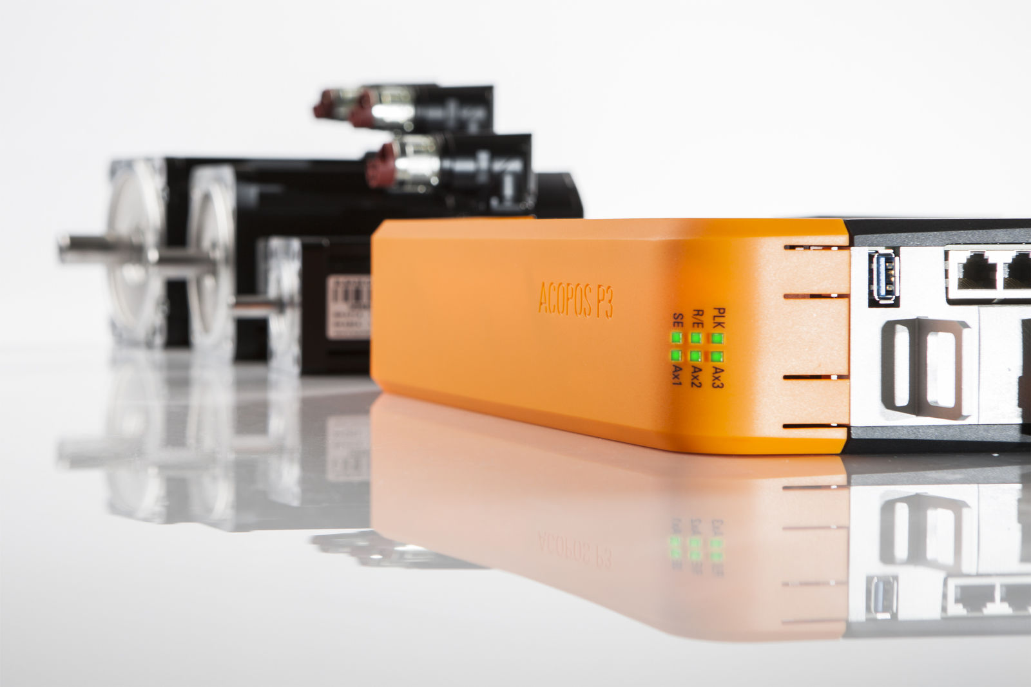
B&R has added three new model-based control functions for its ACOPOS P3 servo drive.

About B&R
B&R, a division of ABB Group, is a global leader in industrial automation headquartered in Austria. B&R combines state-of-the-art technology with advanced engineering to provide customers in virtually every industry with complete solutions for machine and factory automation, motion control, HMI and integrated safety technology. With Industrial IoT communication standards including OPC UA, POWERLINK and openSAFETY as well as its Automation Studio software, B&R is constantly redefining the future of automation engineering. The innovative spirit that keeps B&R at the forefront of industrial automation is driven by a commitment to simplifying processes and exceeding customer expectations.
For more information, visit www.br-automation.com.

