Compact performance
B&R simplifies development of modular machines with compact remote drives
B&R introduces two completely new, particularly compact motor-mounted drives. The two new additions to the ACOPOSmotor series facilitate development of modular plants and machinery. De minskar installationskostnaderna och sparar skåputrymme.

The new devices cover a power range up to 0.35 kW, and the smallest version measures just 60 mm x 90 mm (w x h). Trots deras kompakta dimensioner har de en fullfjädrad integrerad servo-enhet som möjliggör kontroll-loopar så snabbt som 50 μs. They are optionally available with an integrated gearbox and brake.
Daisy-chaining
The devices have two connections for hybrid cables, so only a single cable is required to connect to the control cabinet. The hybrid cable transmits both the power supply and POWERLINK communication. Additional ACOPOSmotor units are easily added on via daisy-chain cabling. The unique 300° swivel connections also facilitate easy installation. The time and cost of cabling are reduced significantly.

The new ACOPOSmotor variants have a wide voltage range of 24 to 60 VDC. Thanks to the low voltage, no special training is necessary in order to exchange devices. It is also possible to feed regenerative braking energy back into the DC bus. This can reduce energy consumption by up to 30%.
Integrated safety
The STO safety function comes standard on motor-mounted drives. It is controlled via the hybrid cable, so no extra wiring is necessary. Available encoder variants include: multi-turn, multi-turn with battery and single-turn. ACOPOSmotor is designed for use in harsh environments. It offers IP65 protection and requires neither fans nor heat sinks.

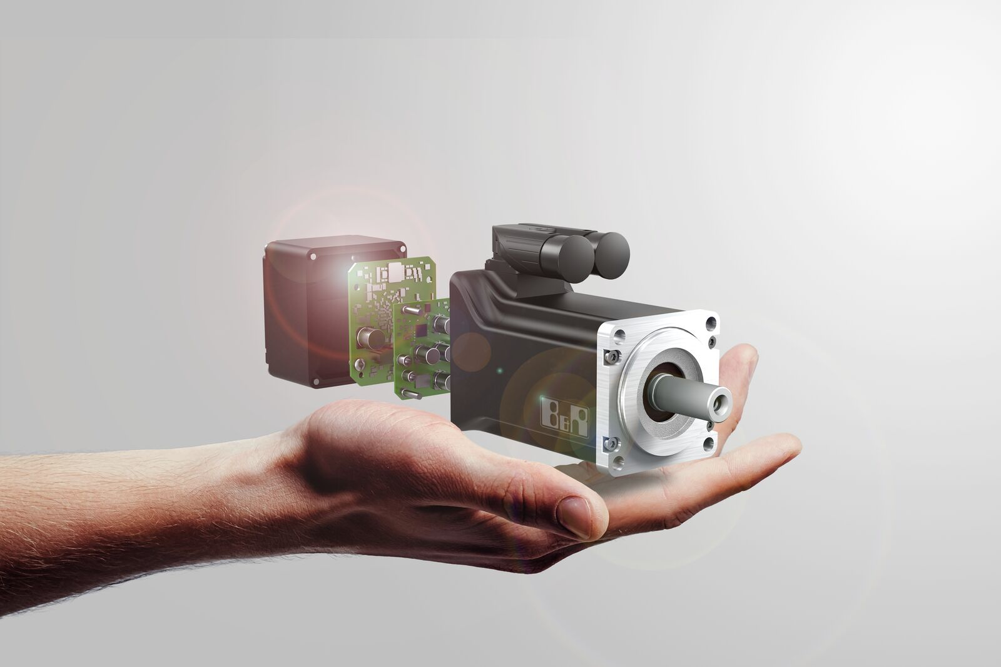
The compact motor-mounted drives facilitate the development of modular plants and machinery.

About B&R
B&R, a division of ABB Group, is a global leader in industrial automation headquartered in Austria. B&R combines state-of-the-art technology with advanced engineering to provide customers in virtually every industry with complete solutions for machine and factory automation, motion control, HMI and integrated safety technology. With Industrial IoT communication standards including OPC UA, POWERLINK and openSAFETY as well as its Automation Studio software, B&R is constantly redefining the future of automation engineering. The innovative spirit that keeps B&R at the forefront of industrial automation is driven by a commitment to simplifying processes and exceeding customer expectations.
For more information, visit www.br-automation.com.

