New X20 generation for the future of automation
B&R introduces new controllers with OPC UA over TSN and Intel processors
B&R is among the first manufacturers to introduce controllers with OPC UA over TSN communication technology and Intel Apollo Lake I processors. The new X20 controllers are distinguished by significantly higher performance, additional RAM and integrated onboard flash memory.

The new controller generation supports OPC UA over TSN and can be used as a field-level master in corresponding networks. It offers considerably more processing power than previous X20 generations with the same compact design. The controllers are equipped with high-speed Intel Apollo Lake I processors and enable cycle times as fast as 100 µs. They also offer a large L2 cache, a faster floating point unit (FPU) and faster RAM access for optimal command processing.
Integrated flash memory
The new X20 controller generation has integrated flash memory. This allows them to be optionally operated without a CompactFlash card. In this case, the integrated flash drive replaces the functionality of the CompactFlash card.
Extreme space savings
As with all X20 controllers, up to 250 I/O modules can be connected directly to the controllers and line up seamlessly. The entire system saves a large amount of space in the control cabinet. Even with it's compact design, the controller has a built-in power supply for itself and the connected I/O modules. POWERLINK, TSN-enabled standard Ethernet, RS232 and USB are available as integrated interfaces. Additional interfaces can be added via interface modules.

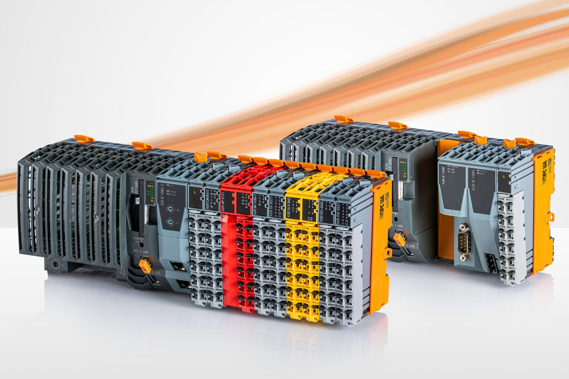
B&R is among the first manufacturers to introduce controllers with OPC UA over TSN communication technology and Intel Apollo Lake I processors.

About B&R
B&R, a division of ABB Group, is a global leader in industrial automation headquartered in Austria. B&R combines state-of-the-art technology with advanced engineering to provide customers in virtually every industry with complete solutions for machine and factory automation, motion control, HMI and integrated safety technology. With Industrial IoT communication standards including OPC UA, POWERLINK and openSAFETY as well as its Automation Studio software, B&R is constantly redefining the future of automation engineering. The innovative spirit that keeps B&R at the forefront of industrial automation is driven by a commitment to simplifying processes and exceeding customer expectations.
For more information, visit www.br-automation.com.

