OPC UA over TSN implementation
B&R introduces TSN machine switch for converged real-time networks
B&R has added a real-time Ethernet switch to its portfolio. The new machine switch can be used to set up networks using the vendor-agnostic communication solution OPC UA over TSN. Its design and form factor fit perfectly into the B&R portfolio for space-saving mounting in the control cabinet.

The TSN machine switch allows cycle times under 50 µs. It offers four real-time capable TSN ports and one standard Ethernet port – to connect a display, for example. The switch also opens up the possibility of star, tree or ring topologies in addition to daisy-chaining. Multiple switches can be cascaded in order to reach remote cabinets or implement large, complex real-time networks. Non-TSN nodes can also be incorporated in the network via the switch. Implementing modular machine concepts is now faster and easier than ever.
Automatic configuration
The switch is completely integrated in B&R's Automation Studio engineering environment. Configuration occurs automatically. The device fully supports a centralized approach to hardware and software management. Application development and machine-specific configurations can be performed either offline or online. The TSN switch can also be used as a conventional unmanaged switch for non-real-time networks. No special configuration is required.
Compact design
Since the TSN machine switch is designed in the X20 form factor, it takes up minimal space in the control cabinet, mounted right alongside the X20 control and I/O system. The switch can be mounted in two different positions, depending on the cable outlet. This allows it to be installed in tight spaces.

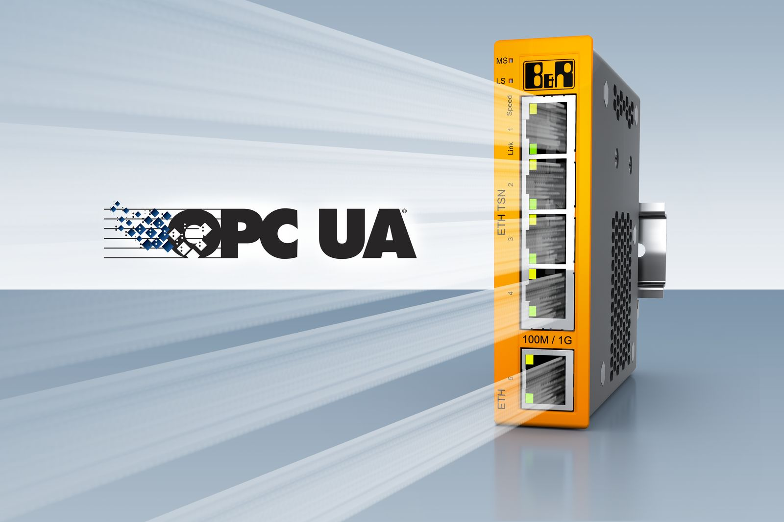
B&R is expanding its portfolio with a TSN machine switch for converged real-time networks with vendor-agnostic OPC UA over TSN communication.

About B&R
B&R, a division of ABB Group, is a global leader in industrial automation headquartered in Austria. B&R combines state-of-the-art technology with advanced engineering to provide customers in virtually every industry with complete solutions for machine and factory automation, motion control, HMI and integrated safety technology. With Industrial IoT communication standards including OPC UA, POWERLINK and openSAFETY as well as its Automation Studio software, B&R is constantly redefining the future of automation engineering. The innovative spirit that keeps B&R at the forefront of industrial automation is driven by a commitment to simplifying processes and exceeding customer expectations.
For more information, visit www.br-automation.com.

