ABB and B&R present first fully integrated solution at SPS
ABB robots become an integral feature of the B&R automation portfolio
As part of ABB's Robotics & Discrete Automation business, B&R will be introducing ABB robots as an integral feature of its automation landscape at the SPS trade fair. Machine builders will be able to buy robots and their machine control system from a
single source. B&R will also be among the first to launch a comprehensive portfolio for open, real-time capable OPC UA over TSN communication – on display in Hall 7 / Booth 206.

Integration of ABB robots into the B&R automation system eliminates the need for dedicated robotics controllers, separate control cabinets and programming specialists. The new solution reduces complexity and optimizes synchronization. Customers benefit from unprecedented precision and user-friendly programming.
B&R products speak OPC UA over TSN
A comprehensive portfolio of products for open, real-time capable OPC UA over TSN communication will also be on display at the B&R booth. With X20 PLCs, bus controllers, industrial PCs and a TSN machine switch, B&R enables fully standardized networks for modular, adaptive machines. The open standard reduces a multitude of protocols down to a single one – with a single interface exchanging standardized data between all the nodes in the network. Machinery and plants become substantially easier to develop and operate.
Decentralized compact drives simplify machine development
Also to be found at the B&R booth will be two completely new, especially compact motor-mounted drives. The new ACOPOSmotor devices facilitate the development of modular plants and machinery. They reduce installation costs and save cabinet space. The new motors cover a power range from 0.22 to 0.35 kW, and the smallest version measures just 60 mm x 90 mm (w x h). Despite their compact dimensions, they have a full-fledged integrated servo drive that enables control loops as fast as 50 µs.

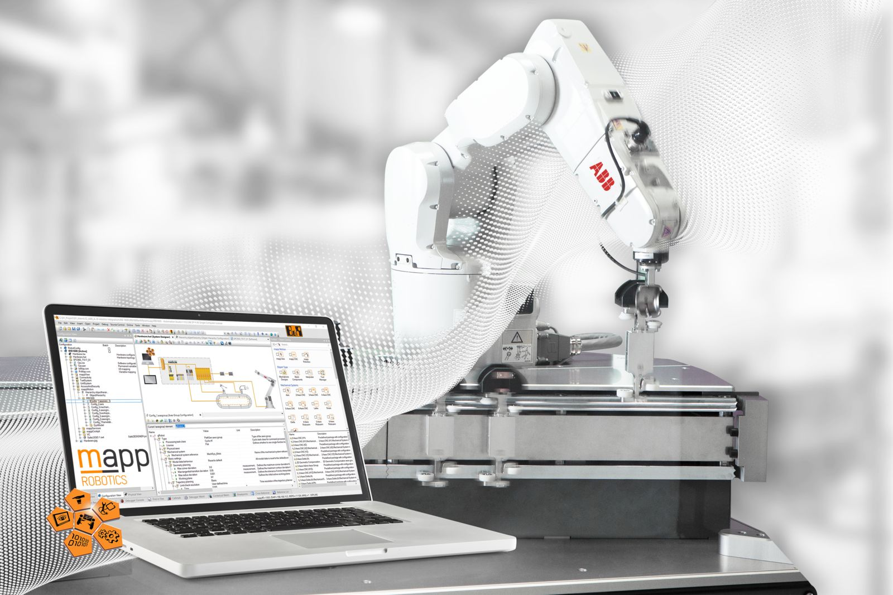
ABB and B&R present the first fully integrated solution at 2019 SPS.

About B&R
B&R, a division of ABB Group, is a global leader in industrial automation headquartered in Austria. B&R combines state-of-the-art technology with advanced engineering to provide customers in virtually every industry with complete solutions for machine and factory automation, motion control, HMI and integrated safety technology. With Industrial IoT communication standards including OPC UA, POWERLINK and openSAFETY as well as its Automation Studio software, B&R is constantly redefining the future of automation engineering. The innovative spirit that keeps B&R at the forefront of industrial automation is driven by a commitment to simplifying processes and exceeding customer expectations.
For more information, visit www.br-automation.com.

