B&R and ABB team up to eliminate healthcare bottlenecks through automation
B&R brings track technology to enable the adaptive machine at Texas Medical Center Innovation Campus
On October 9, 2019 B&R teamed up with ABB to launch the first dedicated global healthcare research hub at the Texas Medical Center (TMC) innovation campus in Houston.
B&R Industrial Automation, a member of the ABB Group, demonstrated their ACOPOStrak intelligent track technology, which seamlessly integrates with robots to enable an adaptive machine that automates tasks requiring high variability, precision and mass customization. The adaptive machine brings a new level or flexibility to product handling, assembly and packaging in the healthcare industry and beyond.
ABB’s healthcare research hub will contribute to eliminating bottlenecks in laboratory work and addressing the global shortage of skilled medical and hospital staff, with the potential to enhance speed, safety and consistency in laboratories and hospitals around the world.

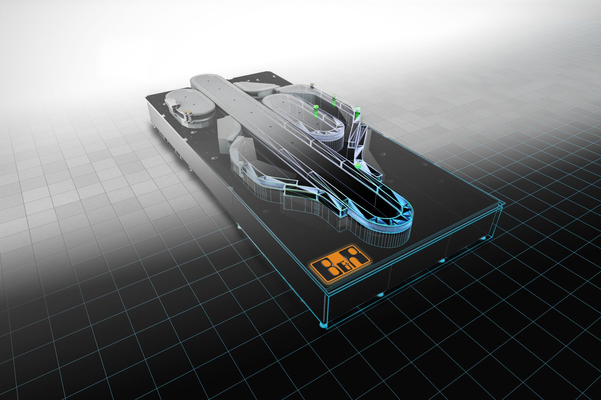
B&R Industrial Automation, a member of the ABB Group, demonstrated their ACOPOStrak intelligent track technology, which seamlessly integrates with robots to enable an adaptive machine that automates tasks requiring high variability, precision and mass customization.

About B&R
B&R, a division of ABB Group, is a global leader in industrial automation headquartered in Austria. B&R combines state-of-the-art technology with advanced engineering to provide customers in virtually every industry with complete solutions for machine and factory automation, motion control, HMI and integrated safety technology. With Industrial IoT communication standards including OPC UA, POWERLINK and openSAFETY as well as its Automation Studio software, B&R is constantly redefining the future of automation engineering. The innovative spirit that keeps B&R at the forefront of industrial automation is driven by a commitment to simplifying processes and exceeding customer expectations.
For more information, visit www.br-automation.com.

