The perfect lens for every situation
B&R adds C-mount cameras to vision portfolio
B&R's Smart Camera and Smart Sensor are now available with a C mount. This greatly expands the range of possible applications for the vision system.
Along with the new cameras, B&R is introducing five C-mount lenses that cover a wide range of focal lengths from 12 to 50 mm. The lenses are specially optimized for the image sensors used to achieve maximum resolution and high detail contrast.
By committing to market standard C-mount connections, B&R offers users free selection of optimized B&R lenses or third-party lenses for special applications, such as those that require a telecentric lens. Special covers are available for applications that need IP67 protection. The covers seal the housing without compromising imaging performance.

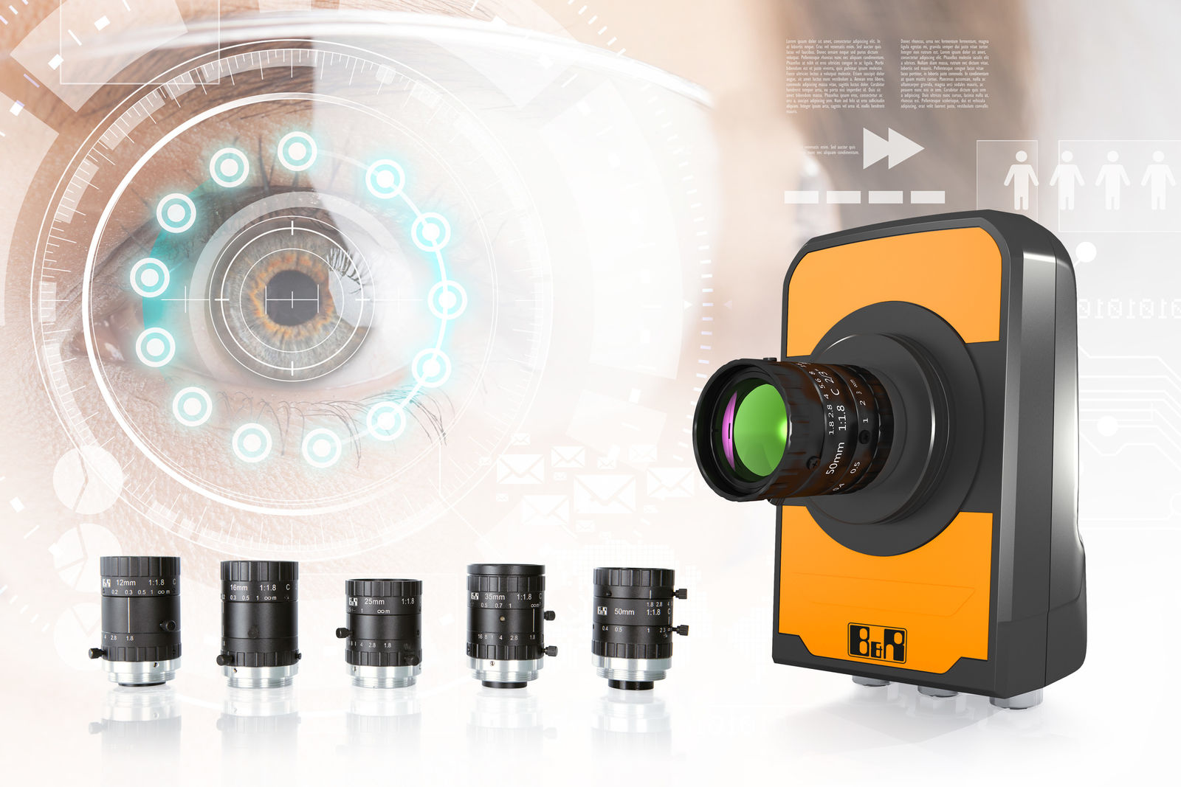
The Smart Camera and Smart Sensor are now also available with a C mount.

About B&R
B&R, a division of ABB Group, is a global leader in industrial automation headquartered in Austria. B&R combines state-of-the-art technology with advanced engineering to provide customers in virtually every industry with complete solutions for machine and factory automation, motion control, HMI and integrated safety technology. With Industrial IoT communication standards including OPC UA, POWERLINK and openSAFETY as well as its Automation Studio software, B&R is constantly redefining the future of automation engineering. The innovative spirit that keeps B&R at the forefront of industrial automation is driven by a commitment to simplifying processes and exceeding customer expectations.
For more information, visit www.br-automation.com.

