Leader in Mobile Automation Performance, Construction Tough
B&R to present mobile solutions for increasing demands of modern off-highway equipment applications at CONEXPO/IFPE 2020
On March 10 – 14, B&R Industrial Automation will highlight industry leading mobile automation innovations at their booth #83231 in the South Hall, Las Vegas Convention Center.
At CONEXPO/IFPE, B&R will present its X90 controller with integrated safety technology. The modular X90 control system is perfect for implementing flexible automation concepts built from standardized components. The heart of the X90 control system is a powerful ARM processor and multifunction I/O channels. The X90 family is designed for use in harsh industrial environments. It can handle operating temperatures from -40 to +85°C and are resistant to environmental factors such as shock and vibration, salt, UV light and oil.
Another highlight of the B&R booth will be the compact and rugged Power Panel T50 mobile operator terminal.The panel offers highly reliable operation of mobile equipment and vehicles with IP67 protection against all types of environmental influences.
The new Automation PC Mobile 3100 will be one of the major highlights at the B&R booth. B&R's new mobile automation PC provides the combination of performance and robust form factor to handle the increasing demands of modern off-highway equipment applications. Higher efficiency goals in construction, forestry and mining applications mean more data to be collected and managed from multiple machines. The Automation PC mobile 3100 is the newest addition to the B&R family of products, which is designed for just those demands.
Connect with our subject matter experts at the show.
B&R’s very own subject matter expert, Sean Grieve, Business Development Manager of Mobile Automation, will be presenting at CONEXPO on Wednesday, March 11 at 1:00 PM – 2:30 PM in the South Hall #230 on IoT Preventive Maintenance.

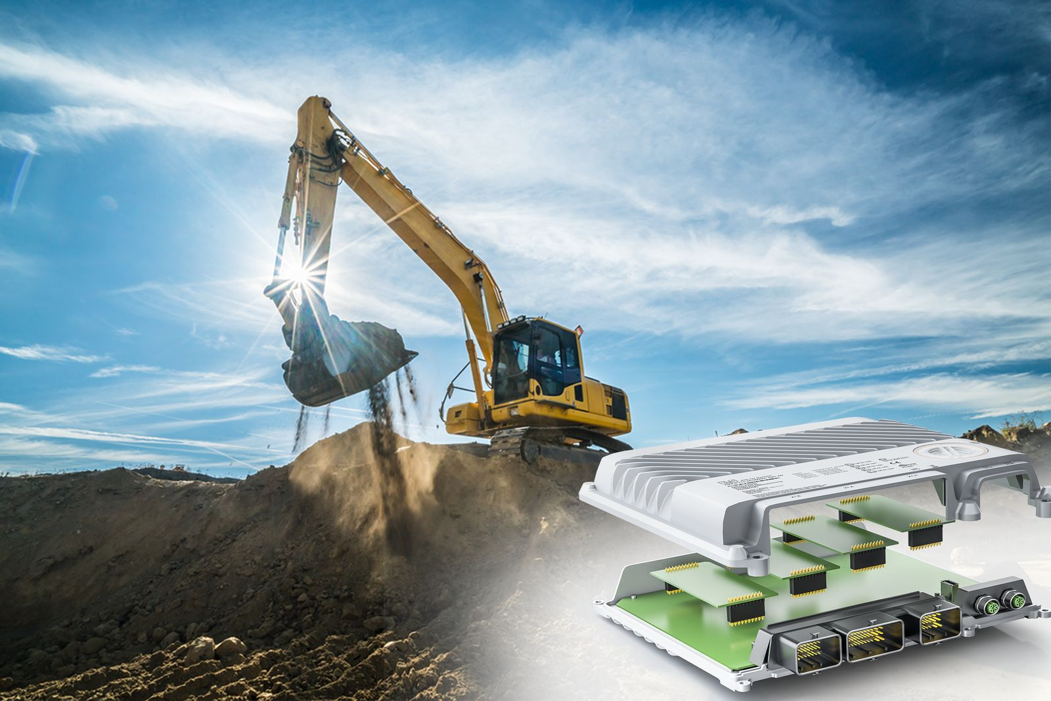
The modular X90 control system is perfect for implementing flexible automation concepts built from standardized components.

About B&R
B&R, a division of ABB Group, is a global leader in industrial automation headquartered in Austria. B&R combines state-of-the-art technology with advanced engineering to provide customers in virtually every industry with complete solutions for machine and factory automation, motion control, HMI and integrated safety technology. With Industrial IoT communication standards including OPC UA, POWERLINK and openSAFETY as well as its Automation Studio software, B&R is constantly redefining the future of automation engineering. The innovative spirit that keeps B&R at the forefront of industrial automation is driven by a commitment to simplifying processes and exceeding customer expectations.
For more information, visit www.br-automation.com.

