Cost-effective motor/valve control
B&R introduces new digital output module with pulse width modulation
X20 System In addition, the module offers a dither function that prevents valves from sticking.

Pulse width modulation (PWM) is mainly used for controlling larger loads, such as motors. Instead of using electronics to regulate a continuous input voltage down to the desired motor voltage, the motor is controlled by the width of the switching pulses. This process saves a considerable amount of energy.

With its dither function, the module also prevents valves from sticking. This is particularly common when valves are held for extended times at a constant position, especially in liquids. The dither function oscillates the valve slightly around the position setpoint to prevent it from sticking. The X20 module is equipped with four outputs with three-wire connections and offers a nominal output current of 2 A.

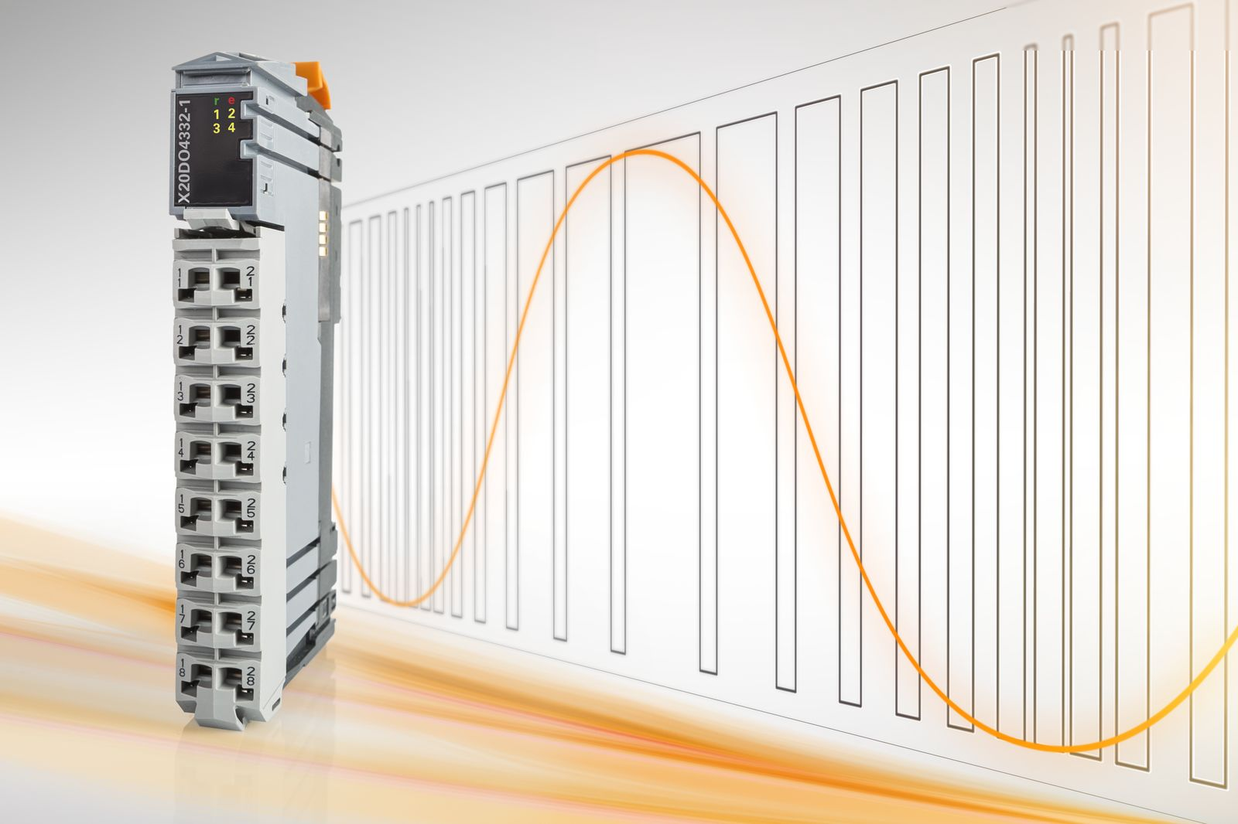
B&R's new digital output module X20DO4332-1 has integrated pulse width modulation and is a cost-effective alternative to motor modules.

About B&R
B&R, a division of ABB Group, is a global leader in industrial automation headquartered in Austria. B&R combines state-of-the-art technology with advanced engineering to provide customers in virtually every industry with complete solutions for machine and factory automation, motion control, HMI and integrated safety technology. With Industrial IoT communication standards including OPC UA, POWERLINK and openSAFETY as well as its Automation Studio software, B&R is constantly redefining the future of automation engineering. The innovative spirit that keeps B&R at the forefront of industrial automation is driven by a commitment to simplifying processes and exceeding customer expectations.
For more information, visit www.br-automation.com.

