Maximum productivity with a compact footprint
B&R introduces a new curved segment for SuperTrak.
B&R now offers a wider 180° curved segment for its intelligent SuperTrak track system. The new curve enables greater holding and propulsion forces. The shuttles can travel at higher speeds and accelerate faster. This boosts the productivity of the system.

At 838 millimeters, it is significantly wider than the previous variant. The curve is particularly suitable for automated assembly lines, where larger assemblies interact with the track system. The assemblies can be placed inside the SuperTrak oval to reduce the machine's overall footprint.

The curved segment fits seamlessly into existing machine layouts, replacing elements such as a rotary indexing table with a diameter of 1 meter. The machine gets a substantial productivity boost in a minimal amount of space. In order to allow more design freedom in the machine layout, the track system is now also available with power supply cables in various lengths.
Flexibility, precision and high payload
B&R's SuperTrak enables advanced manufacturing concepts that deliver flexible, efficient production at any batch size. The track system was designed specifically for 24/7 operation under harsh industrial conditions. It is highly reliable and safe. Individual segments and shuttles can easily be replaced without having to disassemble the track. Downtime for mechanical changeover can often be eliminated entirely. The impact on overall equipment effectiveness (OEE) is substantial.

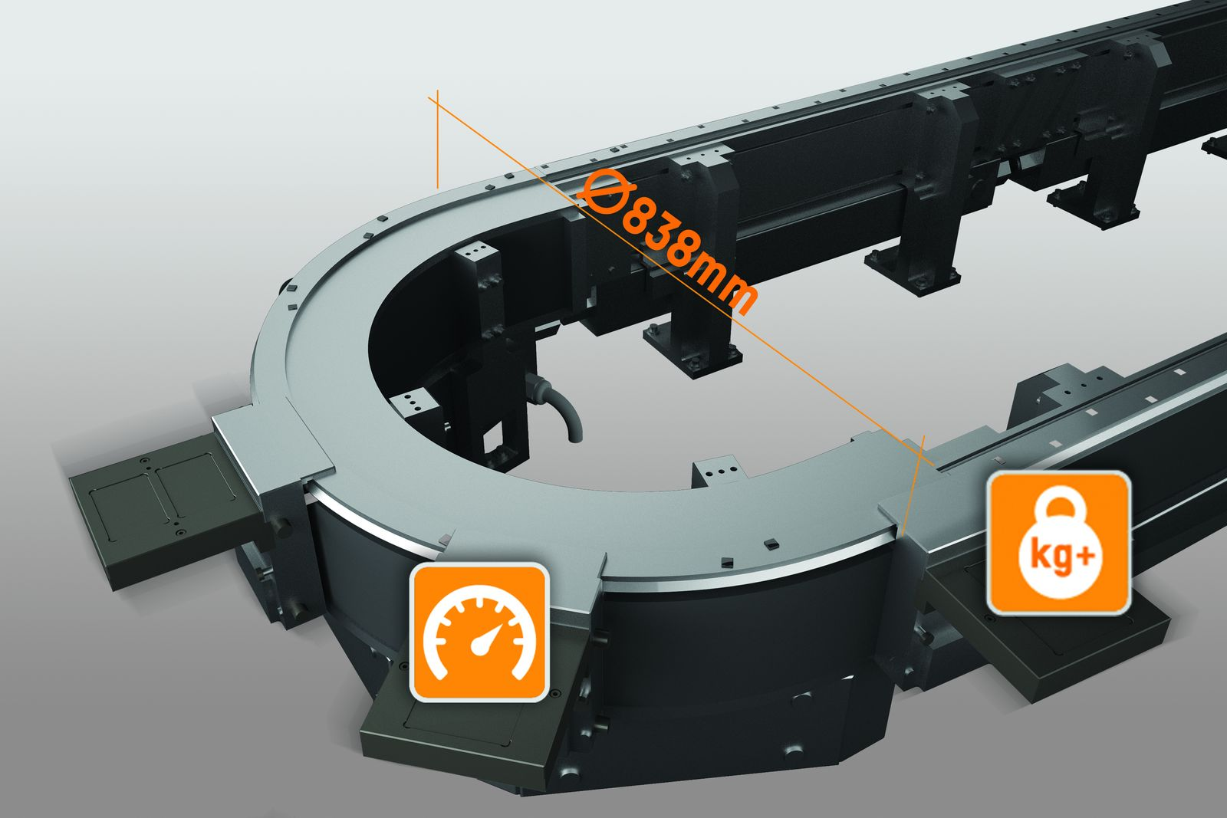
The 838 millimeter-wide curved segment for SuperTrak is particularly suitable for automated assembly lines, where larger assemblies have to interact with the track system.

About B&R
B&R, a division of ABB Group, is a global leader in industrial automation headquartered in Austria. B&R combines state-of-the-art technology with advanced engineering to provide customers in virtually every industry with complete solutions for machine and factory automation, motion control, HMI and integrated safety technology. With Industrial IoT communication standards including OPC UA, POWERLINK and openSAFETY as well as its Automation Studio software, B&R is constantly redefining the future of automation engineering. The innovative spirit that keeps B&R at the forefront of industrial automation is driven by a commitment to simplifying processes and exceeding customer expectations.
For more information, visit www.br-automation.com.

