See more, better and faster

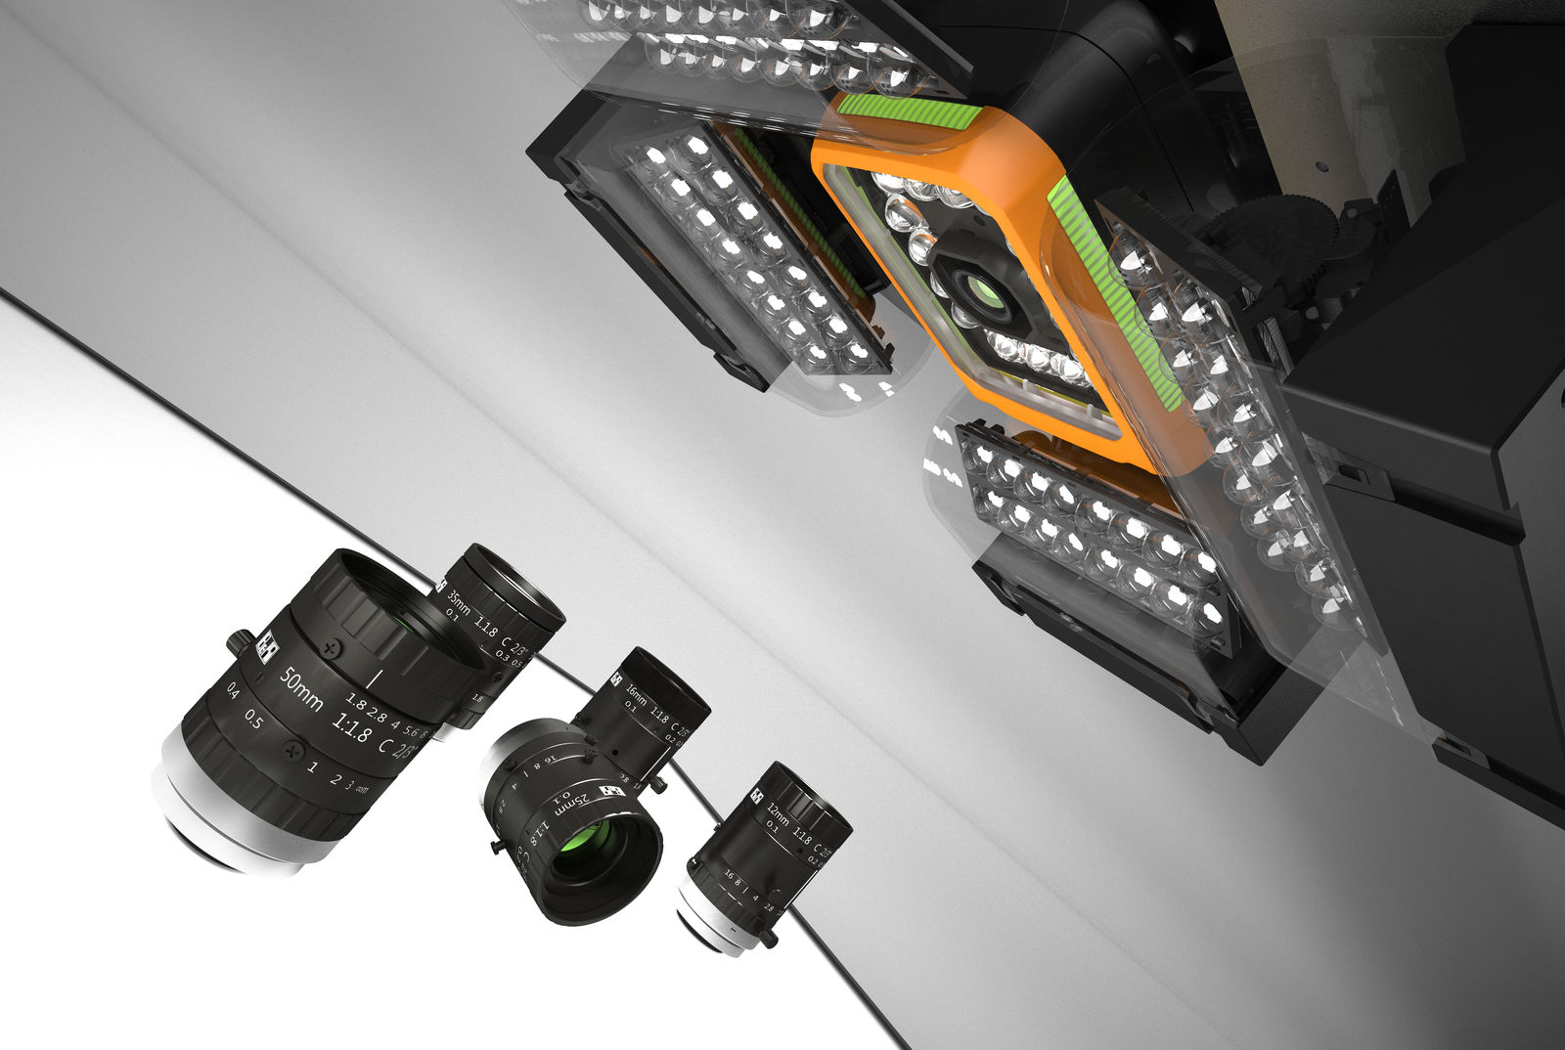
Fig. Seamless integration of machine vision into B&R automation systems.

Integrated machine vision
As integral parts of the automation system, both cameras and lighting are easily synchronized with other sensors, motor positions and events in the machine application. Lighting control with microsecond accuracy is guaranteed even when synchronizing multiple cameras and light sources.
In the next edition of Advanced Factories in the booth C309, it could be seen how B&R has seamlessly integrated machine vision into its automation system. The product range includes smart cameras, quality lenses, flexible lighting and powerful image processing algorithms. The high degree of integration can be found at all levels of the B&R system, with machine vision fully incorporated into the engineering tool, the real-time operating system and the applications on the machine. Any automation engineer can implement a large part of the machine vision applications on his own.
In addition to machine vision, B&R will be presenting the latest developments in adaptive, intelligent and flexible transport systems with unprecedented synchronization between robotics and machine control thanks to the real-time communication and management capability OPC UA on TSN.
During the last edition of the SPS, the adaptation of ACOPOStrak to the characteristics of IP69K, the wash-down version, was made official. This version will be especially suitable for sectors such as food and beverage and pharmaceuticals.
In addition, B&R presents two completely new and especially compact motor-mounted servo drives. The two new additions to the ACOPOSmotor series facilitate the development of modular machinery and plants. They reduce installation costs and save space in the cabinet.
The new devices cover a power range of up to 350 W, and the smaller version measures only 60 mm x 90 mm (width x height). Despite their compact dimensions, they have an integrated, fully operational servo drive that allows control loops with a speed of up to 50 µs. They are optionally available with an integrated gearbox and brake.

