Vertical mounting saves space
B&R offers new vertical-mount variant of SuperTrak
B&R's intelligent track system SuperTrak is now available in a vertical-mount variant. This helps to optimize the output per square meter of floor space. If products are only transported on the upper side of the SuperTrak, the weight is not supported magnetically. Instead the load is transferred directly to the rollers. The shuttles have a much higher payload capacity.

The SuperTrak power electronics have been repositioned, making them readily accessible from the front even when mounted vertically for easy installation. The connections between SuperTrak segments have also been reinforced to ensure mechanical rigidity and maximum stability and reliability in the vertical orientation.
Increased output
The independently controlled SuperTrak shuttles can be positioned freely to group products of different sizes and create a multi-pack of different beverages or other products. On a vertically mounted SuperTrak system, this type of solution can be implemented on approximately half the floor space for a significant increase in output per square meter.
Flexibility, precision and high payload
B&R's SuperTrak enables advanced manufacturing concepts that deliver flexible, efficient production at any batch size. The track system was designed specifically for 24/7 operation under harsh industrial conditions. It is highly reliable and safe. Individual segments and shuttles can easily be replaced without having to disassemble the track. Downtime for mechanical changeover can often be eliminated entirely. The impact on overall equipment effectiveness (OEE) is substantial.

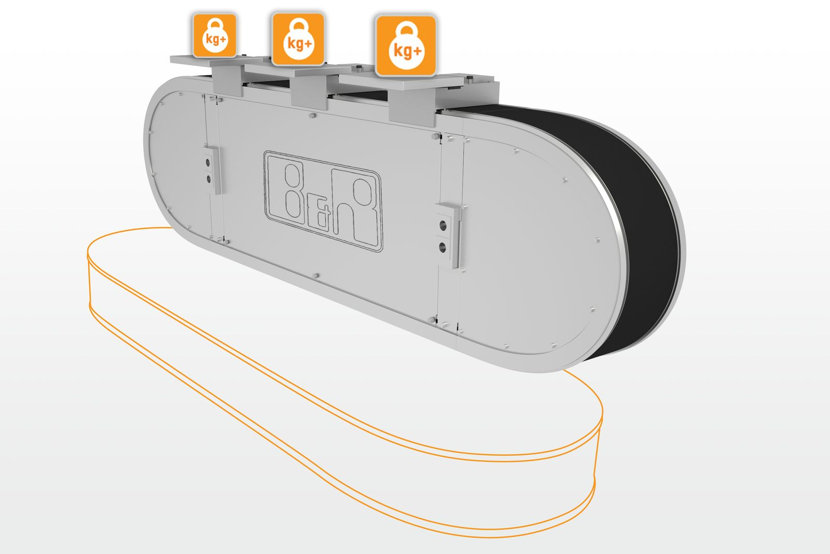
A vertically mounted SuperTrak system offers increased shuttle payload and optimizes utilization of available floor space.

About B&R
B&R, a division of ABB Group, is a global leader in industrial automation headquartered in Austria. B&R combines state-of-the-art technology with advanced engineering to provide customers in virtually every industry with complete solutions for machine and factory automation, motion control, HMI and integrated safety technology. With Industrial IoT communication standards including OPC UA, POWERLINK and openSAFETY as well as its Automation Studio software, B&R is constantly redefining the future of automation engineering. The innovative spirit that keeps B&R at the forefront of industrial automation is driven by a commitment to simplifying processes and exceeding customer expectations.
For more information, visit www.br-automation.com.

