When the robot sorts the garbage for you
Students build garbage sorting machine using B&R technology in just three days
At the international Smart Green Island Makeathon engineering competition, 13 students were given three days to build a machine that uses robots to sort garbage. Austrian automation specialist B&R supported an interdisciplinary team of students from Brno University of Technology (CZ), the Kempten University of Applied Sciences (DE), the Technical University of Ostrava (CZ), the University of Applied Sciences in Bremerhaven (DE) and the University of Erlangen-Nuremberg (DE). This year's Makeathon in Gran Canaria was entirely devoted to sustainability.
The team supported by B&R received their assignment at the beginning of the event and had to turn the concept into a functioning prototype in only three days time. On the last day of the Makeathon, Professor Dirk Jakob, one of the supervisors of the team from the Kempten University of Applied Sciences, concluded: "It was quite a challenge, but we are proud that our team was able to develop the garbage sorting machine and get it running in such a short time."
To help with the project implementation, students were provided with software and hardware from B&R as well as 3D printed robots that the Kempten University of Applied Sciences had developed themselves and brought to the event. Thanks to the open and flexible robotics solutions integrated in the B&R system, it was no problem to operate the homemade robots with a B&R controller. In the finished solution, three different types of robots sort garbage using a variety of sensors. OPC UA was used as the central communication protocol.
Exciting and educational
The Makeathon is designed to get young people excited about automation technology and at the same time to encourage them to think about sustainability. "I find the concept of the Makeathon extremely exciting and educational," says Patrick Haberstroh, head of B&R's Education Network. "You aren't likely to find too many events like this where a comparable number of concepts and prototypes are created within a matter of a few days. This also allowed us to make initial contact with some talented young people who we may someday welcome as colleagues."

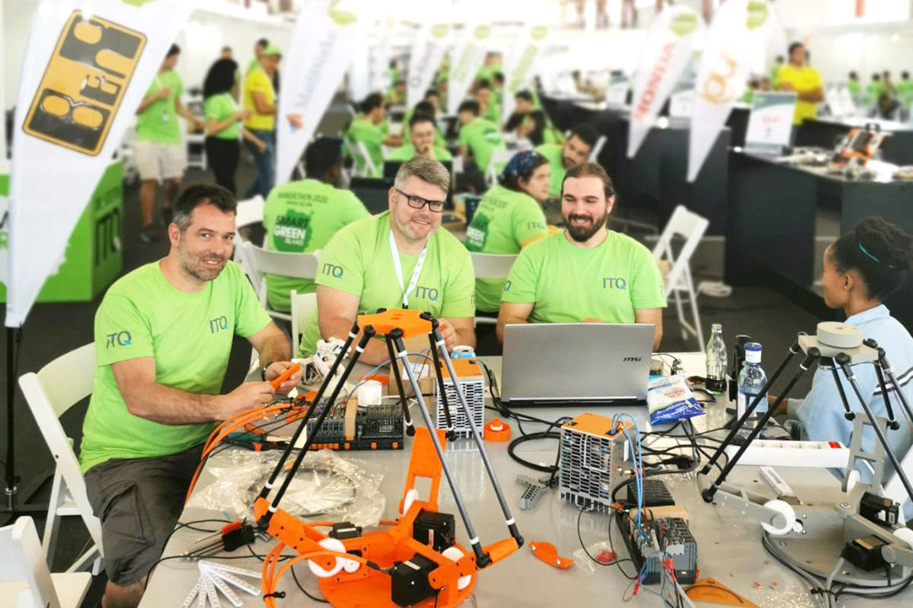
At the Smart Green Island Makeathon, student teams had three days to turn an idea and countless hardware components into a functioning garbage sorting machine. (Source: ITQ GmbH)

About B&R
B&R, a division of ABB Group, is a global leader in industrial automation headquartered in Austria. B&R combines state-of-the-art technology with advanced engineering to provide customers in virtually every industry with complete solutions for machine and factory automation, motion control, HMI and integrated safety technology. With Industrial IoT communication standards including OPC UA, POWERLINK and openSAFETY as well as its Automation Studio software, B&R is constantly redefining the future of automation engineering. The innovative spirit that keeps B&R at the forefront of industrial automation is driven by a commitment to simplifying processes and exceeding customer expectations.
For more information, visit www.br-automation.com.

