Say goodbye to switches
B&R takes intuitive operation to a new level
B&R enables a unique new form of intuitive operator guidance. Typical operating functions are now incorporated directly into the glass of B&R touch screen panels. This eliminates the need for hardware switches and leaves no chance for dirt and grime to collect or enter the device. The panels are therefore ideal for environments with the strictest hygienic requirements.

Upon customer request, B&R offers all HMI variants with a projected capacitive touch screen with corresponding finger guides. The guides can be any shape and size, enabling optimal integration of all types of sliders and dials in the HMI application. This opens up the entire screen surface for displaying content. B&R's patented tactile finger guides allow eyes-off operation. Operators can adjust settings without ever taking their attention off the machine.
Ergonomic finger guides
The ergonomic finger guides are approximately one millimeter deep and can have a matt or clear finish. The integrated keys and rotary switches never wear out. The panels are available in sizes from 5" to 24" as either a display unit or Panel PC.
Hygienic design
B&R panels with finger guides are ideally suited for the food and beverage, pharmaceutical and medical technology industries. In addition to the easy-to-clean touch screen, the panels are also available with a joint-free stainless steel housing that offers IP69K protection. Hygienic-design panels are constructed from highly resistant materials such as smooth stainless steel, high-quality polyester overlays and special sealants.

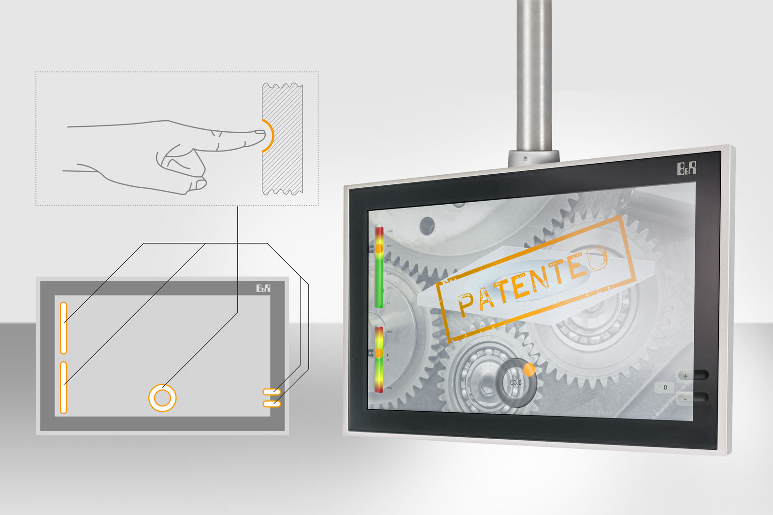
B&R now incorporates typical operating functions directly into the glass of its touch screen panels, replacing hardware elements such as function keys and rotary switches.

About B&R
B&R, a division of ABB Group, is a global leader in industrial automation headquartered in Austria. B&R combines state-of-the-art technology with advanced engineering to provide customers in virtually every industry with complete solutions for machine and factory automation, motion control, HMI and integrated safety technology. With Industrial IoT communication standards including OPC UA, POWERLINK and openSAFETY as well as its Automation Studio software, B&R is constantly redefining the future of automation engineering. The innovative spirit that keeps B&R at the forefront of industrial automation is driven by a commitment to simplifying processes and exceeding customer expectations.
For more information, visit www.br-automation.com.

