Intelligent lifecycle management for maximum security
Monthly security updates for APROL industrial control system
B&R has updated its lifecycle management strategy for the APROL industrial control system. In addition to the usual main releases and security patches, B&R will now also provide monthly operating system updates. APROL is now better prepared than ever for the implementation of modern cybersecurity strategies.
B&R publishes a new APROL build version once per year. Each of these versions is kept current with monthly operating system updates for a period of 14 months. After that, there are four more updates: one every six months.
To maintain stability, B&R conducts intensive testing on updates for the Suse Linux Enterprise Server operating system with the APROL system software before they are made available for downloading. APROL itself is maintained using patches. The interval at which this occurs depends on the severity of the bugs to be fixed.

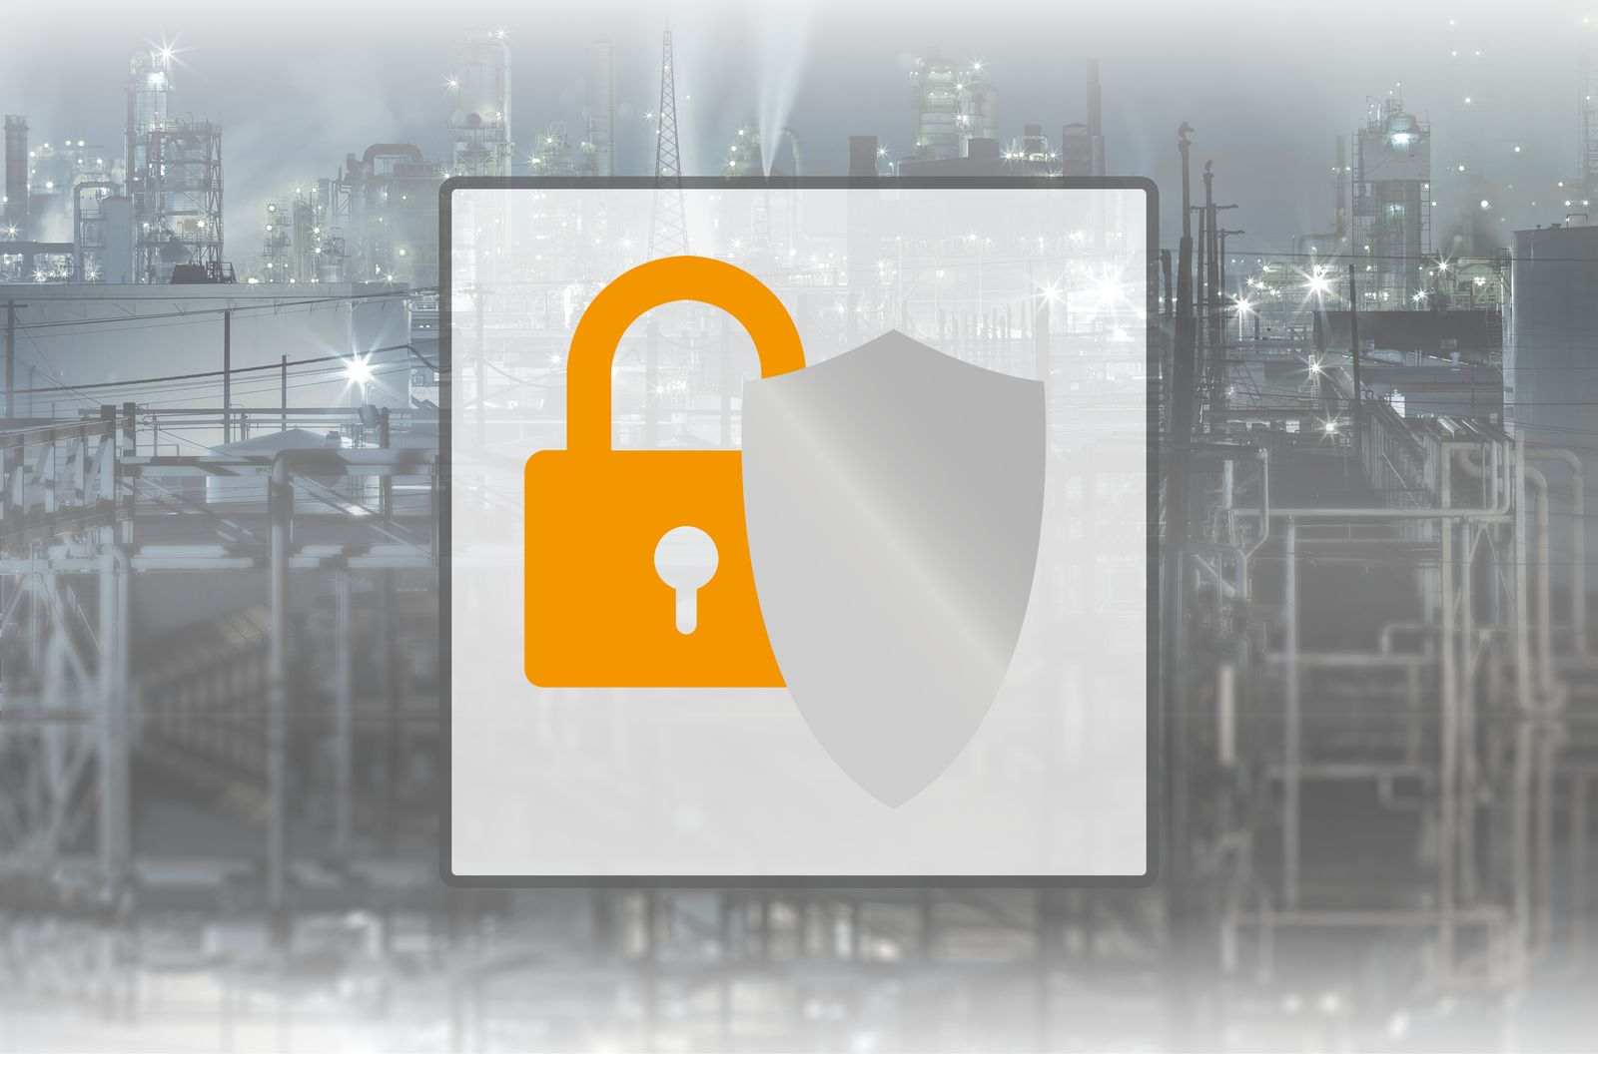
With monthly operating system updates and numerous security functions, the APROL industrial control system is now better prepared than ever for the implementation of modern cybersecurity strategies.

About B&R
B&R, a division of ABB Group, is a global leader in industrial automation headquartered in Austria. B&R combines state-of-the-art technology with advanced engineering to provide customers in virtually every industry with complete solutions for machine and factory automation, motion control, HMI and integrated safety technology. With Industrial IoT communication standards including OPC UA, POWERLINK and openSAFETY as well as its Automation Studio software, B&R is constantly redefining the future of automation engineering. The innovative spirit that keeps B&R at the forefront of industrial automation is driven by a commitment to simplifying processes and exceeding customer expectations.
For more information, visit www.br-automation.com.

