Frequency inverters for broad range of applications
B&R presents new ACOPOSinverter series for three-phase synchronous and induction motors
The ACOPOSinverter P86 is a series of frequency inverters for three-phase synchronous and induction motors, with or without encoders. It covers a wide power spectrum from 0.75 to 75 kW and is particularly well-suited for packaging, conveyor system, material processing and hoisting gear applications.

B&R's P86-series inverters already comply with the IE efficiency factors standardized in EN 61800-9-2. The future-proof inverters are easy to configure and exceptionally flexible. The new ACOPOSinverter series is also equipped with the dual-channel safety function Safe Torque Off (STO) in accordance with SIL3 / PLe.
Powerful dynamics and scalability
The frequency inverters are particularly well suited for dynamic applications. They can deliver up to 220% of the nominal output torque for two seconds. They can be used for open-loop or closed-loop control of induction motors (IE2, IE3), synchronous motors and reluctance motors. An integrated POWERLINK interface, numerous I/O channels, and embedded encoder and optional interface cards offer maximum flexibility in plant design.
Rugged design for years of duty
The ACOPOSinverter P86 series has an exceptionally rugged design, and is built to perform under harsh conditions. They easily cope with vibrations, shock, dust and temperatures up to 60°C while maintaining consistent performance.
Extensive portfolio
The new P86 series further expands B&R's ACOPOSinverter portfolio. Together with the P66, P76 and P96 series, they cover a range of drive technology profiles for three-phase induction motors and synchronous motors with a voltage supply from 200 to 600 V and a power rating from 0.18 to 200 kW. With easily scalable functionality and full integration into the B&R automation landscape, the ACOPOSinverter family is suited for a wide range of applications, from small machine modules to complex plants.

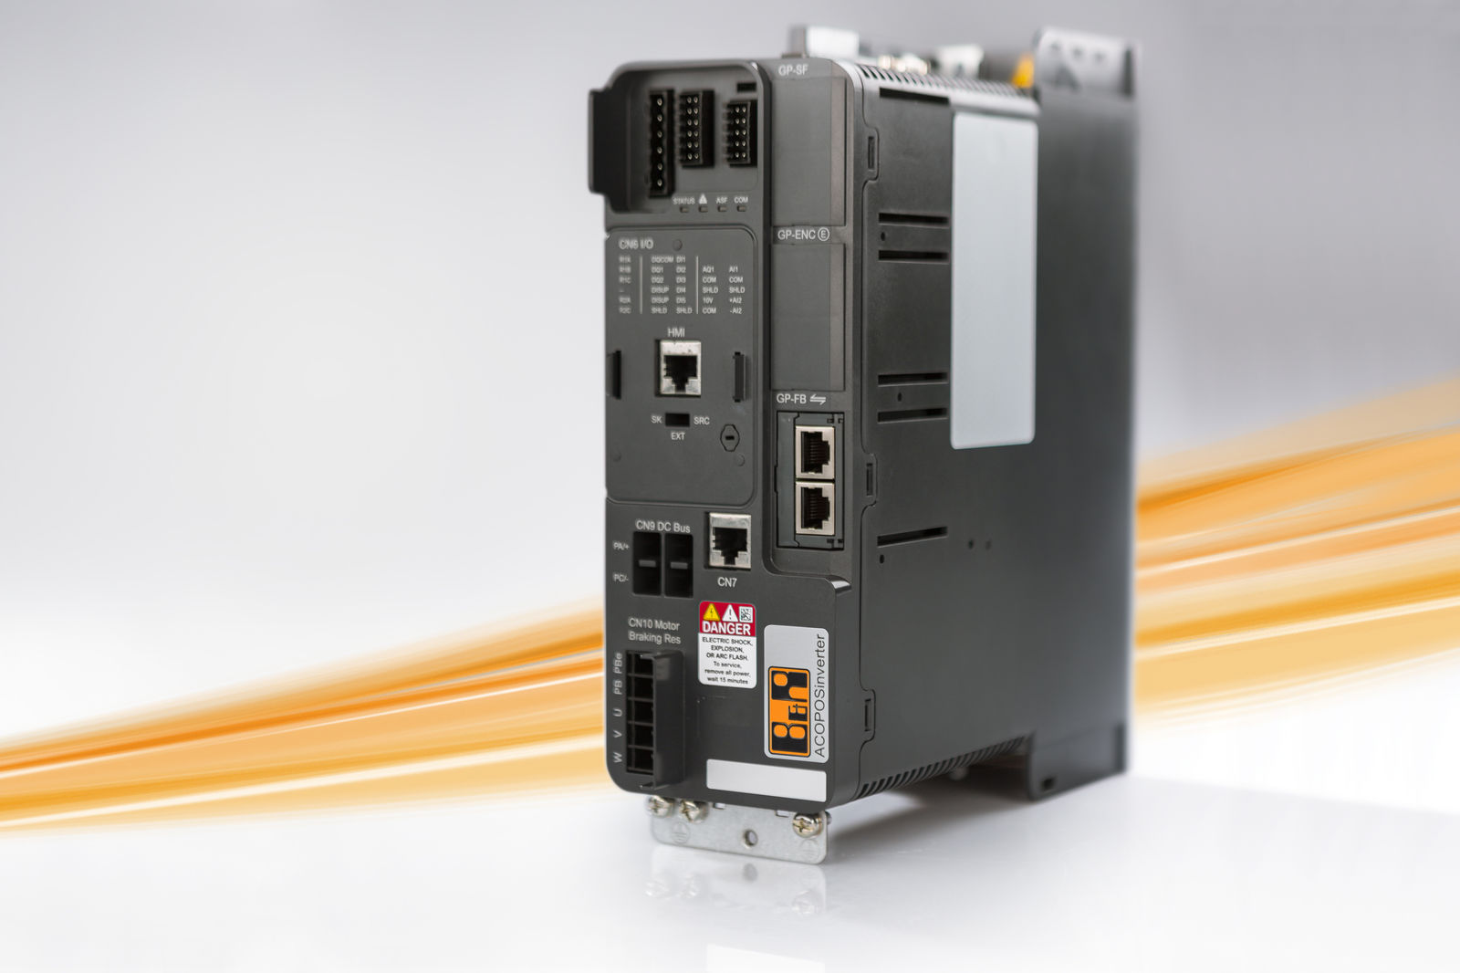
The ACOPOSinverter P86 is a series of frequency inverters for three-phase synchronous and induction motors, with or without encoders.

About B&R
B&R, a division of ABB Group, is a global leader in industrial automation headquartered in Austria. B&R combines state-of-the-art technology with advanced engineering to provide customers in virtually every industry with complete solutions for machine and factory automation, motion control, HMI and integrated safety technology. With Industrial IoT communication standards including OPC UA, POWERLINK and openSAFETY as well as its Automation Studio software, B&R is constantly redefining the future of automation engineering. The innovative spirit that keeps B&R at the forefront of industrial automation is driven by a commitment to simplifying processes and exceeding customer expectations.
For more information, visit www.br-automation.com.

