Intelligent cooling opens up new potential
Improved performance with ACOPOStrak cooling system
Motor segments for the intelligent ACOPOStrak system are now also available with built-in liquid cooling. This further expands the track's performance spectrum. Integrated directly in each motor segment, the cooling system requires no additional installation.

The new motor segments can be used to cool specific sections of track that need it most. In highly dynamic applications, large numbers of shuttles accelerate and brake on certain track segments. The resulting heat is absorbed by the liquid cooling system and transported away via a cooling medium that is pumped through the cooling circuit.
Thermal calculations made easy
The mapp Trak system software calculates exactly where the track system has the highest power requirements. From this information, it is able to determine how much heat will be generated in each track segment. The software's simulation indicates which parts of the track require cooled motor segments. Track segments can be connected in series, in parallel or a combination of the two. The ability to limit cooling to where it is actually needed makes the ACOPOStrak cooling system particularly cost effective. It adapts flexibly to any application without any additional hardware testing, ensuring the maximum benefit for the user.

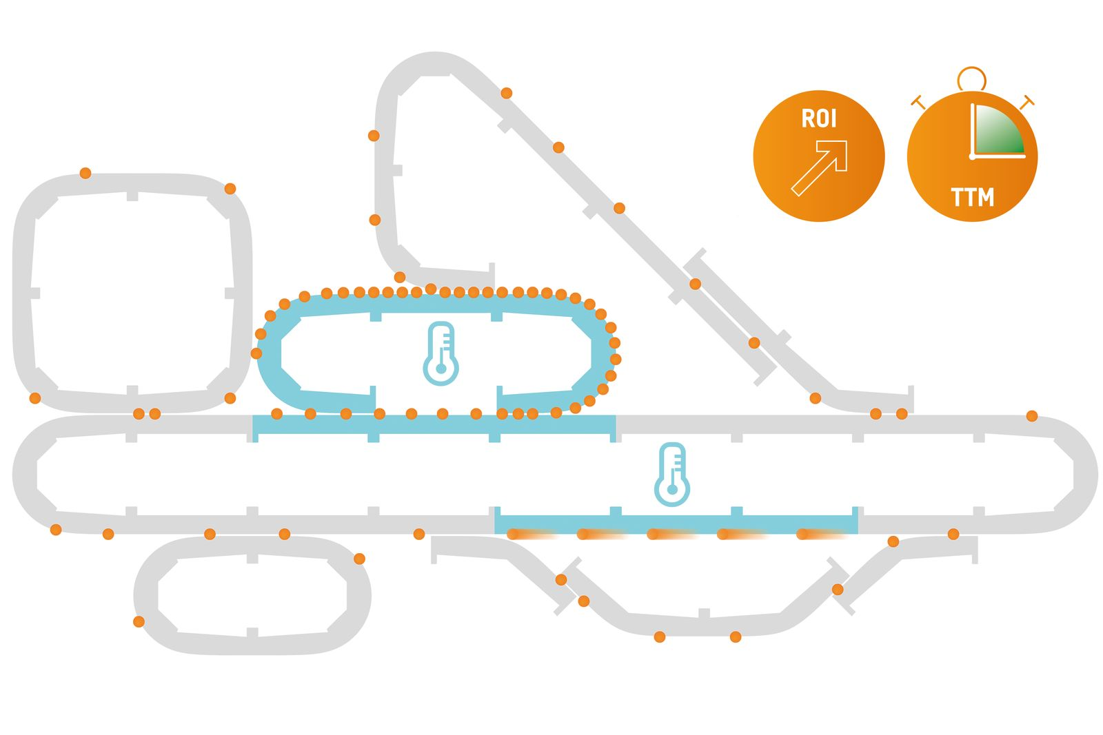
The ACOPOStrak cooling system provides efficiently targeted cooling.

About B&R
B&R, a division of ABB Group, is a global leader in industrial automation headquartered in Austria. B&R combines state-of-the-art technology with advanced engineering to provide customers in virtually every industry with complete solutions for machine and factory automation, motion control, HMI and integrated safety technology. With Industrial IoT communication standards including OPC UA, POWERLINK and openSAFETY as well as its Automation Studio software, B&R is constantly redefining the future of automation engineering. The innovative spirit that keeps B&R at the forefront of industrial automation is driven by a commitment to simplifying processes and exceeding customer expectations.
For more information, visit www.br-automation.com.

