Detailed machine analysis with mapp Cockpit from B&R
Easy-to-use tool for deployment and diagnostics
B&R's mapp Cockpit is an advanced yet easy-to-use tool for commissioning and troubleshooting machines. Based on standard web technology and OPC UA communication, it's ready to use at the push of a button with no additional programming.
Information is exchanged between mapp Cockpit and the automation project via the vendor-agnostic OPC UA communication protocol, and displayed in a web-based user interface. As a result, performing diagnostics with mapp Cockpit and a B&R automation system is not just extremely flexible, but also compliant with an established standard.
Easy integration in any application
Axes and axis groups, for example, can be controlled directly in the clearly organized mapp Cockpit dashboard. The commands for the components – which are otherwise available as function blocks – are easily executed with the simple push of a button. How the components react can then be observed in real time in the Watch window, where all relevant values are displayed in graphic form. You therefore have everything you need without having to install an extra tool.

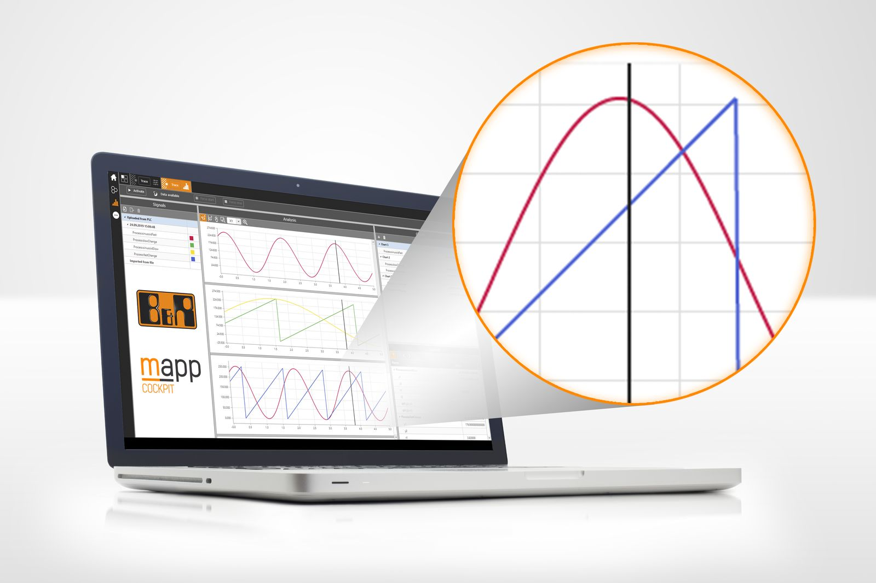
Since it is based on standard technologies, B&R's mapp Cockpit is easy to integrate into any application.

About B&R
B&R, a division of ABB Group, is a global leader in industrial automation headquartered in Austria. B&R combines state-of-the-art technology with advanced engineering to provide customers in virtually every industry with complete solutions for machine and factory automation, motion control, HMI and integrated safety technology. With Industrial IoT communication standards including OPC UA, POWERLINK and openSAFETY as well as its Automation Studio software, B&R is constantly redefining the future of automation engineering. The innovative spirit that keeps B&R at the forefront of industrial automation is driven by a commitment to simplifying processes and exceeding customer expectations.
For more information, visit www.br-automation.com.

