Secure Remote Maintenance

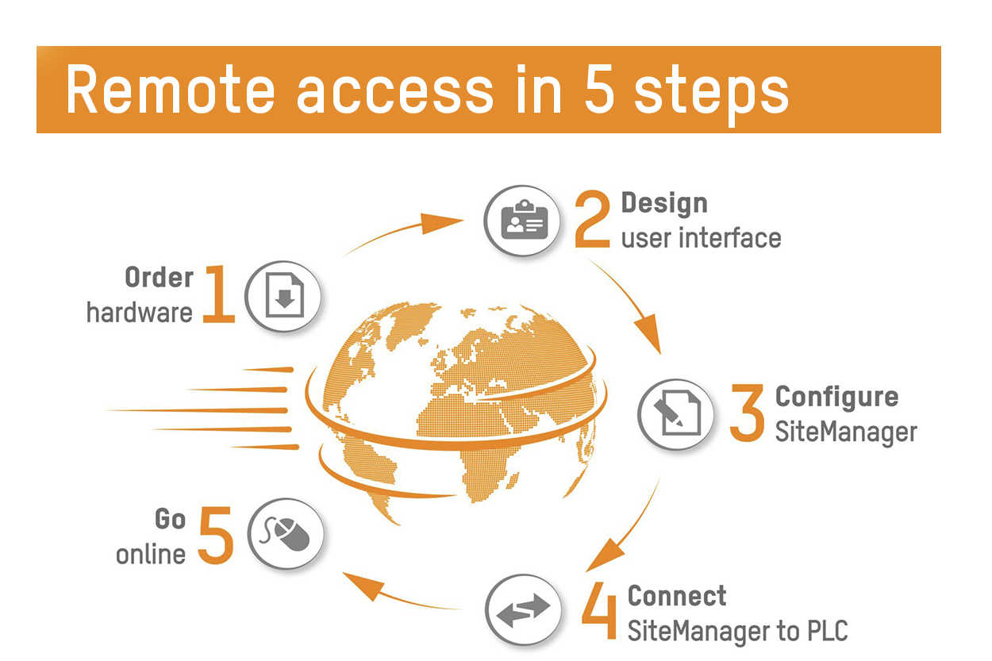
In only a few simple steps, users are able to connect to a machine and control it as though they were right there on site.

"Remote maintenance needn't be complex or costly"
Service your plants and machinery all over the world – from the comfort of your office or on the go? Our remote maintenance expert explains the five easy steps to deploy your own Secure Remote Maintenance solution.
"We have created a solution that is remarkably easy to deploy, while at the same time providing the necessary security," says Andreas Hager, remote maintenance specialist at B&R.
to the interview with Andreas Hager

