A perfect match – ABB Jokab sensors and B&R safety technology
Broad portfolio simplifies design of protection and safety systems
ABB Jokab's proven range of innovative safety sensors can now be used directly with B&R's integrated safety technology. The ABB portfolio includes a complete set of gate closures, light curtains and safety mats. The broad selection will make it easier than ever to implement safety concepts.
Safety products from ABB Jokab are simply wired to B&R's safe I/O modules. Both B&R safety technology and the ABB safety portfolio satisfy the requirements of ISO 13849-1 up to PL e / Cat. 4.
Reduced costs
ABB Jokab safety sensors support the wiring of a safety function with multiple different sensors connected in series. This could be used to connect a series of safety gates, for example. This approach reduces cabling and installation costs immensely and thus also reduces the number of safe input channels required. The series connection does not change the maximum safety level of PL e / Cat. 4.
Modern technology
ABB Jokab offers a comprehensive range of safety components that greatly simplify the design of protection and safety systems. The proven range of innovative safety products includes the well-known Eden series of inductive gate switches and Safeball devices for two-hand control.

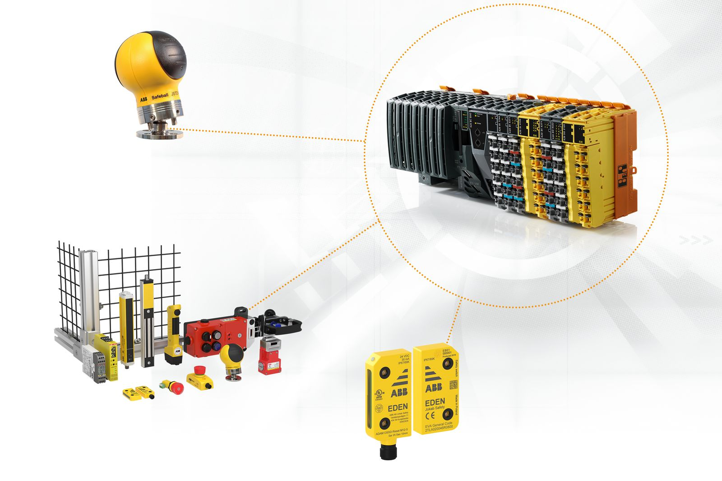
The combination of ABB Jokab safety sensors and B&R's own portfolio will make it easier than ever to implement safety concepts.

About B&R
B&R, a division of ABB Group, is a global leader in industrial automation headquartered in Austria. B&R combines state-of-the-art technology with advanced engineering to provide customers in virtually every industry with complete solutions for machine and factory automation, motion control, HMI and integrated safety technology. With Industrial IoT communication standards including OPC UA, POWERLINK and openSAFETY as well as its Automation Studio software, B&R is constantly redefining the future of automation engineering. The innovative spirit that keeps B&R at the forefront of industrial automation is driven by a commitment to simplifying processes and exceeding customer expectations.
For more information, visit www.br-automation.com.

