New CSO at B&R
Luca Galluzzi to succeed Peter Gucher as Chief Sales Officer
On August 1st, Luca Galluzzi (52) will join the executive management team of automation specialist B&R. As the new Chief Sales Officer, he will succeed Peter Gucher, who will be entering a well earned retirement after 34 years at the company.
In his new role, Galluzzi will be responsible for all of B&R's global sales activities and advancing its entry into new markets. In addition to his position on the executive management team, he will retain his current responsibilities as Managing Director for Southern Europe.
"Luca Galluzzi has done an exceptional job in the Southern Europe region and has demonstrated a commitment to expanding our business there. I am very pleased that our executive team will now be able to benefit from his knowledge and experience," says B&R CEO Hans Wimmer.
27 subsidiaries
Peter Gucher began his career at B&R at a time when the company was still a small Upper Austrian start-up with 60 employees. Over the years, he built up a sales network that now comprises 27 subsidiaries and over 180 offices all around the world.
"This global presence and the closeness it gives us to our customers are the result of Peter Gucher's personal dedication," says Wimmer. "We owe him a debt of gratitude for his hard work and wish him all the best for his well earned retirement."

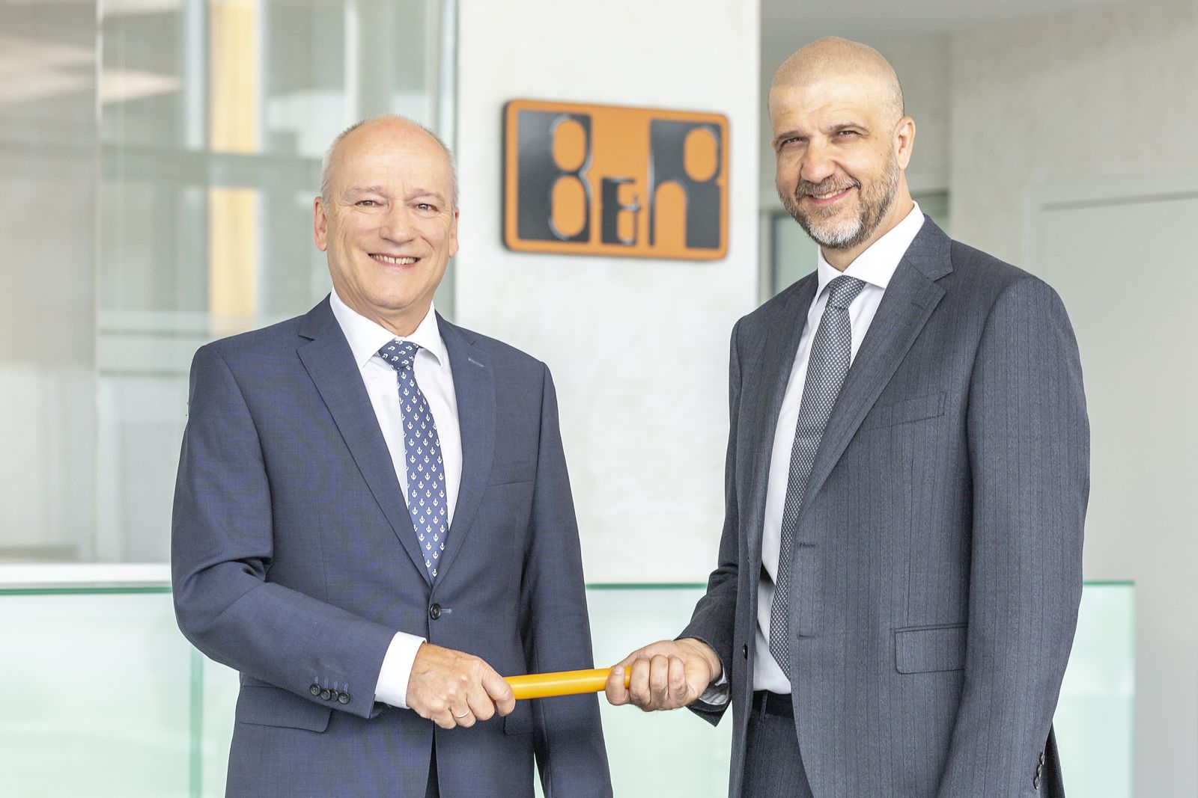
After 34 years at the company, Peter Gucher (left) will be entering a well earned retirement and hand over his role as Chief Sales Officer to Luca Galluzzi.

About B&R
B&R, a division of ABB Group, is a global leader in industrial automation headquartered in Austria. B&R combines state-of-the-art technology with advanced engineering to provide customers in virtually every industry with complete solutions for machine and factory automation, motion control, HMI and integrated safety technology. With Industrial IoT communication standards including OPC UA, POWERLINK and openSAFETY as well as its Automation Studio software, B&R is constantly redefining the future of automation engineering. The innovative spirit that keeps B&R at the forefront of industrial automation is driven by a commitment to simplifying processes and exceeding customer expectations.
For more information, visit www.br-automation.com.

