Valuable insight into machine performance
B&R provides easy, flexible overview of historical data
It's now easy to display historical process variable data in a machine's HMI application. Machine operators can constantly monitor and optimize their processes. A clear overview of machine performance enables early detection of irregularities and helps minimize maintenance costs.

The new OnlineChartHDA HMI element from the mapp View software package gives users valuable insight into how their machines are behaving. Process data is recorded constantly via the machine controller and made available to the widget automatically.
Open communication standard
The solution is based on the OPC UA standard. Machine data is retrieved from an OPC UA server and displayed in the HMI application using a standardized interface, so the widget can use data from any device that has an OPC UA server. All settings, including the sampling time and buffer size, are configured on the server.
State-of-the-art user interface
The mapp View software package gives automation engineers all the tools they need to create powerful, intuitive, web-enabled HMI screens. They can create modern HTML5 applications with ready-made widgets. Users simply drag and drop the OnlineChartHDA widget to the desired screen in the HMI application and configure it as necessary. Multi-touch gestures like swiping and zooming deliver an intuitive user experience.

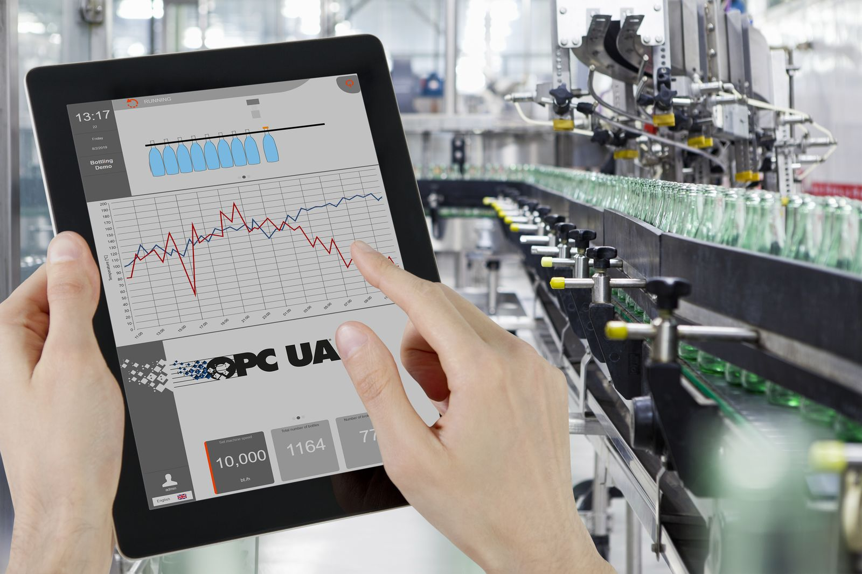
The new OnlineChartHDA HMI element gives users clear insight into the performance of their machines.

About B&R
B&R, a division of ABB Group, is a global leader in industrial automation headquartered in Austria. B&R combines state-of-the-art technology with advanced engineering to provide customers in virtually every industry with complete solutions for machine and factory automation, motion control, HMI and integrated safety technology. With Industrial IoT communication standards including OPC UA, POWERLINK and openSAFETY as well as its Automation Studio software, B&R is constantly redefining the future of automation engineering. The innovative spirit that keeps B&R at the forefront of industrial automation is driven by a commitment to simplifying processes and exceeding customer expectations.
For more information, visit www.br-automation.com.

