Industrial PC memory gets a turbo boost
M.2 memory means faster access and higher capacity
B&R is adding new mass memory options for its Automation PC 3100 and Panel PC 3100 industrial PCs. In addition to CFast cards, it is now also possible to use M.2 modules. This type of memory offers fast access and up to 1 TB of storage capacity.
M.2 memory modules are very compact and are based on MLC technology. Their high throughput makes them particularly attractive for data logging and other data-intensive applications. They also offer substantially more storage capacity than CFast cards, which allows more data to be written over the course of their service life.
The M.2 memory card occupies a predefined interface slot on in the industrial PC. It can be factory-installed or added by the user on site. Together with the two CFast slots, each Automation PC can now be equipped with a total of three mass memory modules.

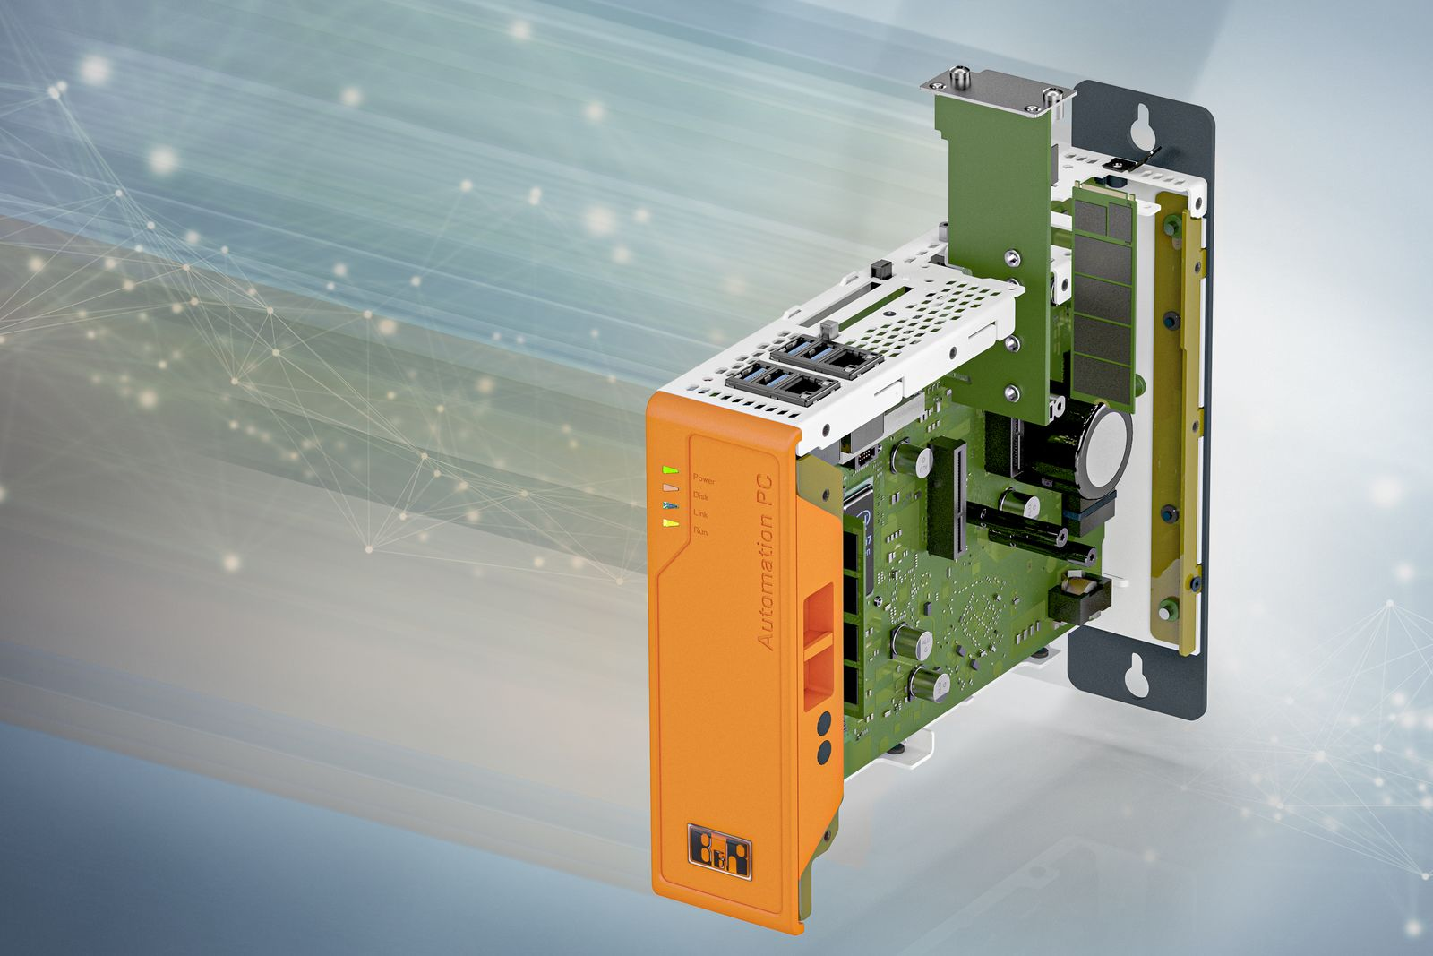
The Automation PC 3100 can now be optionally equipped with an M.2 memory module.

About B&R
B&R, a division of ABB Group, is a global leader in industrial automation headquartered in Austria. B&R combines state-of-the-art technology with advanced engineering to provide customers in virtually every industry with complete solutions for machine and factory automation, motion control, HMI and integrated safety technology. With Industrial IoT communication standards including OPC UA, POWERLINK and openSAFETY as well as its Automation Studio software, B&R is constantly redefining the future of automation engineering. The innovative spirit that keeps B&R at the forefront of industrial automation is driven by a commitment to simplifying processes and exceeding customer expectations.
For more information, visit www.br-automation.com.

