More productive with ready-made software components
B&R simplifies development of pick-and-place applications
A ready-made software solution from B&R helps OEMs implement pick-and-place applications significantly faster. Not only does the system control the robot itself, it also handles coordination with other axes, conveyor belts or tracks.
mapp Pick&Place grants the user maximum freedom to solve the requirements of their process using any number of delta, articulated arm or SCARA robots. The software also allows developers to automatically optimize their process in different ways. They can choose whether the movement profiles should prioritize shortest pick duration, first in first out, or energy-optimized movement.
Configuring, not programming
As part of the mapp Technology software framework, mapp Pick&Place is automatically linked to all of the other mapp components. As a result, it takes only a few clicks to set up coordination with other motion axes, B&R machine vision components or web-based mapp View HMI applications. The manual programming this would normally require has been largely eliminated.
Robot and machine become one
B&R is the world's only single-source supplier of controls and robotics. Robots from its parent company ABB are fully integrated in the B&R automation system. Customers benefit from unprecedented precision in synchronization between robotics and machine control. They need only one controller and one engineering system for development, diagnostics and maintenance.

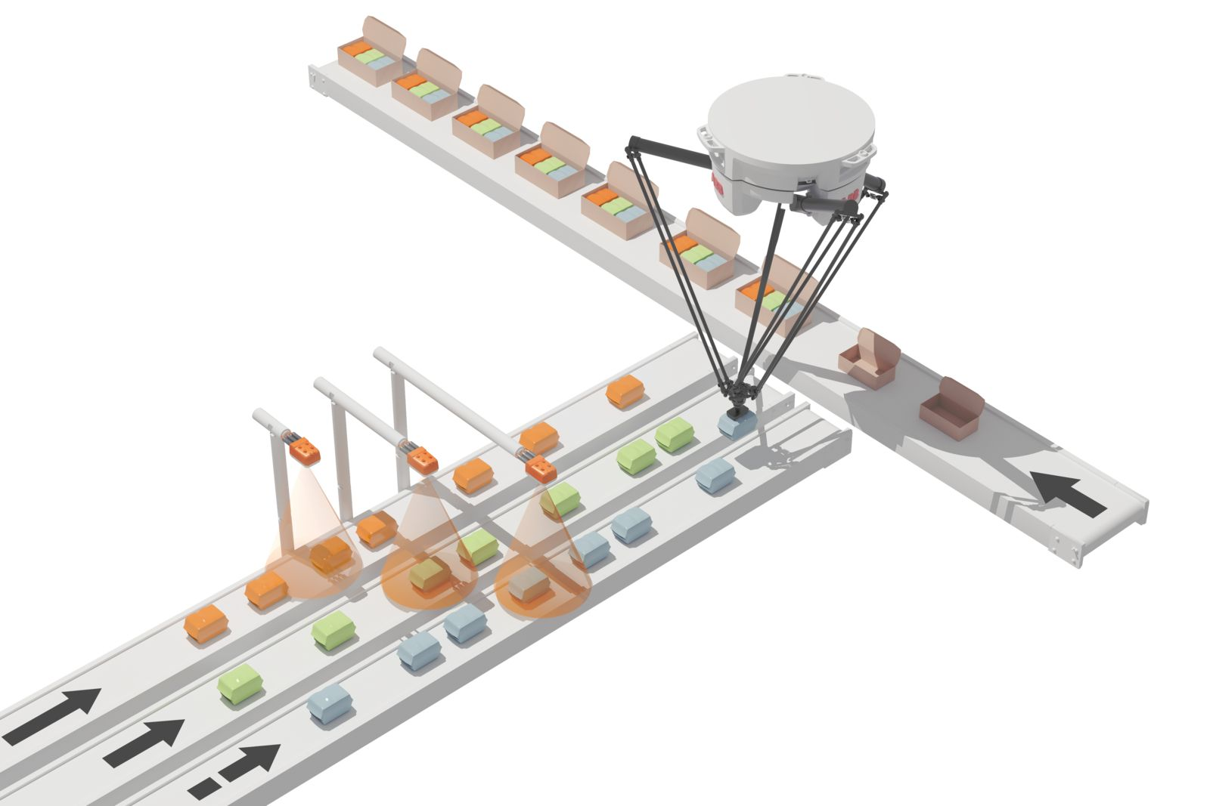
B&R has simplified the development of pick-and-place applications.

About B&R
B&R, a division of ABB Group, is a global leader in industrial automation headquartered in Austria. B&R combines state-of-the-art technology with advanced engineering to provide customers in virtually every industry with complete solutions for machine and factory automation, motion control, HMI and integrated safety technology. With Industrial IoT communication standards including OPC UA, POWERLINK and openSAFETY as well as its Automation Studio software, B&R is constantly redefining the future of automation engineering. The innovative spirit that keeps B&R at the forefront of industrial automation is driven by a commitment to simplifying processes and exceeding customer expectations.
For more information, visit www.br-automation.com.

