Pre-engineered automation solution for VFFS machines

B&R to present out-of-the-box technology ospVFFS

B&R Industrial Automation, a global leader in industrial automation, has recently launched an out-of-the-box automation solution for vertical form fill seal (VFFS) machines called ospVFFS – a scalable, configurable and pre-engineered new technology. It can be used for new as well as retrofit machines with limitless possibilities and configurations. ospVFFS enables machine builders to configure a VFFS machine within 30 minutes with various possibilities. This not only improves machine performance but also enables a shorter time-to-market. In addition, the configurable solution is Industry 4.0 ready with web-based diagnostics and secure IT connectivity over inbuilt OPC UA.
Products and packaging are undergoing changes as demand for efficient and sustainable packaging grows exponentially. By engaging in strong partnerships with their automation vendors, machine builders can keep pace with these rapidly changing needs.. "Developing sustainable packaging solutions with minimum time to market (TTM) is a challenge for machine builders. New technology must ensure efficient processing and higher flexibility, “says B&R packaging expert Dinesh Mungi. With B&R's advanced, pre-engineered automation solutions for VFFS machines, we are sure that our customers will be able to efficiently satisfy the ever changing market demands.
ospVFFS: Scalable and configurable solution for higher performance
"B&Rs OEM Solution Package for Vertical Form, Fill and Seal machine (ospVFFS) will give a completely new perspective to Indian VFFS machine builders. ospVFFS enables machine builders to meet various in-dustry standards, reduces engineering effort, achieves higher performance, reduces total cost of ownership (TCO) and significantly reduces time to market (TTM)," confirms Prashant Rasal, Manager - Machine Intelli-gence Technology Centre (MITC), B&R India. With ospVFFS, B&R India has brought about a revolution in VFFS machine building, enabling machine builders to reduce machine development time, improve efficiency and ROI, minimize maintenance and bene-fit from a cost-effective solution.
B&R partnering for packaging machines
B&R India recently hosted a virtual product launch for ospVFFS, which was attended by more than 100 ma-chine manufacturers and brand owners. With the out-of-the-box solution, B&R yet again proves itself to be a perfect automation and digitalization partner to help packaging OEMs build a new generation of Industry 4.0 ready VFFS machines.

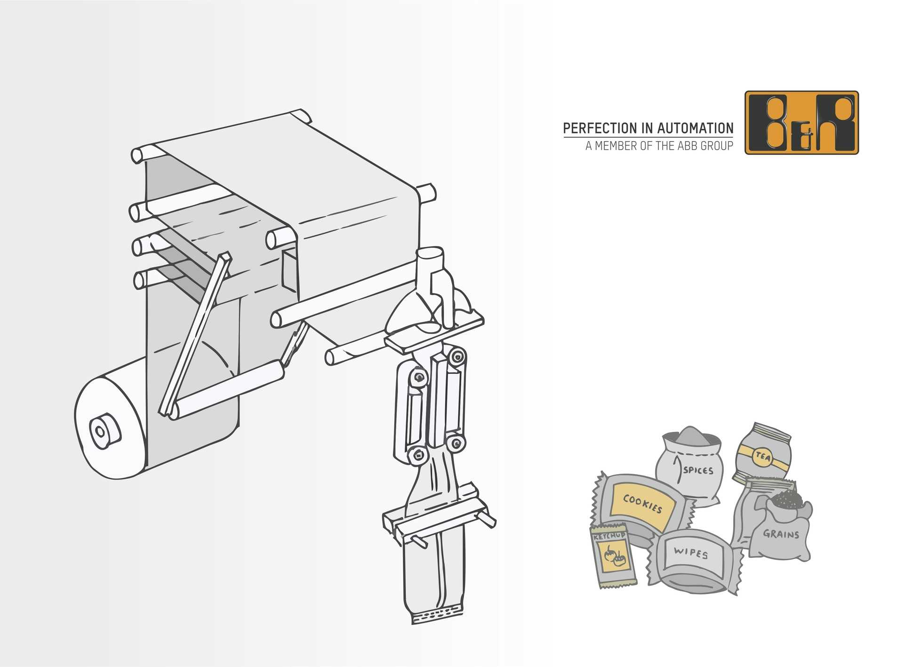
B&R's out-of-the-box ospVFFS solution enables rapid development and testing of the VFFS machine with minimal engineering overhead and time to market.

About B&R
B&R, a division of ABB Group, is a global leader in industrial automation headquartered in Austria. B&R combines state-of-the-art technology with advanced engineering to provide customers in virtually every industry with complete solutions for machine and factory automation, motion control, HMI and integrated safety technology. With Industrial IoT communication standards including OPC UA, POWERLINK and openSAFETY as well as its Automation Studio software, B&R is constantly redefining the future of automation engineering. The innovative spirit that keeps B&R at the forefront of industrial automation is driven by a commitment to simplifying processes and exceeding customer expectations.
For more information, visit www.br-automation.com.

