More torque in less space
New servo motor series from B&R offer up to 75% higher nominal torque
B&R is adding the new 8LW and 8LS servo motor series with high torque density to its portfolio. The sophisticated design of these motors helps them achieve up to 75% higher nominal torque than comparable motors when used together with an ACOPOS servo drive. Machine builders can make their machines substantially more compact and economical.

With an optimized design that improves heat dissipation, B&R has significantly increased the performance of these motors. A new winding design substantially reduces speed fluctuations. This results in exceptionally smooth rotation, which is especially beneficial in printing and grinding processes. The new design also offers more precise positioning and repeatability.
Perfectly scalable
The 8LW and 8LS servo motor series are suitable for a connection voltage of 325 or 750 VDC and can be installed at altitudes up to 4,000 meters. All sizes of all motors are optionally available as either a robust single-cable solution for EnDat 2.2 in conjunction with scalable safety functions, or as a dual-cable solution for resolvers and EnDat 2.2. This makes it easy to find the right solution for every application.
All the data at a glance
The motors offer IP64 protection and come with an embedded parameter chip that contains all the mechanical and electronic data of the motor. This enables the user program to identify the entire power transmission system without time consuming and error-prone manual configurations. Commissioning times are reduced considerably. Additionally, the ability to easily compare machine configurations during service helps to diagnose faulty arrangements immediately and minimizes costly downtime.

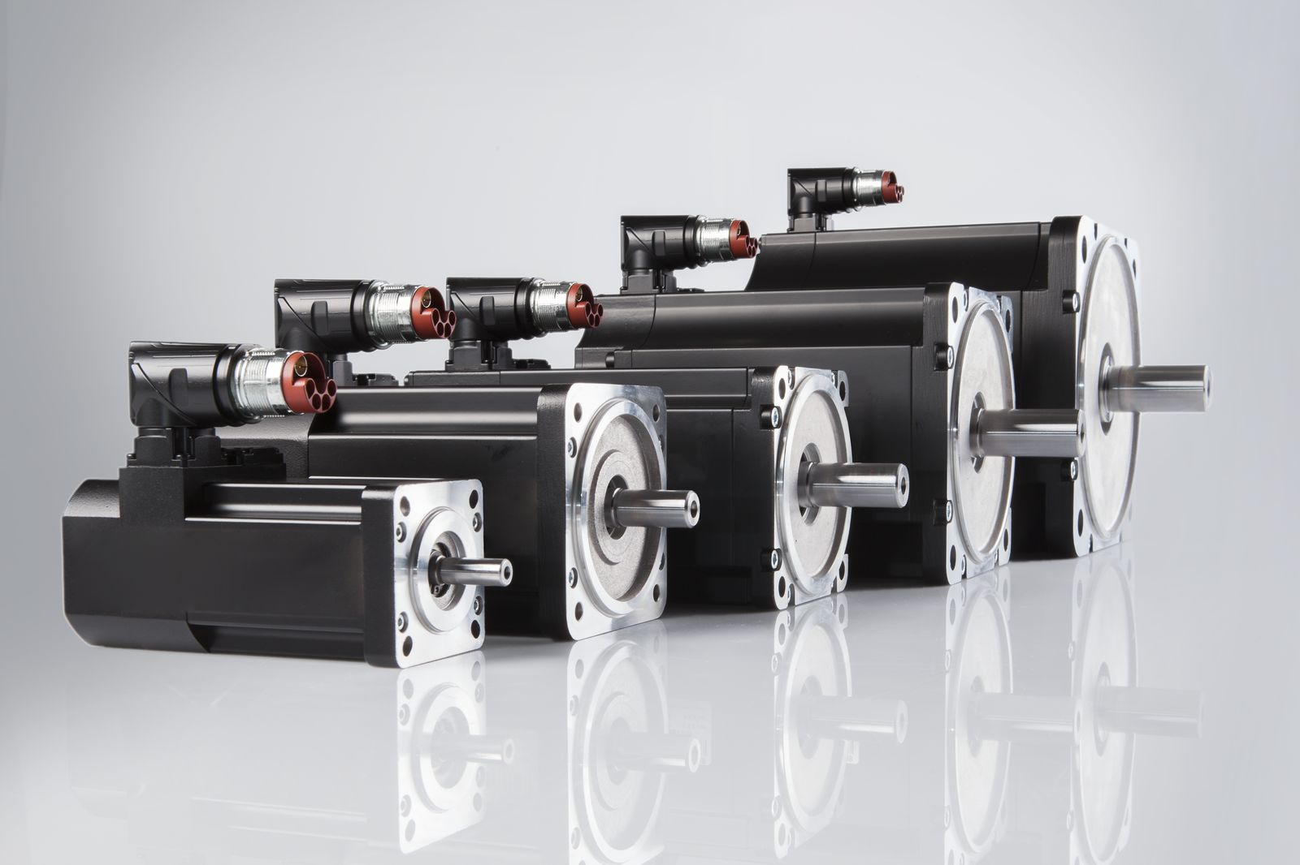
The sophisticated design of the new motors helps them achieve up to 75% higher nominal torque than comparable motors when used together with an ACOPOS servo drive.

About B&R
B&R, a division of ABB Group, is a global leader in industrial automation headquartered in Austria. B&R combines state-of-the-art technology with advanced engineering to provide customers in virtually every industry with complete solutions for machine and factory automation, motion control, HMI and integrated safety technology. With Industrial IoT communication standards including OPC UA, POWERLINK and openSAFETY as well as its Automation Studio software, B&R is constantly redefining the future of automation engineering. The innovative spirit that keeps B&R at the forefront of industrial automation is driven by a commitment to simplifying processes and exceeding customer expectations.
For more information, visit www.br-automation.com.

