Change in leadership at B&R Turkey
Ömer Yücel takes over as managing director
In September, Ömer Yücel took over as managing director of B&R Turkey. The B&R subsidiary has been on a steady course of growth since it was established in 2012. In his new position, Yücel aims to further expand B&R's market presence.

Yücel began his B&R career in 2014 as an application engineer, before later moving to Sales. He most recently served as sales manager of B&R Turkey. Yücel's career path at B&R has given him insight into the various areas of the company, and he is very familiar with the challenges B&R customers face every day.

Among Yücel's primary goals as the new managing director is to strengthen B&R's presence in the Turkish market. "Turkey's automation industry is on the way up," says Yücel. "It's driven by a strong increase in exports to Europe and Asia, and that creates exciting opportunities for B&R."
Vision 2030
Yücel draws inspiration from the Vision 2030 concept laid out by the Turkish machine manufacturing association, Makfed. "Vision 2030 and B&R's goals complement each other perfectly," says Yücel. Vision 2030 aims to boost industry's share of the Turkish gross domestic product from the current 15% to at least 21%. "To realize that vision, you need machines where the hardware and software work in perfect harmony – from the earliest phases of development. That's where B&R really shows off the know-how that comes with decades of experience in industrial automation."

As a country managing director, Yücel reports to Piero Pederzani, the area manager for Turkey and Israel. "Turkey's machine building sector is growing and gaining in global significance. Ömer Yücel knows his market well, and brings to his new role a wealth of experience that will really benefit Turkey's machine builders," says Pederzani.

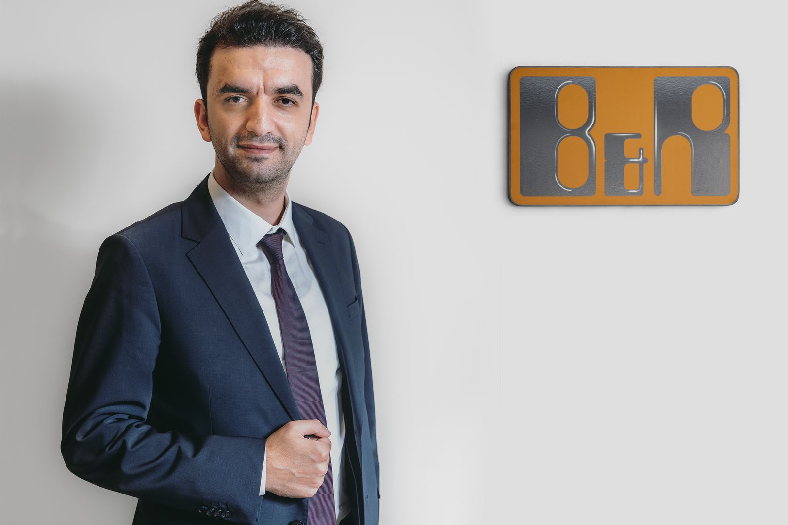
In September, Ömer Yücel took over as managing director of B&R Turkey.

About B&R
B&R, a division of ABB Group, is a global leader in industrial automation headquartered in Austria. B&R combines state-of-the-art technology with advanced engineering to provide customers in virtually every industry with complete solutions for machine and factory automation, motion control, HMI and integrated safety technology. With Industrial IoT communication standards including OPC UA, POWERLINK and openSAFETY as well as its Automation Studio software, B&R is constantly redefining the future of automation engineering. The innovative spirit that keeps B&R at the forefront of industrial automation is driven by a commitment to simplifying processes and exceeding customer expectations.
For more information, visit www.br-automation.com.

