New freedom through IT-OT integration
Use any Linux code in an automation system
The enhanced crossover Operating System (exOS) makes it possible to use any Linux code within B&R systems. This gives machine builders unprecedented freedom in the design of their automation solutions. Code written in high-level languages like C++, Python and JavaScript can be easily integrated in the machine application.

With the enhanced crossover connection between Linux and B&R's real-time operating system, Automation Runtime, software developers can write, compile and debug their code in the integrated development environment (IDE) of their choice and then easily load and run it on the control system. This opens up new freedom for implementing the advanced automation solutions envisioned by Industry 4.0 and the Industrial IoT. exOS makes it possible to execute machine learning algorithms directly at the edge, for example. A Tensorflow ML model can run in Linux on an Automation PC and receive machine data from an X20 PLC via the exOS API. This type of machine learning solution could be used to optimize maintenance.
One central engineering tool
Developers can create Linux code using their preferred tool, such as Eclipse or Visual Studio, and then import it into the B&R system as an exOS package. This lets them use Automation Studio as a central engineering tool. Managing and debugging software solutions becomes simple and straightforward. Commissioning no longer requires any extra tools.
IT functions in Linux can be distributed and maintained using established OT tools and workflows. In the event of service or hardware replacement, the necessary software can be installed without any expert knowledge. exOS also offers an array of diagnostics functions for installation and execution. The B&R system provides the user with a complete log of all error messages from both Linux and the controller operating system.
High-performance interface
exOS includes a user-friendly API for high-performance data exchange. The API ensures easy, buffered process data communication between the controller operating system and Linux. The data is transmitted consistently in the millisecond range. To synchronize execution, applications can access a shared time basis via the NetTime mechanism. This enables consistent timing of data transmission and timestamping of process data.
Scalable solutions
Machine builders can choose between two different types of exOS implementation. Automation Runtime and Linux can be installed either on the same device, such as an Automation PC, or each on their own separate hardware. With the second option, any B&R Automation PC can be combined with any X20 controller.

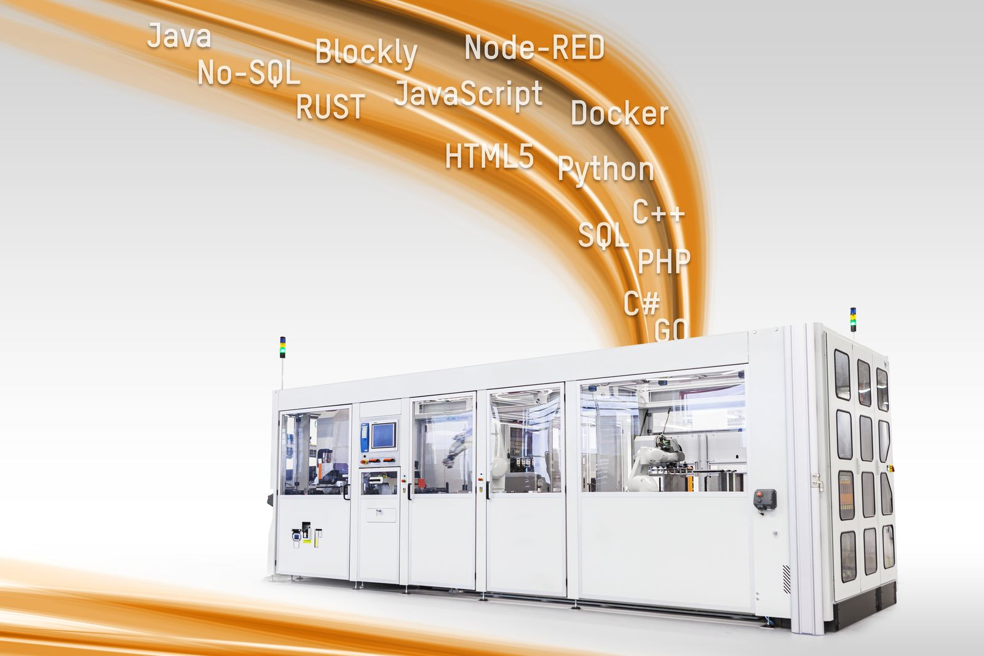
The enhanced crossover Operating System (exOS) allows machine builders to use any Linux code within their B&R system.

About B&R
B&R, a division of ABB Group, is a global leader in industrial automation headquartered in Austria. B&R combines state-of-the-art technology with advanced engineering to provide customers in virtually every industry with complete solutions for machine and factory automation, motion control, HMI and integrated safety technology. With Industrial IoT communication standards including OPC UA, POWERLINK and openSAFETY as well as its Automation Studio software, B&R is constantly redefining the future of automation engineering. The innovative spirit that keeps B&R at the forefront of industrial automation is driven by a commitment to simplifying processes and exceeding customer expectations.
For more information, visit www.br-automation.com.

