Machine vision projects made easy
New Smart Camera supports changeover at full production speed
B&R's integrated machine vision portfolio now includes a Smart Camera that combines multiple machine vision functions in real time. That makes it easy to implement sequences of process-controlled functions that would be costly and time-consuming to achieve with conventional smart cameras.
On a machine producing multiple variants of a product simultaneously, for example, the Smart Camera only needs to capture one image to determine which variant it is looking at and check the printed label. One function provides the feedback needed for the subsequent function. Since the process variables of the machine controller are seamlessly integrated in these processes, decisions can be made in real time. Sequences of image processing functions can be extended almost indefinitely.
Solve complex tasks in minutes
The developer simply connects the individual image processing functions in a visual editor. There is no need for time-consuming programming. Thanks to complete integration in the B&R system, it takes only minutes to set up and synchronize even complex tasks like picking products off a moving conveyor and sorting them into boxes.
Large selection of lenses
B&R's Smart Camera has the same hardware options as its Smart Sensor. Various integrated lenses and housing variants with a standard C mount are available. Other options include a variety of integrated lighting, FPGA image preprocessing and image sensors from 1.3 to 5.3 megapixels.

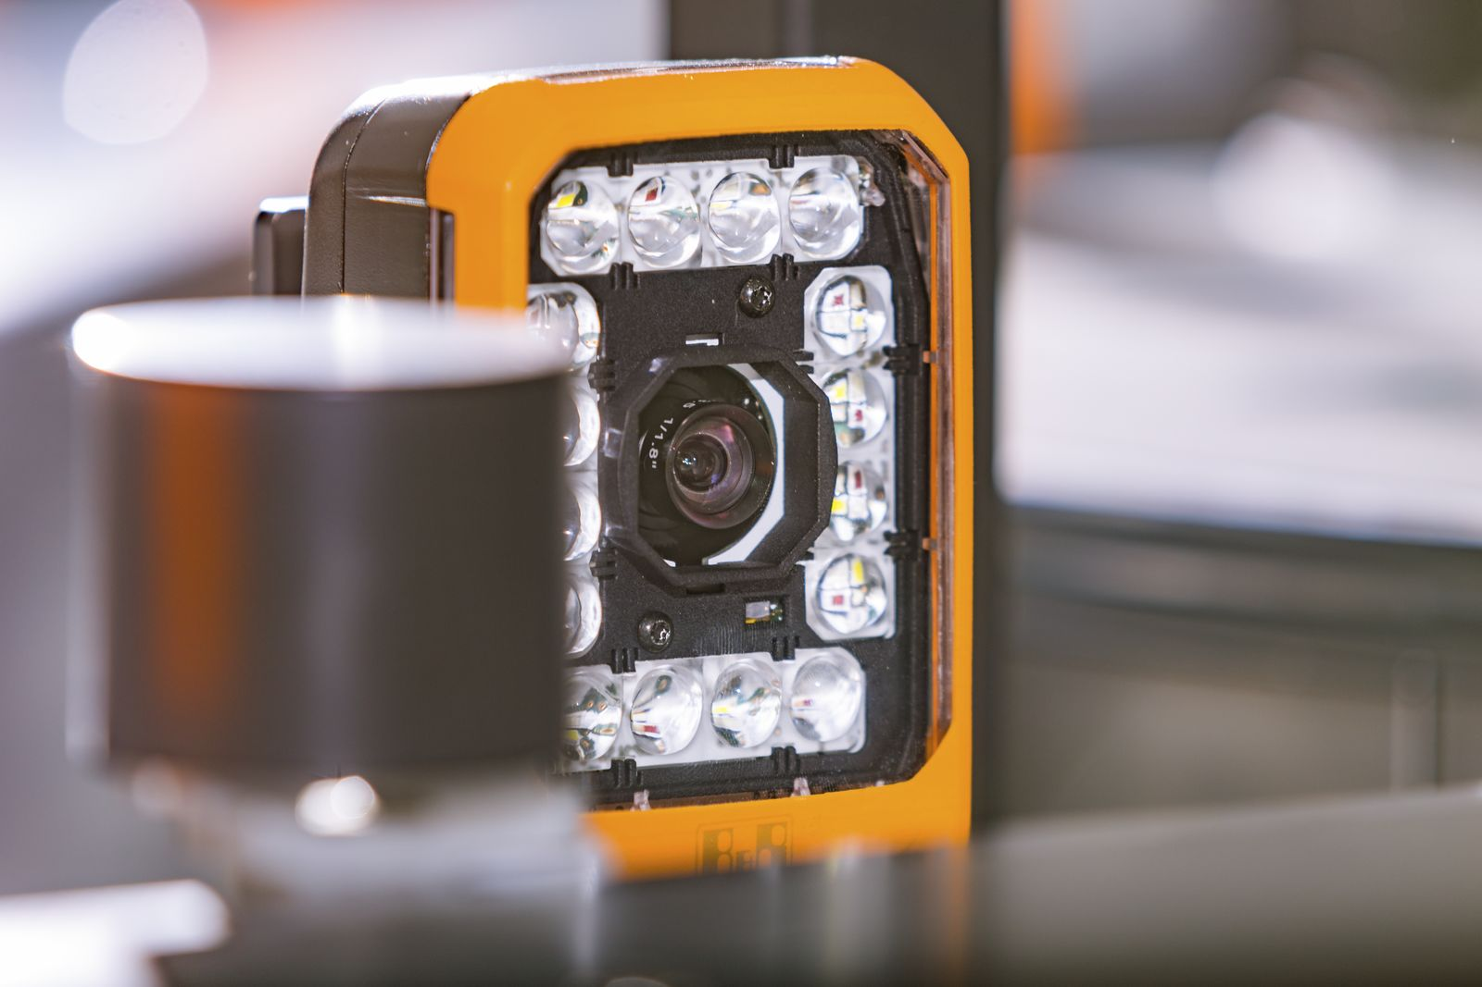
The Smart Camera makes it easy to combine multiple machine vision functions in real time.

About B&R
B&R, a division of ABB Group, is a global leader in industrial automation headquartered in Austria. B&R combines state-of-the-art technology with advanced engineering to provide customers in virtually every industry with complete solutions for machine and factory automation, motion control, HMI and integrated safety technology. With Industrial IoT communication standards including OPC UA, POWERLINK and openSAFETY as well as its Automation Studio software, B&R is constantly redefining the future of automation engineering. The innovative spirit that keeps B&R at the forefront of industrial automation is driven by a commitment to simplifying processes and exceeding customer expectations.
For more information, visit www.br-automation.com.

