The future is adaptive
B&R: Fredrik Holmberg to drive business in the field of medical device assembly
B&R has added Fredrik Holmberg to its business development team as an expert in the field of medical device assembly. Holmberg will spearhead the automation specialist's efforts in this rapidly growing industry with a strong focus on automation solutions for small-batch production.
Many of the products used for medical treatments consist of numerous individual parts. Before a catheter or infusion set can be used, for example, they must first be assembled from an array of tubes, valves and needles. "This is a very complex process that is difficult to automate," explains Holmberg. "Especially if you need to produce multiple variants of each set."
Efficient automation
"Our hardware and software solutions for adaptive manufacturing offer companies in this sector an excellent opportunity to automate even small batches in an efficient way," says Holmberg. "In this context, 'adaptive' means that the machine automatically adjusts to accommodate different products and sets without any mechanical changes."
After obtaining his degree in electrical engineering, Holmberg worked as a software developer and application engineer before taking on various positions in technical sales at B&R Sweden. During this time, he gained years of experience working with customers in the field of medical device assembly. This experience will serve him well in his new position on B&R's international business development team.

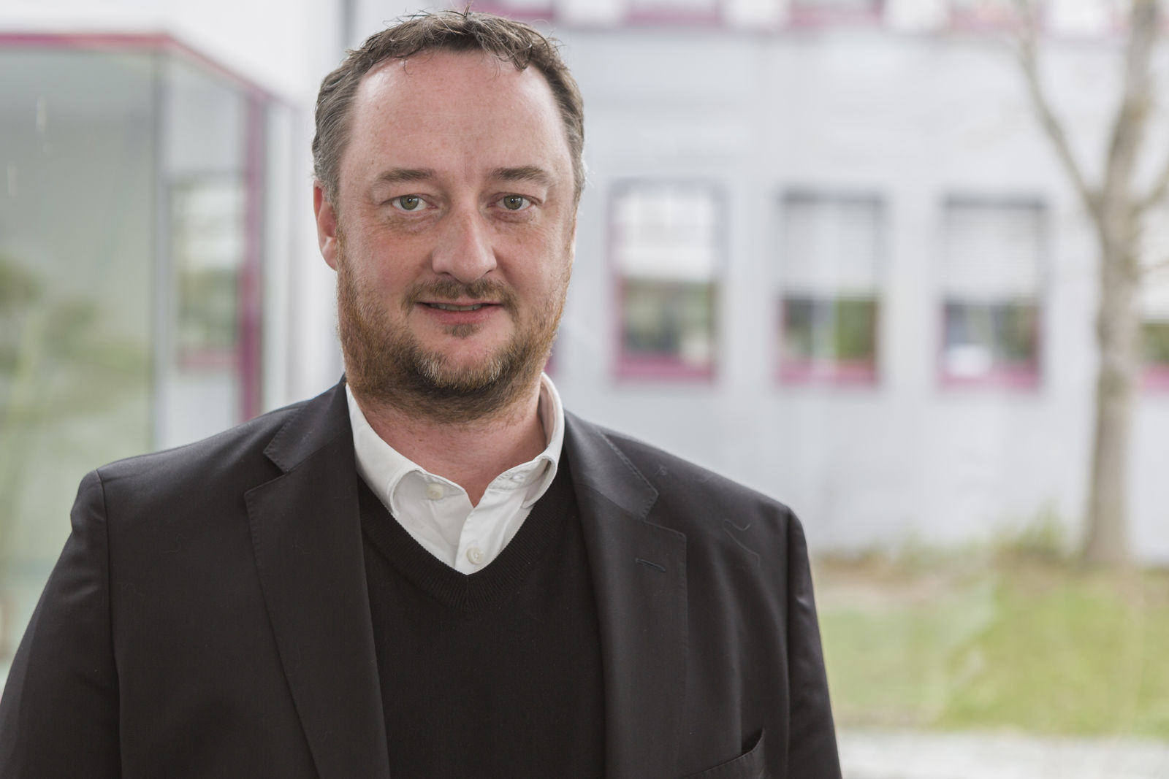
With Fredrik Holmberg, B&R gains a proven expert in the field of medical device assembly.

About B&R
B&R, a division of ABB Group, is a global leader in industrial automation headquartered in Austria. B&R combines state-of-the-art technology with advanced engineering to provide customers in virtually every industry with complete solutions for machine and factory automation, motion control, HMI and integrated safety technology. With Industrial IoT communication standards including OPC UA, POWERLINK and openSAFETY as well as its Automation Studio software, B&R is constantly redefining the future of automation engineering. The innovative spirit that keeps B&R at the forefront of industrial automation is driven by a commitment to simplifying processes and exceeding customer expectations.
For more information, visit www.br-automation.com.

