Switch it on and get started
The Power Panel C80 offers the highest performance for every industry
The new Power Panel C80 offers the combined advantages of a powerful controller and a modern operator terminal in a single HMI device. The C80 installation is compatible with B&R Automation Panels. Machine builders thus have full flexibility when using the new panel and can scale their machine to meet changing performance and cost requirements.

With its low installation depth, the C80 multi-touch HMI is suitable for particularly compact machines where space in the control cabinet is limited. Operation without a hard disk and fan also make it particularly low-maintenance.
Time-saving plug and play
The Power Panel C80 can be put into operation quickly and easily, because all the necessary software packages are pre-installed. I/O modules, motion control axes and safety components can be connected directly to the panel. There's no need for additional controllers. The user only has to switch on the Power Panel C80 and transfer the application.
Powerful and cost-effective
On the Intel Atom processor, B&R's Automation Runtime real-time operating system runs parallel to an embedded Linux operating system for the HMI application. This is made possible by the hypervisor from B&R, which divides the processor's resources between the two operating systems without allowing them to impact each other's performance. In contrast to a solution with a controller and separate operating panel, this integrated solution requires less space in the control cabinet. Costs are further reduced by more efficient utilization of the available hardware resources.
Intuitive touch operation
The high-performance Power Panel C80 is ideal for running mapp View HMI applications. With the mapp View software package, B&R offers direct access to the wide world of web technology right from the engineering environment. The projected capacitive touch screen reacts precisely and reliably even when operated with thick leather gloves. Gestures such as zoom or swipe provide an intuitive user experience. The front of the panel has IP65 protection, making the Power Panel C80 ideal for use in harsh environments. This multi-touch panel is available with a clear or anti-glare glass surface in four different widescreen formats (7.0", 10.1", 12.1" and 15.6") and one 4:3 format (5.7").

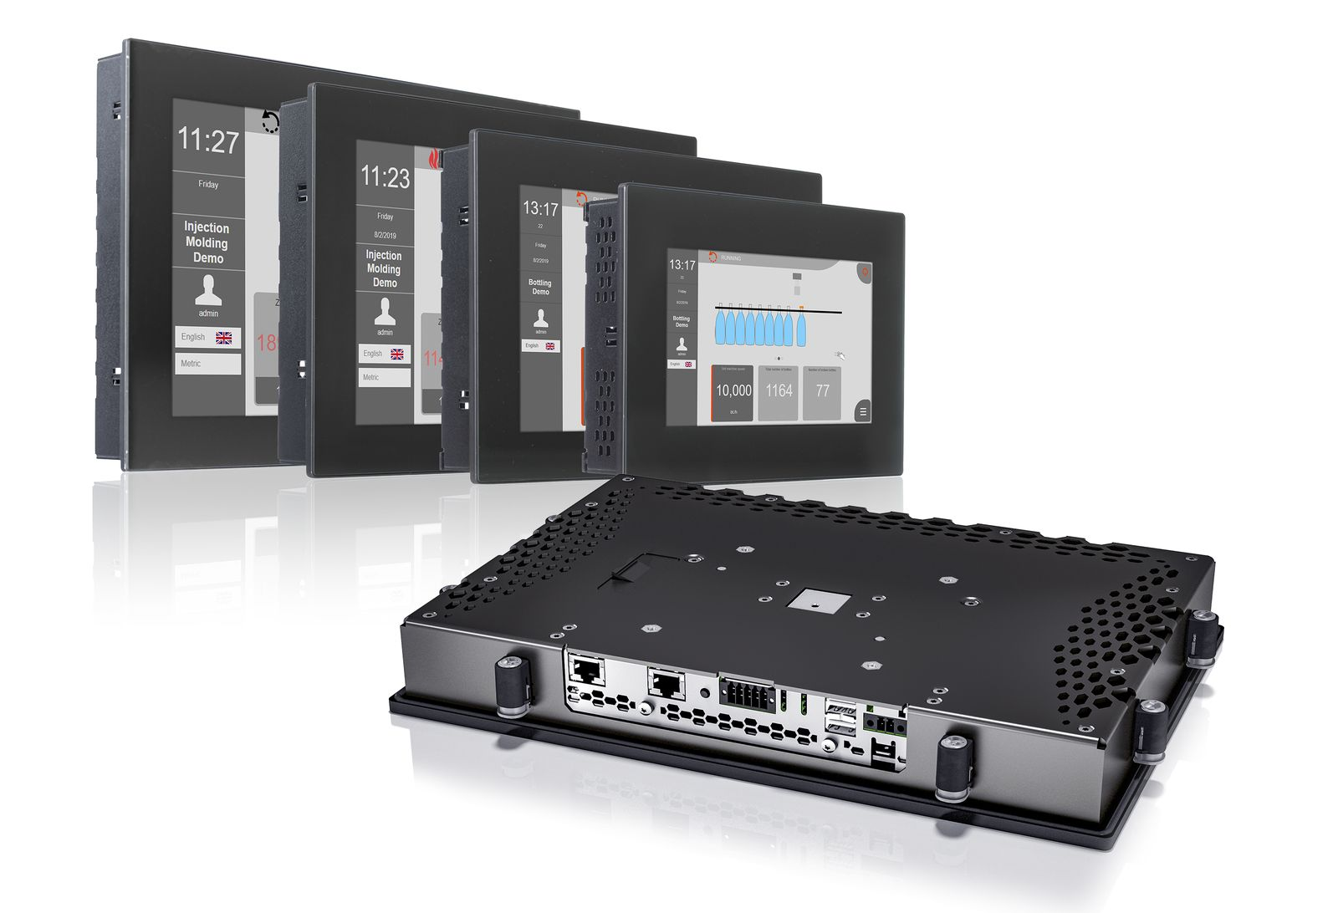
The Power Panel C80 combines the advantages of a powerful controller and a modern operator terminal in a single HMI device.

About B&R
B&R, a division of ABB Group, is a global leader in industrial automation headquartered in Austria. B&R combines state-of-the-art technology with advanced engineering to provide customers in virtually every industry with complete solutions for machine and factory automation, motion control, HMI and integrated safety technology. With Industrial IoT communication standards including OPC UA, POWERLINK and openSAFETY as well as its Automation Studio software, B&R is constantly redefining the future of automation engineering. The innovative spirit that keeps B&R at the forefront of industrial automation is driven by a commitment to simplifying processes and exceeding customer expectations.
For more information, visit www.br-automation.com.

