B&Rs openAutomation challenge 2020 attracts huge participation

Students developed use cases with open source technology OPC UA and automation solutions from B&R.

As a global automation player, B&R is committed to provide a platform for tomorrow’s engineers to learn and explore latest trends. openAutomation Challenge 2020 was an online event for students interested in devel-oping innovative ideas focusing on automation, IoT and cloud-based solutions. The challenge brought in participation from countries elite colleges with teams demonstrating innovative ideas. The zest among students at the online competition was phenomenal with a closely contested final having attractive prizes up for grabs.
Around 39 teams from across various Indian states comprising of over 118 students from 17 institutions applied to participate in the event. A team of experts from industry and academia shortlisted 17 teams based on application concept, innovativeness and feasibility of the idea. The teams were supported by mentors with a range of expertise from B&R India. Rigorous workshops on various topics of automation and OPC UA were conducted enabling students to prepare for the competition. The 5-day challenge al-lowed teams to bring their idea to life and showcase them to the jury. At the end, the jury judged the ide-as for innovativeness, complexity, usability, completeness, feasibility and team effort. OVERWRITE THIS TEXT Add the press text here. OVERWRITE THIS TEXT
Creating solutions to boost social issues through technology
Students displayed sheer commitment in bringing their ideas into a working model. Many ideas focused on health, agriculture, waste management, warehouse, F&B and robotics, addressing challenges of sustainable environment and improved process effectiveness. Machine learning algorithms for fault identification, regression models for predictive maintenance, machine 3D model rendering, OPC UA for data monitoring on python and mobile app for analytics were highlights of the challenge among others. An effective use of B&R technology together with OPC UA was witnessed by students.
B&R’s cooperation with education industry
Industries are undergoing digital transformation for operational excellence with automation, connectivity through open source technology, IoT and data poised to play an important role. “At B&R, we have been promoting talent among engineering community in the context of education in advanced topics of automa-tion with a view to prepare students for exciting innovations coming in future. openAutomation Challenge 2020 was focused on latest trends in automation technology and connectivity,” explains Tanay Sil, Head – Education Network, B&R Industrial Automation, India. “Through our Education Network program, we pro-mote cooperation between technical training centers, colleges, universities and B&R. Automation is an im-portant element in all manufacturing operations and industry expects new recruits to have basic skills and technology knowledge. Moreover, in the era of industrial IoT and industry 4.0 technology evolves rapidly with engineering curriculum struggling to keep pace. B&R Education Network is a well-structured program of collaboration to improve the employability of engineering graduates.”

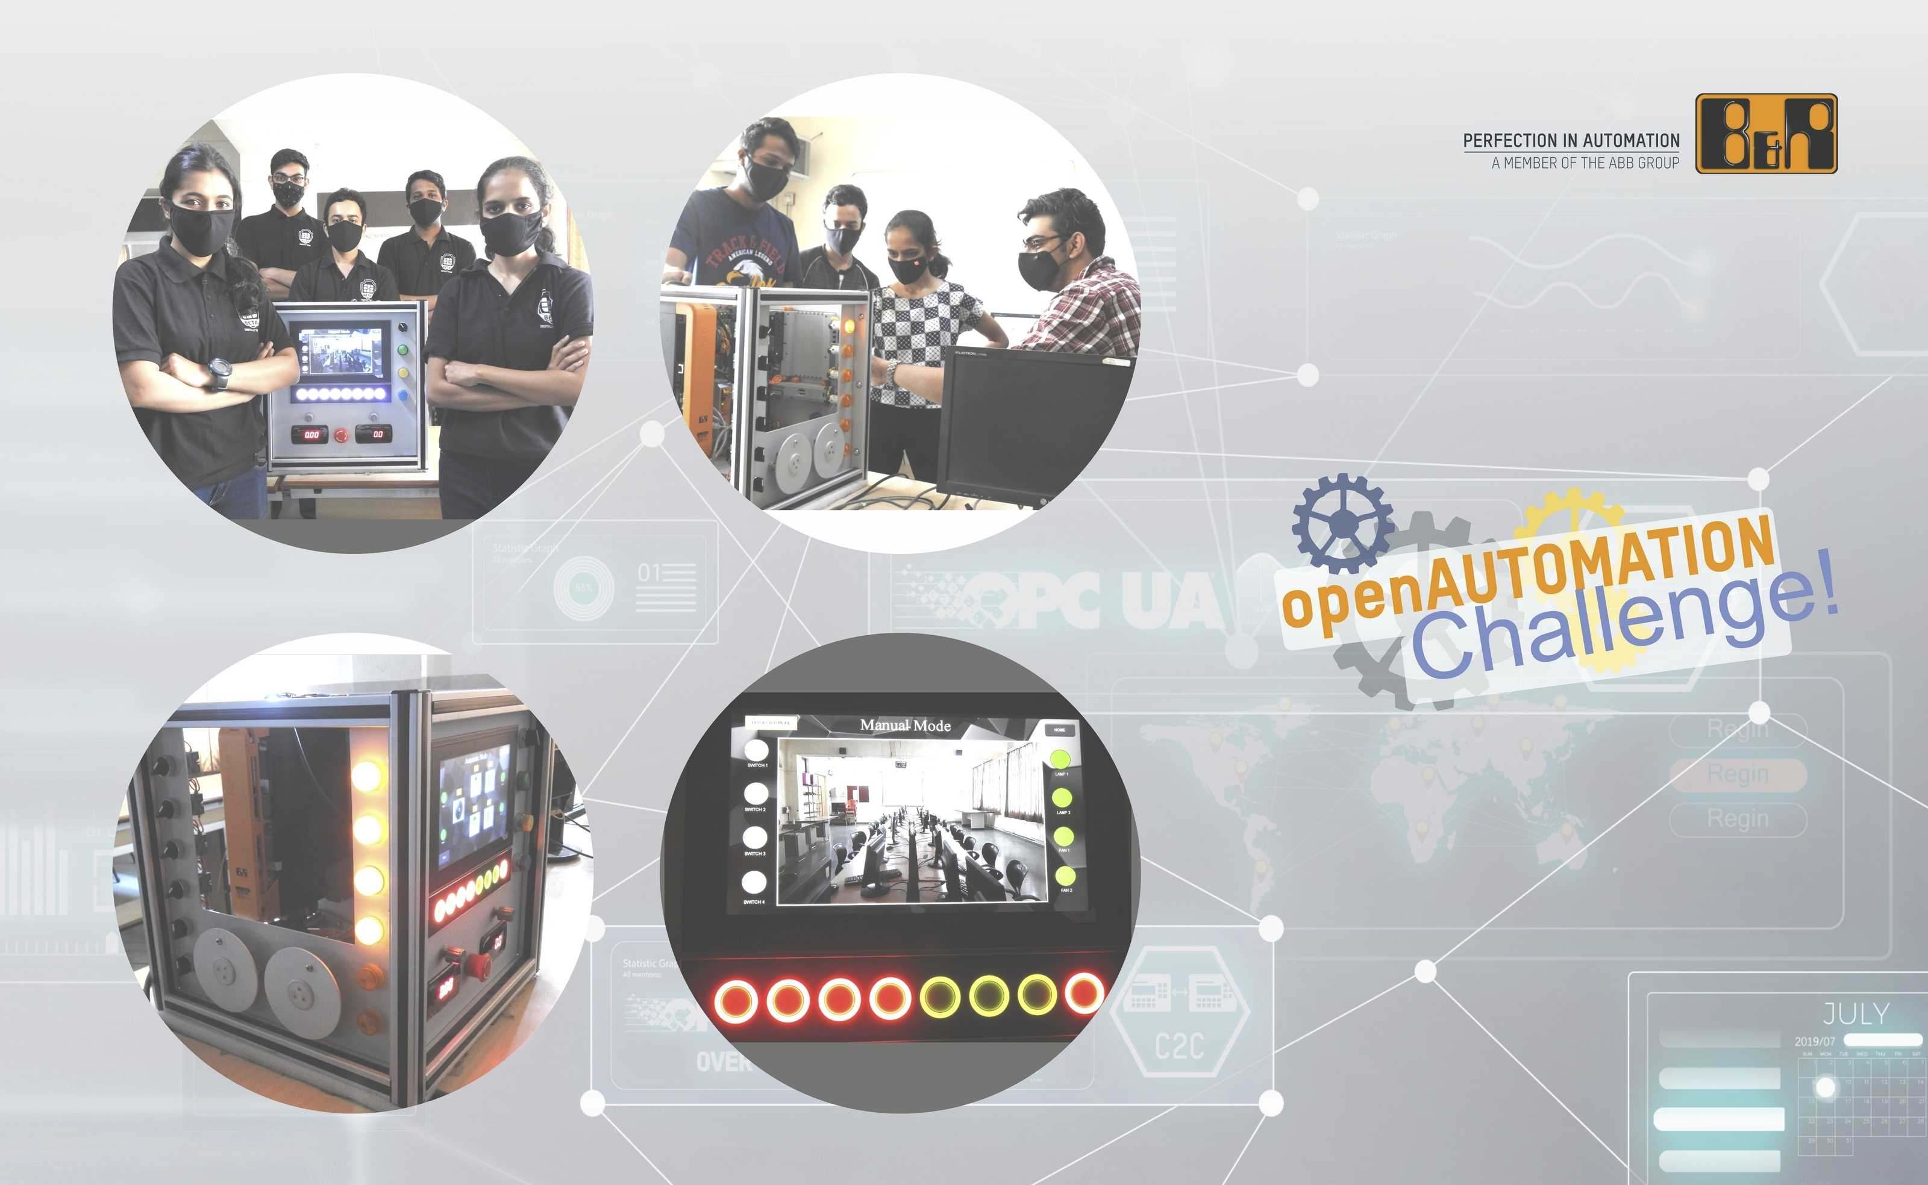
openAutomation Challenge 2020 was an online event for students to develop use cases using open source tech-nology OPC UA and automation solutions from B&R.

About B&R
B&R, a division of ABB Group, is a global leader in industrial automation headquartered in Austria. B&R combines state-of-the-art technology with advanced engineering to provide customers in virtually every industry with complete solutions for machine and factory automation, motion control, HMI and integrated safety technology. With Industrial IoT communication standards including OPC UA, POWERLINK and openSAFETY as well as its Automation Studio software, B&R is constantly redefining the future of automation engineering. The innovative spirit that keeps B&R at the forefront of industrial automation is driven by a commitment to simplifying processes and exceeding customer expectations.
For more information, visit www.br-automation.com.

