B&R India completes expansion of new warehouse & repair facility
Market dynamics & increased demand leads to warehouse expansion
B&R India, one of the leading automation company in India recently extended its warehousing & logistics space at Chakan, Pune as a response to continuous growth the company is experiencing and foreseeing in the future. Indian market growth, ever expanding B&R portfolios in automation, mechatronics and Industry 4.0 and growing customer expectations are a few factors, which played a vital role in this expansion. However, at the core is the customer centric approach of B&R, which drives all our decisions towards providing exceptional services to our customers. B&R’s new warehouse is equipped with advanced technology and more space to become faster and more accurate in our operation.
Bigger and safer facility
“Access to over 10,000 sq ft of warehouse space will enable B&R to facilitate quicker and efficient deliveries due to greater flexibility with stock-holding. B&R has invested in a state-of-the-art warehouse equipped with advanced technology which will enable faster operation and ensure a safer environment. The new stacking arrangements allows much improved storage capabilities, better visibility and better space utilization. Also, being fully integrated in company’s ERP it will enable smooth and accurate material handling” says Ravi-Kumar Changia, Chief Financial Officer at B&R India. “In our new warehouse we have taken utmost care of all human safety norms and it covers all stipulated government and industrial safety guidelines. Moreover, we ensure compliance through regular audits of our offices, training centers and warehouse along with training for our employees,” he adds.
New space with enhanced services
“A designated space for support and service teams along-with the warehouse, means customer service demands can be processed more efficiently, “quotes Jhankar Dutta, Managing Director at B&R India. "This new spacious warehouse & repair facility has so many advantages which I am sure will help B&R to add immense value to our customers and further allow our growth. We have achieved commendable growth in last few years and this investment shows our commitment to our customers in days to come. All our focused business sectors are growing and reflecting the growing demand from customers we need more space to fulfil this demand,” he adds. In addition, the warehouse has created new job opportunities for few locals in the area.

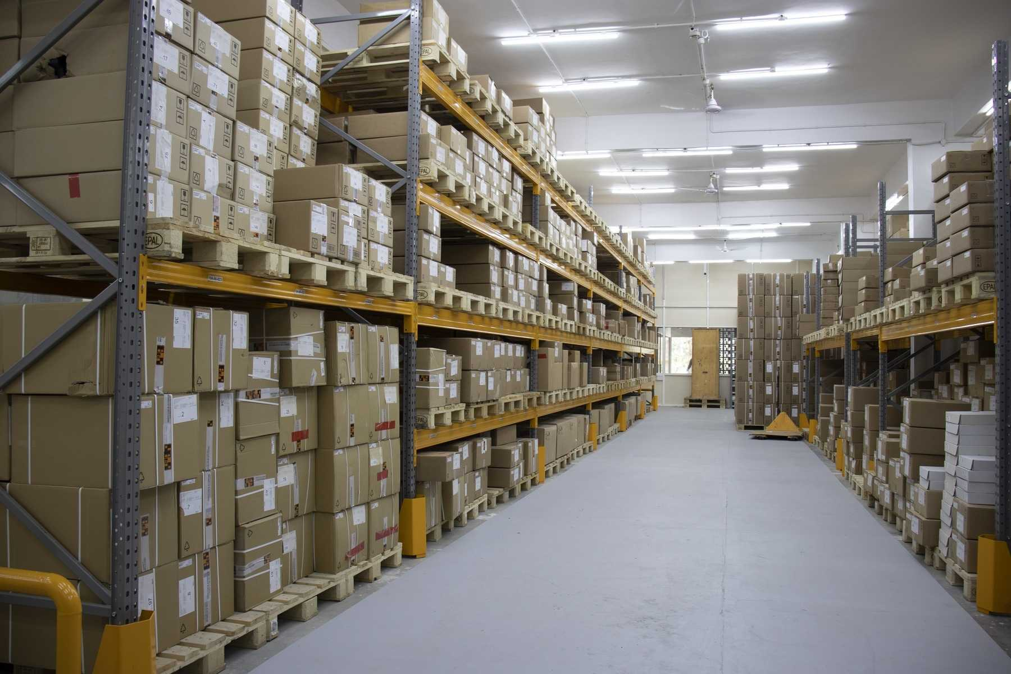
Over 10,000 sq ft of next generation warehouse space ensures quicker and efficient deliveries ensuring excep-tional services to our customers.

About B&R
B&R, a division of ABB Group, is a global leader in industrial automation headquartered in Austria. B&R combines state-of-the-art technology with advanced engineering to provide customers in virtually every industry with complete solutions for machine and factory automation, motion control, HMI and integrated safety technology. With Industrial IoT communication standards including OPC UA, POWERLINK and openSAFETY as well as its Automation Studio software, B&R is constantly redefining the future of automation engineering. The innovative spirit that keeps B&R at the forefront of industrial automation is driven by a commitment to simplifying processes and exceeding customer expectations.
For more information, visit www.br-automation.com.

