Fanless from -20°C to +60°C
New Panel PC from 7.0" to 15.6" with rugged design and shallow installation depth
With the Panel PC 1200, B&R introduces a compact and cost-effective all-in-one PC. Equipped with the latest Intel Atom processors and up to 256 GB of mass storage, the Panel PC 1200 is ideal for running HMI applications under Windows or Linux operating systems.

With 2x Gigabit Ethernet and 2x USB 3.0, the Panel PC 1200 is ready for integration into any machine network. Compact CFast cards are used for data storage.
Precise and reliable, even wearing thick leather gloves
The Panel PC 1200 is available in four sizes from 7.0" to 15.6". The projected capacitive multi-touch screens are available in various resolutions up to HD. Equipped with either clear or anti-glare glass, the state-of-the-art multi-touch panel PC perfectly complements a high-end machine design. Gestures such as zoom or swipe provide an intuitive user experience. The projected capacitive touch screen responds precisely and reliably, even when operated while wearing thick leather gloves.
Compact and low maintenance
The Panel PC 1200 is characterized by its compact dimensions, robust construction and shallow installation depth. It fits easily into any control cabinet. With passive cooling and fanless operation, the Panel PC 1200 can be operated in the extended temperature range of -20°C to +60°C. That makes it ideal for a wide range of applications – even under harsh industrial conditions.

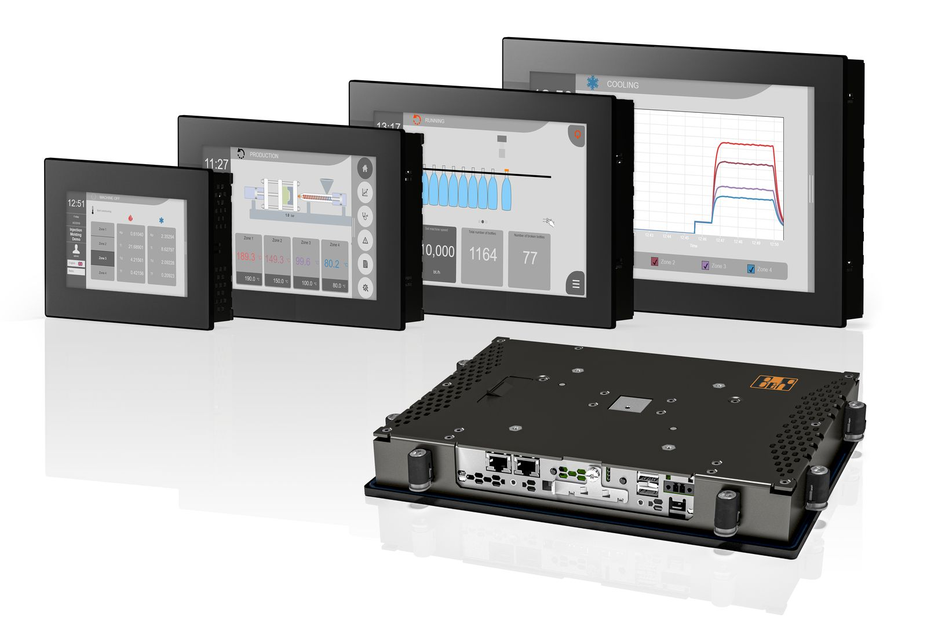
The Panel PC 1200 is characterized by its compact dimensions, robust construction and shallow installation depth.

About B&R
B&R, a division of ABB Group, is a global leader in industrial automation headquartered in Austria. B&R combines state-of-the-art technology with advanced engineering to provide customers in virtually every industry with complete solutions for machine and factory automation, motion control, HMI and integrated safety technology. With Industrial IoT communication standards including OPC UA, POWERLINK and openSAFETY as well as its Automation Studio software, B&R is constantly redefining the future of automation engineering. The innovative spirit that keeps B&R at the forefront of industrial automation is driven by a commitment to simplifying processes and exceeding customer expectations.
For more information, visit www.br-automation.com.

