B&R among first members of new EPLAN Partner Network
Tighter cooperation for more efficient engineering
As electrical engineering solution provider EPLAN launches its new partner network, automation specialist B&R is among the first on board. Today more than ever, such coordinated integration brings users added value in the form of more efficient engineering and faster time to market.
Each a leader in its respective domain, B&R and EPLAN are already joined by nearly a decade of cooperation that allows seamless interaction between their engineering environments. The new EPLAN Partner Network (EPN) further solidifies that relationship and ensures users more powerful round-trip engineering solutions going forward.
Round-trip engineering
Efficient integration between B&R's Automation Studio engineering environment and EPLAN's Electric P8 ECAD platform is made possible by a round-trip connector. These two platforms provide unparalleled support for the automated exchange and synchronization of hardware configurations, I/O mappings and process variables.
Developers can start projects with either software or electrical planning, work in both disciplines simultaneously, and easily compare and merge projects. Parallel engineering and automated interaction between the tools accelerate time to market and prevent errors due to manual changes.
Bringing the best together
B&R knows that one of the keys to successful development is using the best tools available. With the connection to EPLAN, B&R customers enjoy easy access to industry-leading electrical design software for their machines, plants and control cabinets.

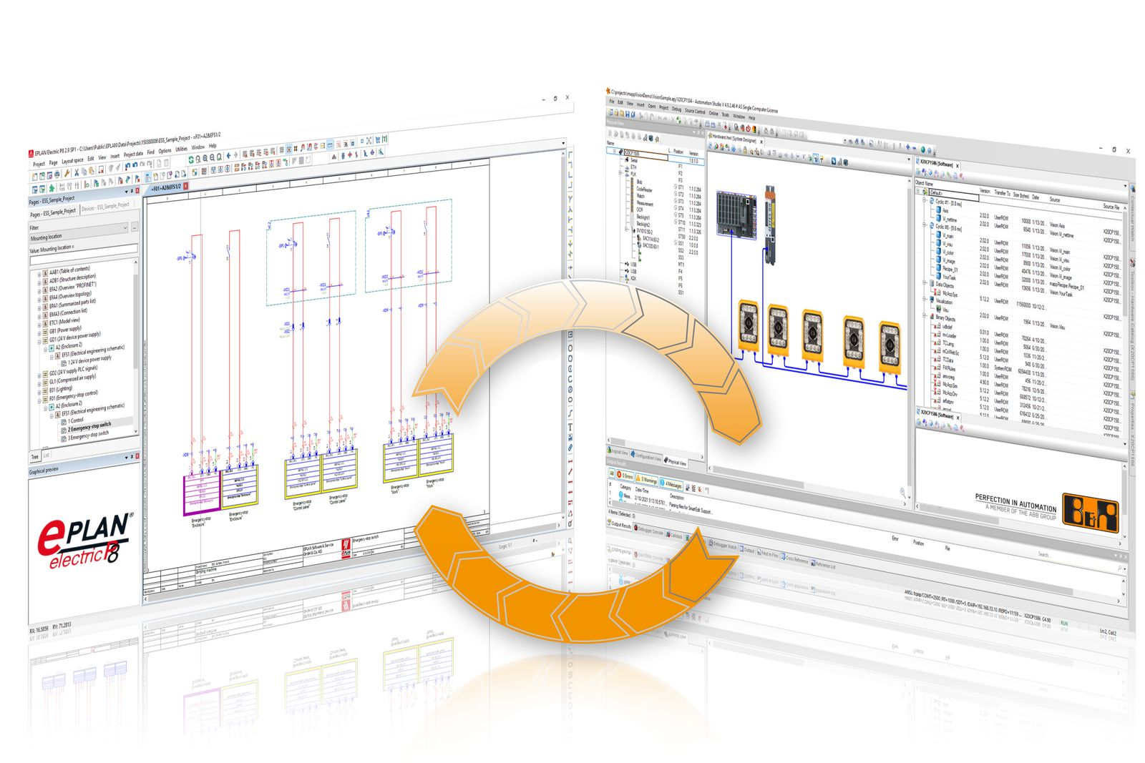
Partnership between B&R and EPLAN ensures more efficient round-trip engineering between the companies' development platforms.

About B&R
B&R, a division of ABB Group, is a global leader in industrial automation headquartered in Austria. B&R combines state-of-the-art technology with advanced engineering to provide customers in virtually every industry with complete solutions for machine and factory automation, motion control, HMI and integrated safety technology. With Industrial IoT communication standards including OPC UA, POWERLINK and openSAFETY as well as its Automation Studio software, B&R is constantly redefining the future of automation engineering. The innovative spirit that keeps B&R at the forefront of industrial automation is driven by a commitment to simplifying processes and exceeding customer expectations.
For more information, visit www.br-automation.com.

