ABB appoints Joerg Theis President of B&R
Seasoned, international ABB leader to head ABB’s Machine Automation Division
ABB has appointed Joerg Theis as President of ABB’s Machine Automation Division (B&R), effective April 1, 2021. He succeeds Clemens Sager, who managed the division ad interim since January 1, 2021.
Theis is a 23-year veteran of ABB. He has deep experience in process and factory automation in Consumer Goods, Pharmaceutical, F&B, Hybrid Industries and Automotive, amongst other segments, with a focus on developing digital services offerings. He has lived and worked in Europe and Asia and most recently was Asia lead for ABB’s Process Automation Division for Energy Industries, based in Singapore. He will relocate from Singapore to B&R’s global headquarters in Eggelsberg, Austria.
“Joerg has impressive global experience in automation and digital services and a strong entrepreneurial mindset,” said Sami Atiya, President of ABB Robotics & Discrete Automation business. “With his deep industry knowledge and proven track record in strategic business development, he is the ideal leader to expand B&R’s profitable growth, continuing B&R’s successful customer and innovation focus, while driving our geographical and portfolio expansion.”
“I am honoured to have the opportunity to lead ABB’s Machine Automation division and to continue to build on B&R’s customer-focused culture and strong legacy of innovation, together with our management team. I am looking forward to working with the team to write the next chapter of our success story together,” said Joerg Theis.
Theis holds a diploma in Chemical Engineering from the FH Aachen, Germany. He is a German citizen, married and has two children.
ABB (ABBN: SIX Swiss Ex) is a leading global technology company that energizes the transformation of society and industry to achieve a more productive, sustainable future. By connecting software to its electrification, robotics, automation and motion portfolio, ABB pushes the boundaries of technology to drive performance to new levels. With a history of excellence stretching back more than 130 years, ABB’s success is driven by about 105,000 talented employees in over 100 countries. www.abb.com
ABB Robotics & Discrete Automation is a pioneer in robotics, machine automation and digital services, providing innovative solutions for a diverse range of industries, from automotive to electronics to logistics. As one of the world’s leading robotics and machine automation suppliers, we have shipped more than 500,000 robot solutions. We help our customers of all sizes to increase productivity, flexibility and simplicity and to improve output quality. We support their transition towards the connected and collaborative factory of the future. ABB Robotics & Discrete Automation employs more than 10,000 people at over 100 locations in more than 53 countries. www.abb.com/robotics

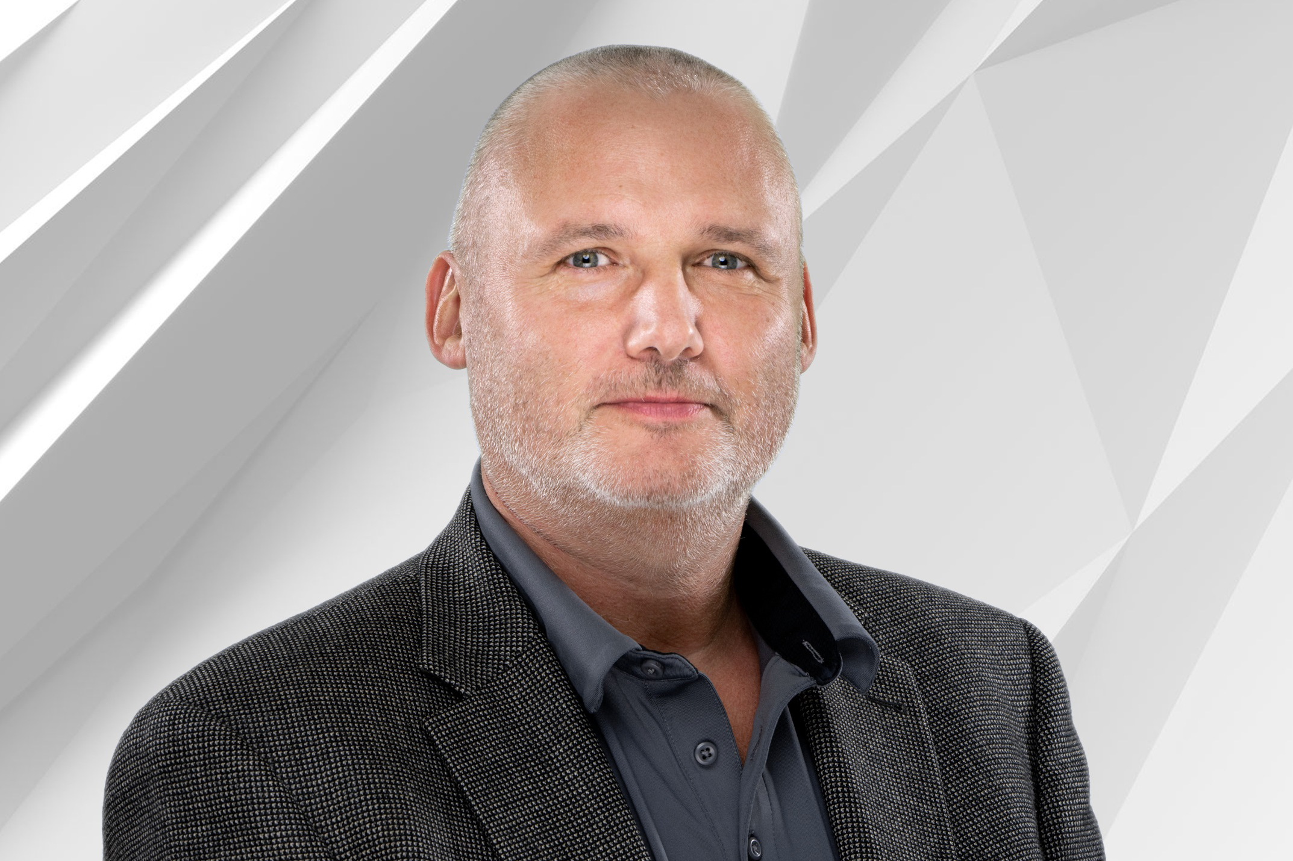
ABB has appointed Joerg Theis as President of ABB’s Machine Automation Division (B&R), effective April 1, 2021.

About B&R
B&R, a division of ABB Group, is a global leader in industrial automation headquartered in Austria. B&R combines state-of-the-art technology with advanced engineering to provide customers in virtually every industry with complete solutions for machine and factory automation, motion control, HMI and integrated safety technology. With Industrial IoT communication standards including OPC UA, POWERLINK and openSAFETY as well as its Automation Studio software, B&R is constantly redefining the future of automation engineering. The innovative spirit that keeps B&R at the forefront of industrial automation is driven by a commitment to simplifying processes and exceeding customer expectations.
For more information, visit www.br-automation.com.

