PharmaEdge: FDA compliant and more than just SCADA

B&R's integrated, out-of-the-box solution for the pharma industry

B&R has developed an integrated single-PC solution for users in the pharmaceutical industry to monitor and control their entire operations, which also meets the increasing demands of FDA compliance. PharmaEdge offers all the benefits of SCADA and a powerful control system in one device. With possibilities to add energy monitoring, condition-based predictive maintenance and MES/ERP connectivity, it enables implementation of smart machines for the future of the industry.
Integrated architecture
The integrated PharmaEdge solution helps users optimize the performance of their automation systems while simultaneously improving cost and energy efficiency. Instead of deploying separate control systems for process control, SCADA, energy monitoring and condition monitoring, users get all this functionality in a single, integrated system with built-in cybersecurity. With this one-box solution, users will be able to monitor as well as control their entire operations.
PharmaEdge consists of a B&R industrial PC running a hypervisor solution with both Linux and Automation Runtime operating systems. It offers machine and process automation libraries for easy configuration. There are no limitations to internal tags and no incremental costs for additional tags. Built-in features support easy reporting and historical data retrieval.
Compliance with FDA 21 CFR Part 11
Quality, regulatory compliance, safety, easy track-and-trace and efficient data access are the trademarks of a world-class pharmaceutical facility. PharmaEdge provides a quick and easy way to implement and customize audit trails. System manufacturers and end users benefit from maximum security without having to implement organizational measures. Features offered by PharmaEdge include data archiving and retrieval, electronic signatures, batch reporting, access protection and central user management as well as audit trail and change management.

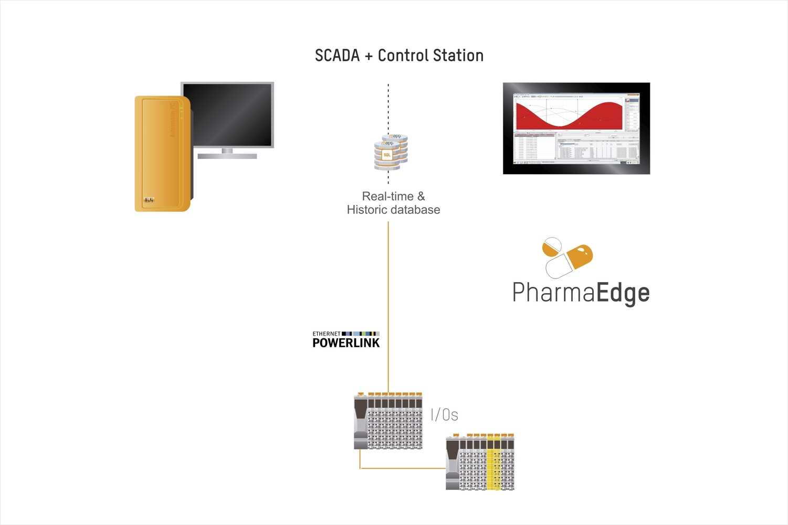
PharmaEdge is an integrated solution for the pharmaceutical industry – all the benefits of SCADA and a powerful control system in one device.

About B&R
B&R, a division of ABB Group, is a global leader in industrial automation headquartered in Austria. B&R combines state-of-the-art technology with advanced engineering to provide customers in virtually every industry with complete solutions for machine and factory automation, motion control, HMI and integrated safety technology. With Industrial IoT communication standards including OPC UA, POWERLINK and openSAFETY as well as its Automation Studio software, B&R is constantly redefining the future of automation engineering. The innovative spirit that keeps B&R at the forefront of industrial automation is driven by a commitment to simplifying processes and exceeding customer expectations.
For more information, visit www.br-automation.com.

