B&R expands its Qualified Partners network with Teknics
Teknics as a competent partner with many years of experience
B&R, a leader in industrial automation systems and intelligent transport systems, has reached an agreement with the engineering company Teknics to join the network of Qualified Partners in Spain. With this company, B&R gains a competent partner with many years of experience.
Since B&R launched its partner programme in 2020, many companies have been interested in joining. Those that have developed high-value projects, as well as the relevant training, have obtained qualifications in visualisation technology, control technology and motion.

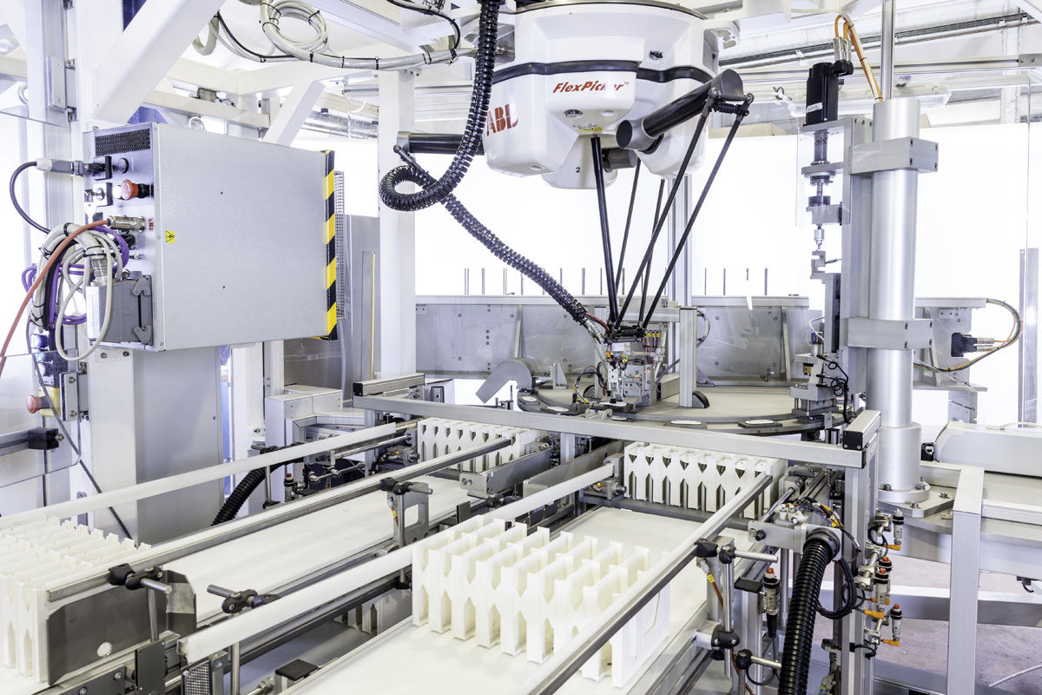
Image of a typical adaptive manufacturing development with ABB's Flexpicker. Picture: Teknics

Track systems qualification
In the case of Teknics, they have also obtained the Track technologies qualification. B&R's conveyor systems are one of the four pillars of adaptive manufacturing and include: SuperTrak, ACOPOStrak and ACOPOS6D.
The latter, launched worldwide in January 2021, is distinguished by its system of magnetic levitating shuttles that allow each of the products to move freely through the machine.
New projects...
Ramon Díaz, General Manager of B&R in Spain, said "we are very pleased to have Teknics as a Qualified Partner. The sum of Teknics' experience in specific sectors and our disruptive technology will allow us to jointly develop projects of high differential value".
... and high value
For its part, Teknics, with almost 30 years of experience in special assembly, testing and packaging machinery for sectors as diverse as pharmaceuticals, cosmetics and automotive, has a strong innovative vocation and bases its technological development on the application of the most advanced technologies. According to its CEO, Jordi Bolea, "the partnership with B&R and its Track technologies, as well as the integration with ABB, opens up a wide range of totally disruptive technical possibilities that will undoubtedly improve the production processes of Teknics' customers".
Global presence
B&R's Qualified Partners programme is present in many other countries with more than 150 companies that allow B&R to reach the entire industrial fabric where it is present.

