Easy implementation of safety functions
B&R enables CANopen Safety on its X90 safety controllers
B&R is simplifying the implementation of safety functions on mobile machinery by equipping its X90 safety controllers with the CANopen Safety protocol.

CANopen Safety provides secure data transfer in accordance with SIL 2, fulfilling a significant requirement for machine safety certification.
Direct, safe connection of external devices
CANopen Safety is available via a simple software update and requires no new control hardware. Following the software update, CANopen Safety devices such as joysticks can be connected directly to existing B&R X90 controllers.
Devices connected via CANopen Safety are configured in the Automation Studio engineering environment. With the ready-made software components provided by B&R, there is no traditional programming work to be done.

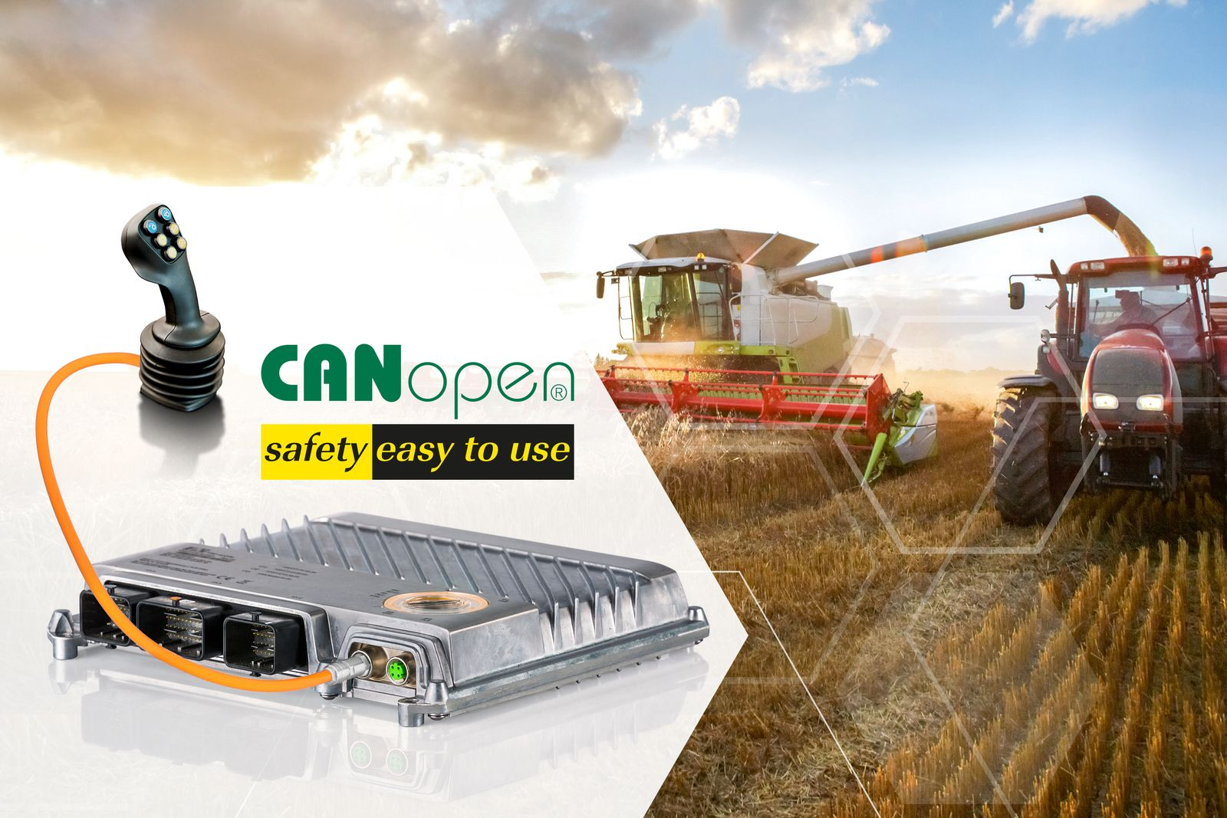
B&R simplifies implementation of safety functions on mobile machinery with the CANopen Safety protocol.

About B&R
B&R, a division of ABB Group, is a global leader in industrial automation headquartered in Austria. B&R combines state-of-the-art technology with advanced engineering to provide customers in virtually every industry with complete solutions for machine and factory automation, motion control, HMI and integrated safety technology. With Industrial IoT communication standards including OPC UA, POWERLINK and openSAFETY as well as its Automation Studio software, B&R is constantly redefining the future of automation engineering. The innovative spirit that keeps B&R at the forefront of industrial automation is driven by a commitment to simplifying processes and exceeding customer expectations.
For more information, visit www.br-automation.com.

