IP69K PC for autonomous agricultural and construction vehicles
B&R introduces high-end PC for mobile machinery
B&R is adding a high-end PC to its mobile automation portfolio. The new PC offers significantly more processing power and memory, giving it plenty of resources to implement autonomous functions for agricultural and construction vehicles or self-driving transport systems.

The PC is specially designed to perform in harsh environments. The housing temperature can be between -40°C and +85°C. The PC is also highly resistant to shock and vibration.
Ideal for resource and data intensive applications
Inside the mobile PC's IP69K housing is a powerful Intel Core i7 processor. It also has 16 GB RAM and 480 GB flash memory, making it ideal for applications that are computationally intensive or involve larger volumes of data.
The increased computing power is needed for tasks such as accurate path planning in autonomous agricultural vehicles. More efficient, more precise vehicles deliver increased yield.
From the field to the cloud with OPC UA or MQTT
The PC's high performance makes it optimally suited for smart machines that communicate with each other, process data and send it to the cloud. Tractors and implements can optimize harvesting efficiency, for example, by exchanging information such as speed and load capacity. B&R supports well-established communication protocols like OPC UA and MQTT.

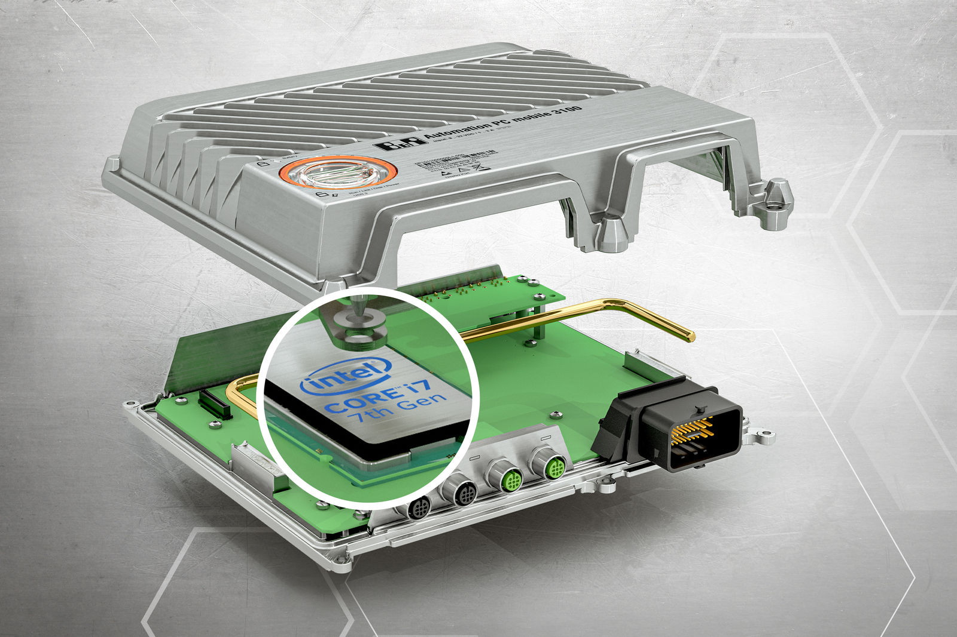
With an Intel Core i7 processor, the new PC variant offers significantly more processing power and memory.

About B&R
B&R, a division of ABB Group, is a global leader in industrial automation headquartered in Austria. B&R combines state-of-the-art technology with advanced engineering to provide customers in virtually every industry with complete solutions for machine and factory automation, motion control, HMI and integrated safety technology. With Industrial IoT communication standards including OPC UA, POWERLINK and openSAFETY as well as its Automation Studio software, B&R is constantly redefining the future of automation engineering. The innovative spirit that keeps B&R at the forefront of industrial automation is driven by a commitment to simplifying processes and exceeding customer expectations.
For more information, visit www.br-automation.com.

