Predict the failure, prevent the loss
Storage media health monitoring helps prevent costly downtime
B&R's real-time operating system, Automation Runtime, now automatically logs data about storage media's health to provide machine operators and service personnel early warnings of impending failure. Storage media can be replaced before a crash causes lost data and costly downtime. B&R is among the first to bring this commercial-grade feature to industrial embedded runtime systems.
"Failure of a storage device can be devastating," says B&R product manager Varad Darji. "Even with a backup, a certain amount of recently changed data and settings are always lost. It can even bring down the entire machine, resulting in expensive lost productivity until an engineer replaces the drive and restores the settings." The new Storage Health Data function is available with an easy update to B&R's Automation Studio engineering environment.
Early warning for technicians and operators
Without any additional programming, Storage Health Data can be viewed in B&R's web-based System Diagnostics Manager tool, allowing service personnel to recommend storage media replacement during scheduled downtime proactively. It is also possible to program HMI functions that notify operators directly on their HMI screen when a drive reaches a defined threshold, such as 80% of its lifespan.

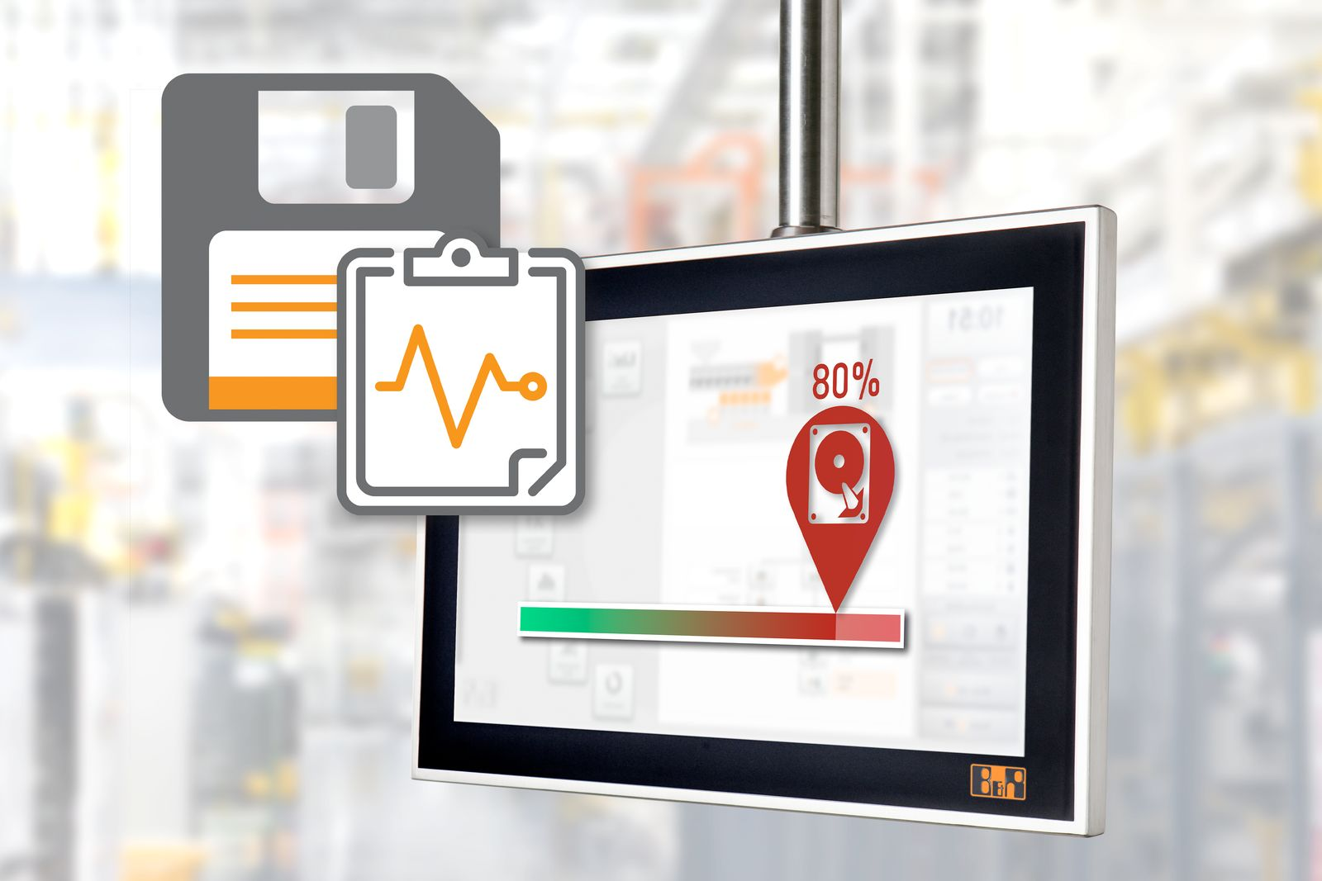
When you can detect the signs of impending failure, you can replace storage media before a crash results in lost data and costly downtime.

About B&R
B&R, a division of ABB Group, is a global leader in industrial automation headquartered in Austria. B&R combines state-of-the-art technology with advanced engineering to provide customers in virtually every industry with complete solutions for machine and factory automation, motion control, HMI and integrated safety technology. With Industrial IoT communication standards including OPC UA, POWERLINK and openSAFETY as well as its Automation Studio software, B&R is constantly redefining the future of automation engineering. The innovative spirit that keeps B&R at the forefront of industrial automation is driven by a commitment to simplifying processes and exceeding customer expectations.
For more information, visit www.br-automation.com.

