Local B&R service and support for Upstate New York
B&R Industrial Automation announces distribution partnership with Empire Automation
Empire Automation has recently joined forces with one of the leading global companies in automation equipment manufacturing, B&R Industrial Automation, as an exclusive distribution partner. With the addition of B&R technology to its existing portfolio of ABB solutions, Empire offers customers a single point of contact for their entire automation solution within the Upstate New York area. Machine builders can now profit from an even closer contact to application services and support for B&R solutions.

"The forward-thinking technology that B&R Automation brings to the marketplace in the form of industrial automation complements our existing technologies tremendously," stated Don Davis, CEO, Empire Automation. "Specific technologies such as Machine-Centric Robotics, vision and ACOPOS 6D allows us to solve some of the most advanced automation challenges presented to companies." Empire Automation Systems can now connect these industrial technology products, which include machine control and robotic systems, to produce a complete automation solution.

"Our recent product launches around the adaptive machine concept create a great synergy for Empire Automation and B&R. They are positioned well in their market to bring this technology into their customer solutions," states Patrick McDermott, President, B&R Industrial Automation, North America. B&R’s partnership with Empire Automation brings a commitment to quality and service, as well as an extensive technology portfolio that will help customers succeed in the fast-paced technology world. Empire Automation is part of the MASEAS brand (Minuteman Automation Systems and Empire Automation Systems).

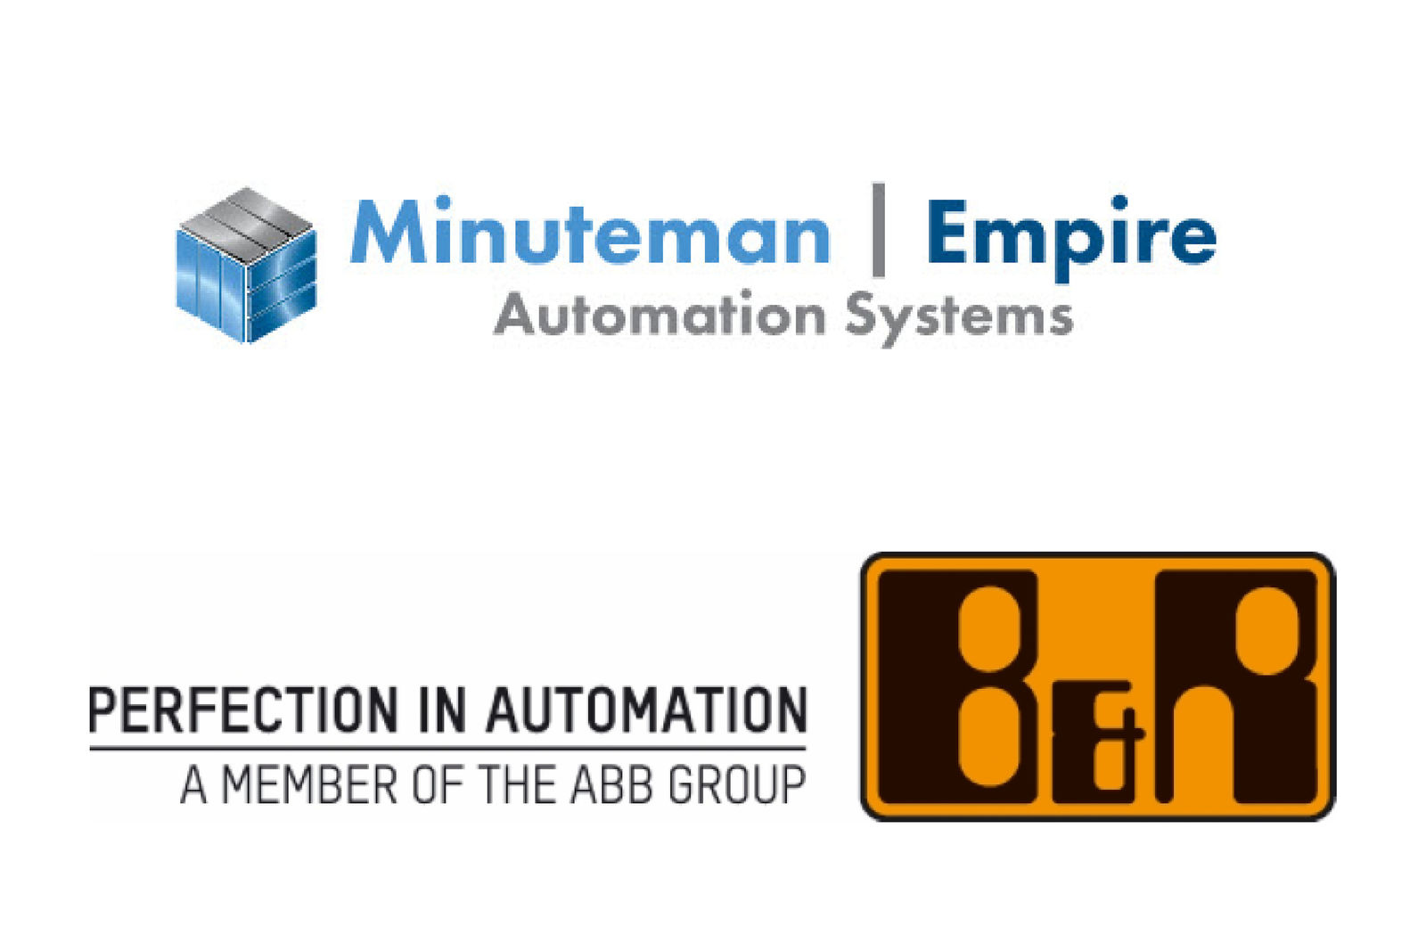
With the addition of B&R technology to its existing portfolio of ABB solutions, Empire Automation now offers customers in Upstate New York a single point of contact for their entire automation solution.

About B&R
B&R, a division of ABB Group, is a global leader in industrial automation headquartered in Austria. B&R combines state-of-the-art technology with advanced engineering to provide customers in virtually every industry with complete solutions for machine and factory automation, motion control, HMI and integrated safety technology. With Industrial IoT communication standards including OPC UA, POWERLINK and openSAFETY as well as its Automation Studio software, B&R is constantly redefining the future of automation engineering. The innovative spirit that keeps B&R at the forefront of industrial automation is driven by a commitment to simplifying processes and exceeding customer expectations.
For more information, visit www.br-automation.com.

