Reliable wear detection
B&R presents new gate measurement module for efficient machine and process automation
With a new bus controller, B&R has added a gate measurement module to its portfolio for efficient monitoring of machinery and processes. The new gate measurement module joins the X67 lineup to help keep manufacturing processes consistent and reduce the rate of rejection, thus increasing both quality and productivity.

By measuring the duration of switching operations with extreme precision, the module is able to detect even the slightest deviations, which can point to component wear, changes in temperature or other environmental factors. This enables automatic compensation for deviations from expected switching times and implementation of predictive maintenance strategies. Unplanned machine downtime and fluctuations in quality can be reliably avoided.
Use it anywhere
The IP67-rated module stands up to the most demanding conditions. It has six digital outputs with readable status and six digital inputs. The digital channels can be configured in pairs to perform gate measurement with a resolution of 100 µs directly on the module. Gate measurement can be triggered on positive or negative edges.

The device also has an analog input with configurable filter functions. Its digital outputs are protected against overload and short-circuits. The module is connected to the machine network via POWERLINK.

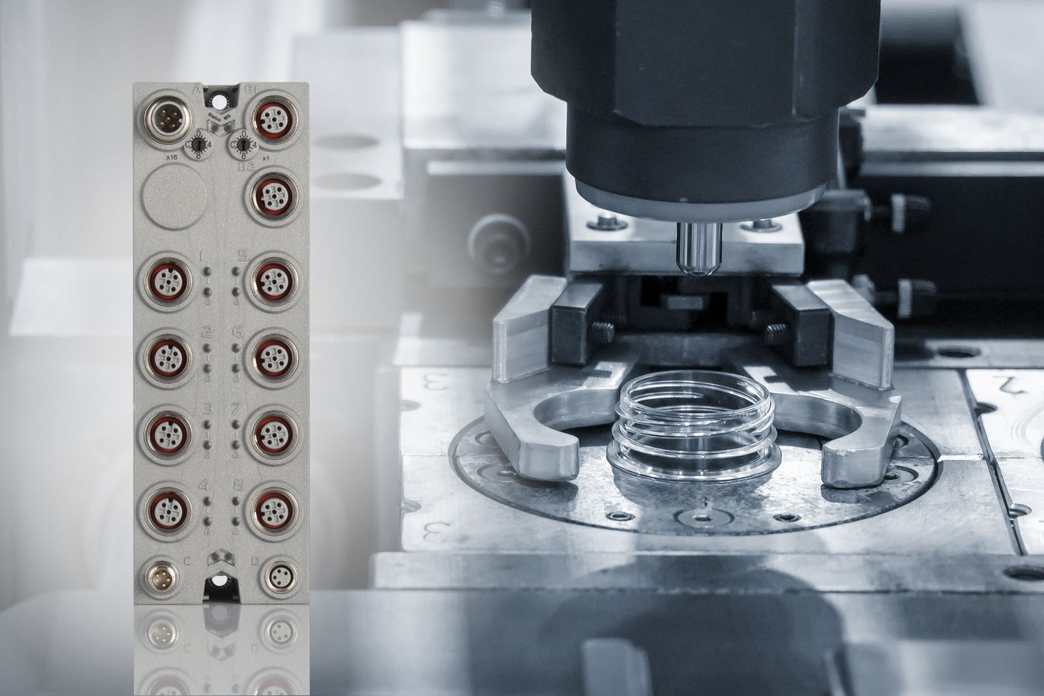
B&R's new gate measurement module quickly and reliably identifies changes in machine components due to wear or external factors – enabling automatic compensation.

About B&R
B&R, a division of ABB Group, is a global leader in industrial automation headquartered in Austria. B&R combines state-of-the-art technology with advanced engineering to provide customers in virtually every industry with complete solutions for machine and factory automation, motion control, HMI and integrated safety technology. With Industrial IoT communication standards including OPC UA, POWERLINK and openSAFETY as well as its Automation Studio software, B&R is constantly redefining the future of automation engineering. The innovative spirit that keeps B&R at the forefront of industrial automation is driven by a commitment to simplifying processes and exceeding customer expectations.
For more information, visit www.br-automation.com.

