Perfect control for every application
Option boards expand range of applications for B&R X90 control system
B&R has added three new option boards for its X90 product line. With the new boards, it is now possible to connect strain gauges and an IO-Link master module to the mobile machinery control system. It is also possible to add relays with normally open contacts for potential-free communication. With all the new options, X90 controllers are more readily adaptable than ever to all types of application requirements.

The X90 option board for strain gauges can evaluate two full bridge strain gauges, each connected to the X90 controller via an M12 connector. Strain gauges are used to detect even the smallest mechanical deformations. They can be used in weighing systems, for example, and for measuring vertical load or the load on a cantilever arm. The measurement data is available for use in the control system in real time without any third-party systems or additional tools.
Intelligent sensor connections with IO-Link
Another option board available for the X90 controller is the IO-Link master module. It enables communication with up to four intelligent IO-Link sensors and actuators. This bidirectional digital communication interface allows IO-Link to exchange parameter data and diagnostic information, thus making it possible to intelligently connect sensors and switching devices to the X90 controller. This makes IO-Link the ideal addition to real-time Ethernet POWERLINK, OPC UA and CAN-based networks.
Potential-free exchange of information
The relay option board on the X90 controller allows the potential-free exchange of digital information with external systems. The option board is equipped with five normally open contacts and can also be used for small loads.
B&R X90 control system for mobile machinery
X90 is a modular control and I/O system for mobile machinery. The comprehensive set of standardized components is perfect for implementing flexible automation concepts. The heart of the X90 control system is a powerful ARM processor and multifunction I/O channels. Standard features include interfaces for CAN, Ethernet and the real-time POWERLINK bus system. All products in the X90 family are designed for use under harsh conditions. They can handle housing temperatures from -40°C to +85°C and are resistant to environmental factors such as shock and vibration, salt, UV light and oil.

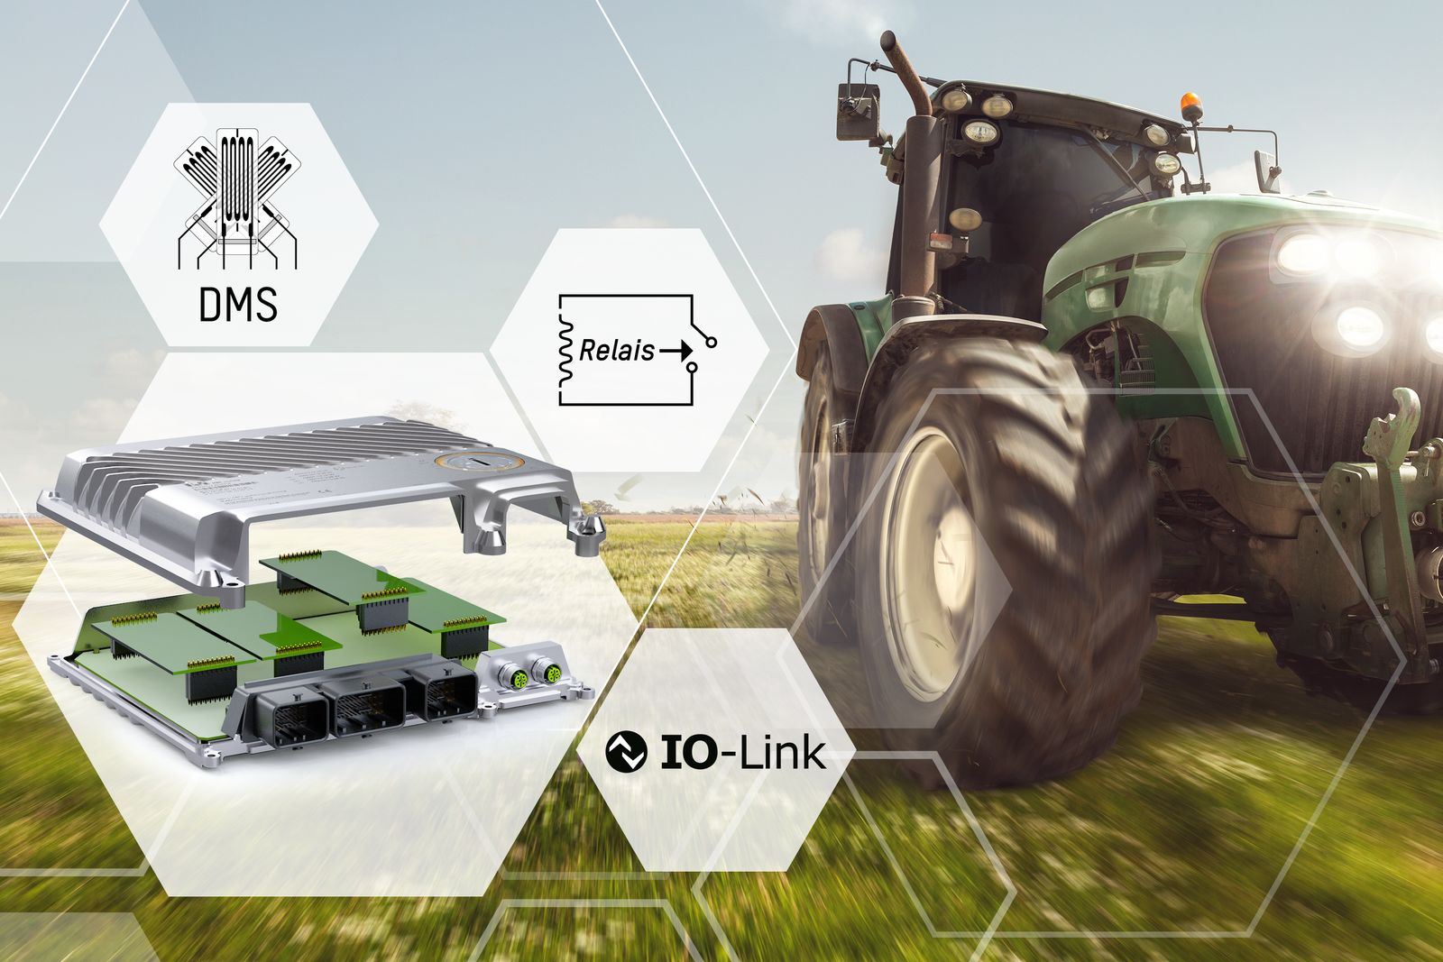
With three new option boards, B&R expands the range of applications for its X90 control system for mobile machinery.

About B&R
B&R, a division of ABB Group, is a global leader in industrial automation headquartered in Austria. B&R combines state-of-the-art technology with advanced engineering to provide customers in virtually every industry with complete solutions for machine and factory automation, motion control, HMI and integrated safety technology. With Industrial IoT communication standards including OPC UA, POWERLINK and openSAFETY as well as its Automation Studio software, B&R is constantly redefining the future of automation engineering. The innovative spirit that keeps B&R at the forefront of industrial automation is driven by a commitment to simplifying processes and exceeding customer expectations.
For more information, visit www.br-automation.com.

