Additive manufacturing ready for industrial-scale production
Evolve brings full-speed flexibility to the production floor
Evolve Additive Solutions has succeeded in combining the flexibility of additive technology with the volume and quality of injection molding. Featuring a fully integrated B&R automation system, the Evolve SVP platform delivers the precision and reliability to make additive manufacturing a real alternative for high-speed, mass-customized serial production.
Additive technology has proven its value in prototyping, yet factors like material quality and unit costs have so far hindered its feasibility for end-use parts. Evolve has now succeeded in removing those remaining barriers. Its SVP (scalable volume production) platform is equipped with a full B&R solution that integrates motion control, process control, safety and HMI as well as IIoT-connectivity. "With the reliable high performance of our B&R solution, we're ready to bring additive technology to the floor of tomorrow's smart, connected factory," says Evolve CEO Steve Chillscyzn.
10x faster than any industrial 3D printer
At the core of Evolve's platform is its STEP (selective thermoplastic electrophotographic process) technology, which lays down layers of material – not unlike a 2D laser printer – and then fuses them into three-dimensional parts with uniform density and quality. This revolutionary approach achieves speeds up to ten times faster than any industrial 3D printer with the unique ability to create multi-material and multi-color parts.
Precision is quality
Material properties have also been among the main obstacles to the use of additive technology for serial production. With its B&R motion control solution, Evolve is able to precisely synchronize the alignment of the 2D-printed layers between the reciprocating platens and the moving belt. Combined with high-performance pressure and temperature control during the fusing stage, Evolve is able to achieve an average surface roughness of only four microns, even without post processing.
Industrial IoT ready for sustained success
With the B&R system, Evolve's platform is perfectly equipped to offer its customers the connected factory solutions they need to stay competitive. With digital molds stored in the cloud, they can produce identical parts anywhere in the world and implement new designs without having to produce new physical molds. Advanced maintenance solutions and machine upgrades can be implemented remotely to optimize availability while reducing costs.

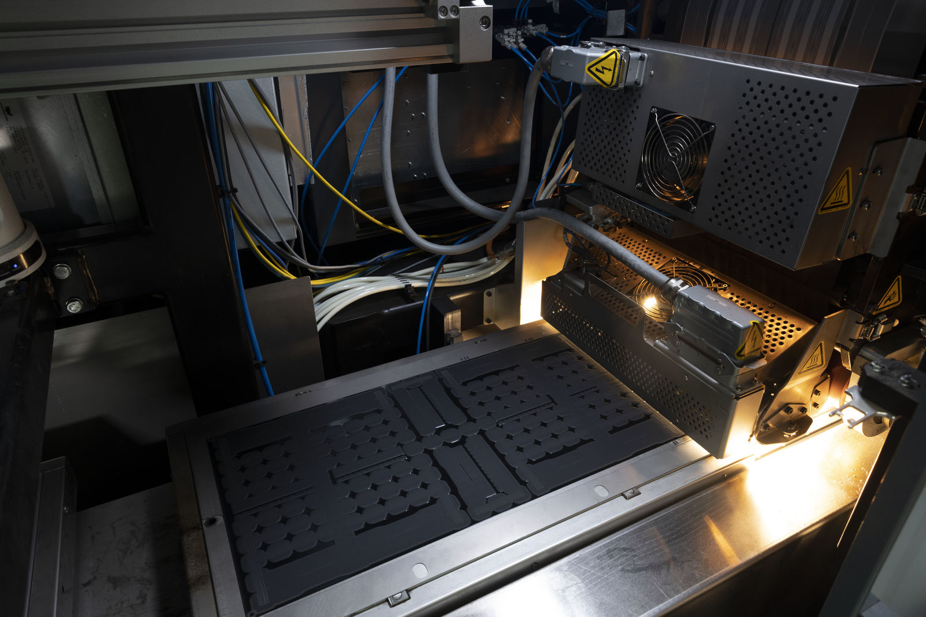
Evolve's B&R-controlled process fuses 2D-printed layers into solid 3D parts – combining the flexibility of additive technology with the material quality and production volume of injection molding.

About B&R
B&R, a division of ABB Group, is a global leader in industrial automation headquartered in Austria. B&R combines state-of-the-art technology with advanced engineering to provide customers in virtually every industry with complete solutions for machine and factory automation, motion control, HMI and integrated safety technology. With Industrial IoT communication standards including OPC UA, POWERLINK and openSAFETY as well as its Automation Studio software, B&R is constantly redefining the future of automation engineering. The innovative spirit that keeps B&R at the forefront of industrial automation is driven by a commitment to simplifying processes and exceeding customer expectations.
For more information, visit www.br-automation.com.

