Premium performance encapsulated in compact footprint
IMA capsule filler achieves breakthrough in production density with integrated B&R platform
IMA Active has taken the advanced functionality found in the larger members of its high-end capsule filler family and packed it into the compact ADAPTA 50. Pushing design limits presented entirely new challenges in terms of decentralized intelligence, motion control synchronization and data-intensive processing. In close collaboration with automation partner B&R, the solid dose pharmaceutical specialist created a compact yet full-featured new capsule filler that delivers unprecedented production density.
The ADAPTA 50 offers the same total in-process control, impeccable precision and dosing flexibility of the larger ADAPTA 100/200 on a one-third smaller footprint. "The extremely compact design required deep-dive problem solving in many aspects of the automation solution," says IMA Active Automation Manager Marco Minardi. "Through our great collaboration with B&R's experts, we were able to master specific challenges like heat dissipation and data-intensive processing, while at the same time maintaining a holistic approach to the overall concept."
Integrated platform for compact performance
"In pharmaceuticals, performance is ultimately a matter of patient safety," says Minardi. "So for a best-in-class product line like ADAPTA, every aspect must meet the absolute highest requirements – particularly the automation technology." From industrial PCs to motion control and machine vision, B&R's automation components helped IMA pack premium performance into tight spaces. And the entire B&R solution is connected by a POWERLINK network with a cycle time of only 400 microseconds and configured in B&R's universal engineering environment.
Close collaboration for lasting success
"Our relationship with B&R is based on more than just technology," emphasizes Minardi. "They're easy to talk to, quick to understand our needs and ready to solve challenges at every phase of the project." Another decisive factor is B&R's strong global presence – particularly important to a company like IMA who sells 90% of its machines abroad. "We really value B&R's customer focus in all aspects of the way they do business," Minardi adds, citing factors like B&R's long-term product availability and track record of cutting-edge R&D. "That gives us confidence that we'll always be among the first to benefit from future advancements in automation technology."

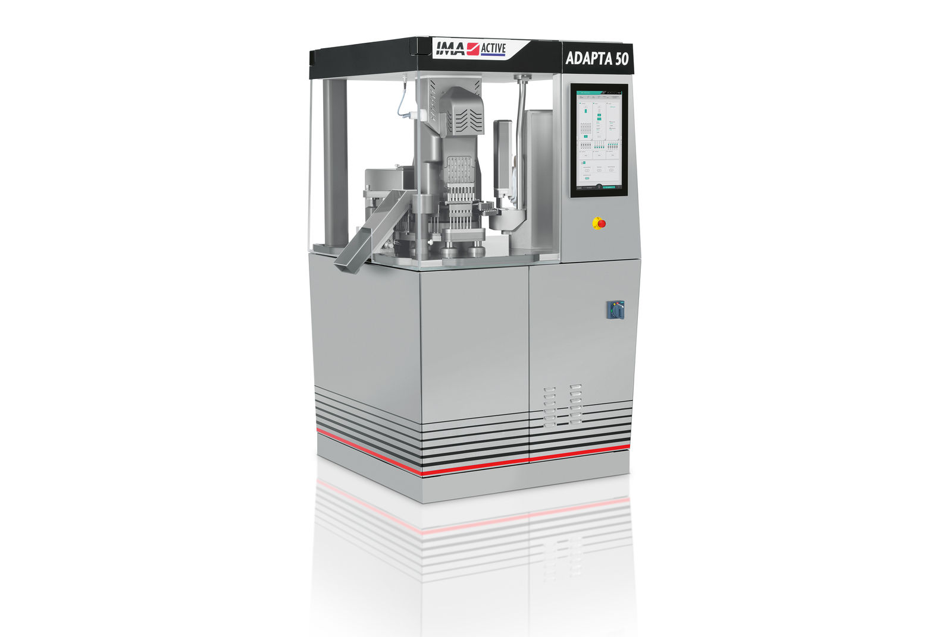
IMA Active's ADAPTA 50 fits high-end capsule filling performance into a one-third smaller footprint thanks to an integrated automation solution and close collaboration from B&R.

About B&R
B&R, a division of ABB Group, is a global leader in industrial automation headquartered in Austria. B&R combines state-of-the-art technology with advanced engineering to provide customers in virtually every industry with complete solutions for machine and factory automation, motion control, HMI and integrated safety technology. With Industrial IoT communication standards including OPC UA, POWERLINK and openSAFETY as well as its Automation Studio software, B&R is constantly redefining the future of automation engineering. The innovative spirit that keeps B&R at the forefront of industrial automation is driven by a commitment to simplifying processes and exceeding customer expectations.
For more information, visit www.br-automation.com.

