Controller and PC in one device
B&R Hypervisor saves space in mobile machines
B&R now equips its PC for mobile machinery with B&R Hypervisor software. This enables it to serve simultaneously as both a high-performance controller and a Windows or Linux PC, allowing smart farming applications to be implemented with only a single device.

The General Purpose Operating System (GPOS) and the real-time operating system are connected via a virtual network interface. Windows software with a cloud connection could be used to calculate the optimal path for a mobile machine to follow, for example, while the real-time operating system turns that information to specific commands for the drives. Combining two operating systems on one device lowers equipment costs. It also allows for a more compact design and makes more efficient use of available hardware resources.
Option board for an external I/O connection
B&R also offers a new option board for connecting external I/O modules or sensors in combination with hypervisor software. It is equipped with three CAN POWERLINK interfaces and one real-time POWERLINK interface.
Standardized communication
B&R offers an option board with four additional Ethernet interfaces in order to further network the PC within the mobile machine. This way, external devices such as GPS receivers or cellular modems can be connected to the PC. The interfaces are already equipped with the TSN Ethernet extension, making them optimally prepared for the OPC UA over TSN communication standard.

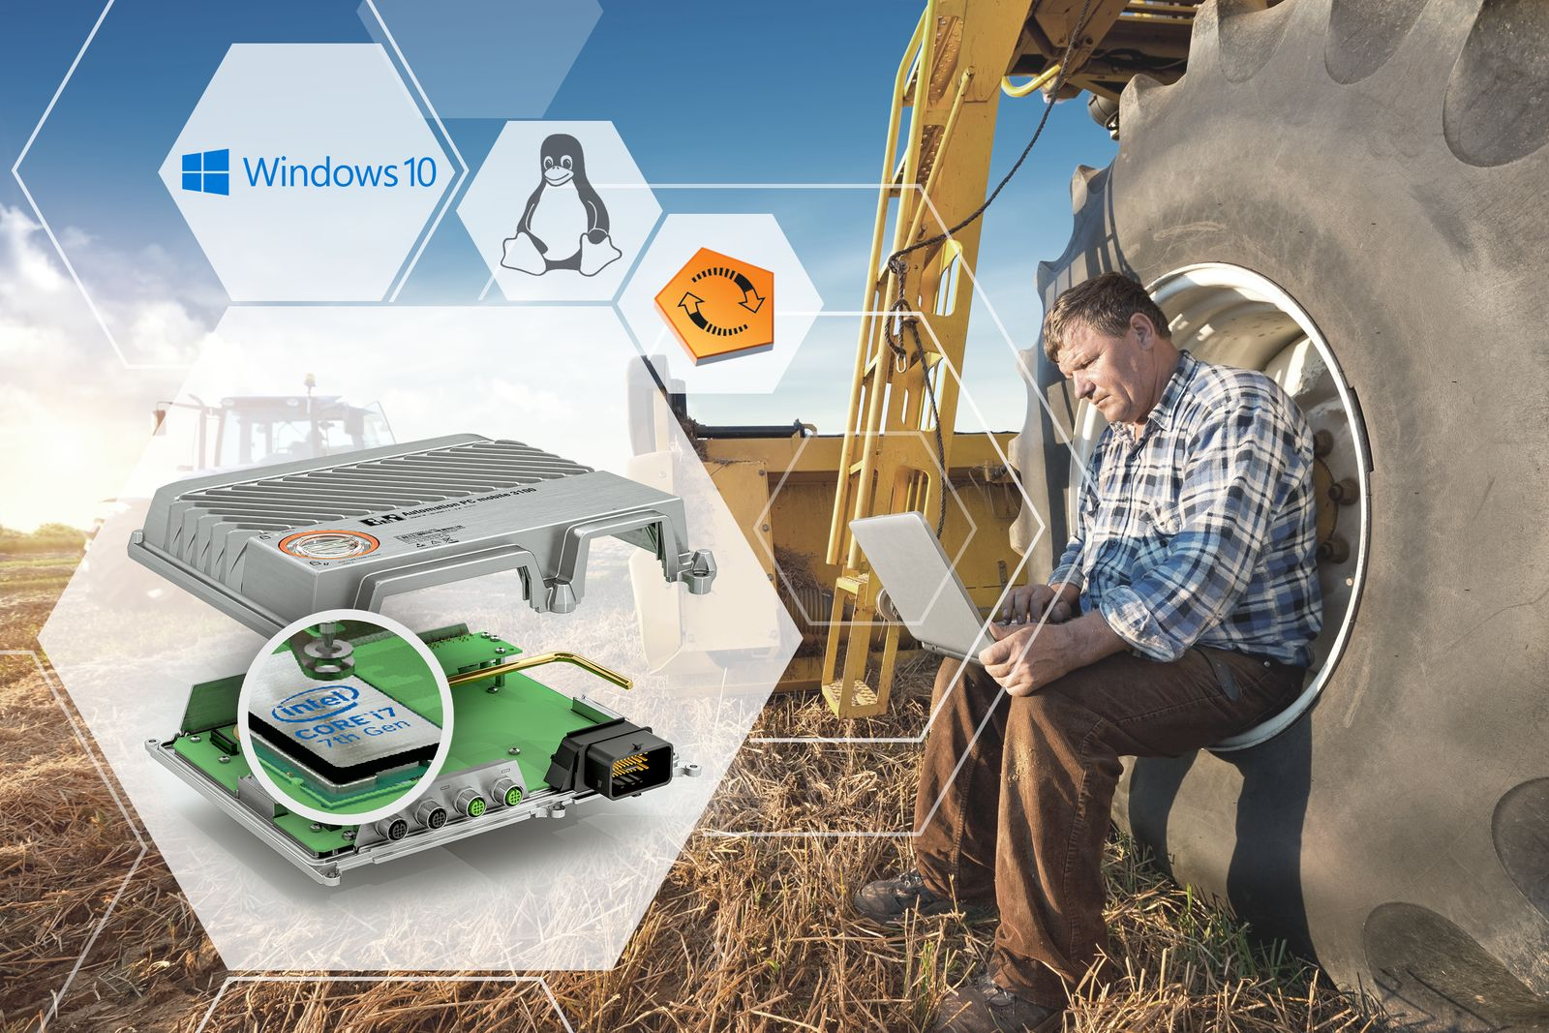
The hypervisor software enables multiple operating systems to run in parallel on a single device. The operating systems can communicate with each other via a virtual network.

About B&R
B&R, a division of ABB Group, is a global leader in industrial automation headquartered in Austria. B&R combines state-of-the-art technology with advanced engineering to provide customers in virtually every industry with complete solutions for machine and factory automation, motion control, HMI and integrated safety technology. With Industrial IoT communication standards including OPC UA, POWERLINK and openSAFETY as well as its Automation Studio software, B&R is constantly redefining the future of automation engineering. The innovative spirit that keeps B&R at the forefront of industrial automation is driven by a commitment to simplifying processes and exceeding customer expectations.
For more information, visit www.br-automation.com.

