B&R joins amec as industrial automation systems provider

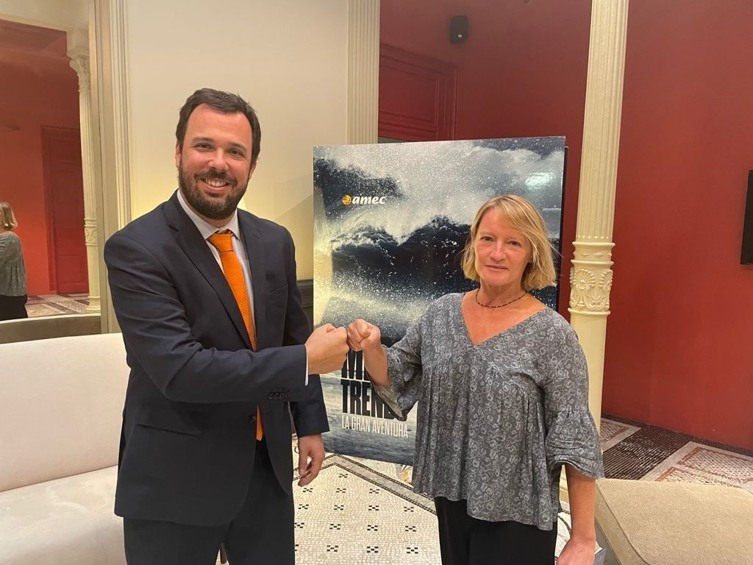
New partners at amec, the umbrella organization for Spain's leading international industries: Oriol Grima, marketing manager at B&R Spain and Carmina Castella, Business Unit Director Food, Packaging and Plastic Technology at amec (from left to right).

B&R to help strengthen the industrial fabric of the amec community
In August 2021, B&R, a leading industrial automation systems company, joined amec, the umbrella organization for Spain's leading international industries: a visionary, collaborative, self-governing community with a powerful lobbying activity.
With this addition, B&R intends to contribute its extensive knowledge in different specific industries such as the packaging, food and beverage and pharmaceutical industries, among others. In addition to the automation systems that are part of B&R's portfolio, the Austrian-based company intends to bring to the amec ecosystem the high degree of professional knowledge of its employees in the different industries, market knowledge and excellence.
Collaborative work in industrial automation systems
Oriol Grima, marketing manager at B&R Spain, comments that "at B&R we have taken this step because we believe that the industry needs powerful players that are up to the task in the current situation and circumstances. With this agreement, B&R will bring its experience and knowledge in industrial automation systems to a networking and collaborative work environment".
On the other hand, the amec community has a first-rate technological expert with whom to solve their doubts and needs. Within amec, B&R is located in the industry group, which is currently working with the following industry trends: energy efficiency and sustainability; process automation; and new materials.
Belonging to the industrial community
"Together, collaborating and sharing, we industrial companies have shown that we can go further. That's why we are very happy to add B&R to our community," explained amec's CEO, Joan Tristany.

