Smart Industry Conference 2021 - Concludes next course in shaping Industry 4.0
Harnessing the power of technology to achieve smart manufacturing
The Ethernet POWERLINK Standardization Group, in collaboration with B&R Industrial Automation, ABB Robotics, Utthunga, and Tata Technologies, held a virtual conference titled 'Smart Industry Conference 2021'. The sixth edition of the flagship conference was designed to benefit the Indian manufacturing companies that are shaping Industry 4.0. Frost & Sullivan was the knowledge partner of the conference. The one-day virtual conference was held on August 19, 2021, and was attended by more than one hundred delegates. Attendees from across the manufacturing ecosystem witnessed various topics covering technology, innovation, and open communication standards. The core agenda of the conference was to look beyond the cutting edge to inspire the Indian manufacturers and construct the next level of Industry 4.0.
Through its keynote address, three presentations, and one-panel discussion, the conference provided a platform for the challenges and solutions of smart industry implementation. The conference focused on the journey of digital transformation towards smart, connected devices with security, analytics, and cloud solutions. Rahul Sharma, Director of Industrial Practice at Frost & Sullivan, delivered the keynote on "Trends and technologies shaping the Indian manufacturing ecosystem," which focused on the preparedness of Indian manufacturers and the readiness of consumers to adopt the various digital mediums. He also spoke on the sustainability perspective for manufacturing transformation in India, noting that sustainability should be the most significant theme of any organization. According to Sharma, sustainability needs to be seen on four dimensions; People, Partnership, Process, and Planet and the mark of a sustainably matured organization successfully interweaving digital transformation strategy with sustainability.
Staying competitive in the new business and economic environment
Well-received by the delegates, the event's panel discussions focused on the connected ecosystem and digital strategies and the way forward for the Indian manufacturing industry to become competitive in the new business environment. The panel discussion topic was addressed by panelists Vinay Rajagopal, ISV, IoT & Embedded Technology Lead, Red Hat; Guruprasad S, Associate Vice President, ABB; and Jhankar Dutta, Managing Director, B&R India.
The panelists discussed that the businesses' new realities have made stakeholders revisit their operations, supply chain, and customer engagement strategies. Advanced automation, robotics, and the latest Industrial IoT technologies are unfolding new opportunities for factories to become more innovative and profitable. The discussion helped identify easy ways to optimize processes, improve productivity, and make shopfloors smart. Identifying low-hanging fruits and harnessing them at the right time will be crucial to achieving industry goals. The panelists agreed that the connection between machines, processes, and people is essential to build a digital culture supported by a data-driven model. But with the looming threat of cyberattacks and data breaches, prioritization of cybersecurity is crucial to preventing profound business impacts. Well-defined strategies, targeted preparation, and alignment with industry standards are the needs of the hour.
Achieving operational excellence
The conference also hosted several technical presentations, including "Democratizing manufacturing via OPC UA" by Smitha Rao, Cofounder and OPC Expert, Utthunga Technologies and connected manufacturing and its significance in a digital world" by Niraj Tyagi, HEAD COE MES Enterprise Solutions, Tata Technologies, amongst others. The presentations covered the topics of connected factories, implementation possibilities, and solutions, stressing the critical aspects of automation, digitalization, m2m communications, interoperability, big data analytics, and new business models. The conference concluded with a presentation titled "New era in real-time industrial communication for smart factories" by Ranjithkumar, B&R, heralding the next phase of unified real-time communication invading the shopfloor to prepare for the digital future. The conference served as an ideal platform for understanding the latest technology trends and helped draw a roadmap for Indian manufacturers to become globally competitive. With an exciting lineup of topics and knowledge exchange, delegates received helpful guidance on the practical application of these state-of-the-art technologies in all the key sectors.

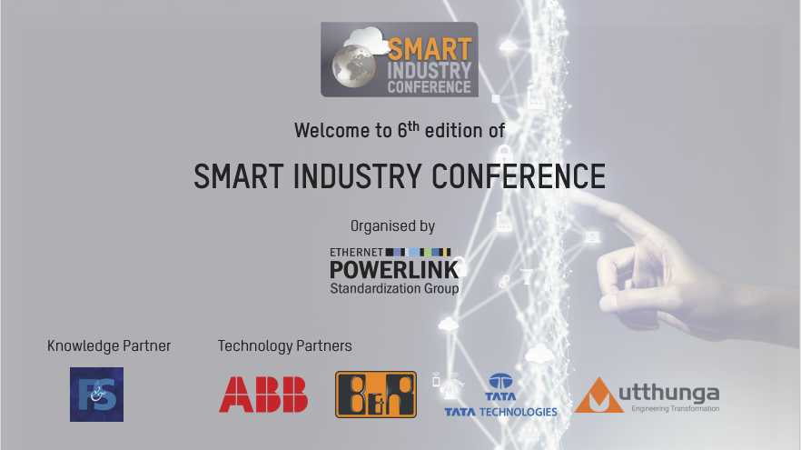
The 6th edition of the Smart Industry Conference was designed to benefit the Indian manufacturing companies that are shaping Industry 4.0.

About B&R
B&R, a division of ABB Group, is a global leader in industrial automation headquartered in Austria. B&R combines state-of-the-art technology with advanced engineering to provide customers in virtually every industry with complete solutions for machine and factory automation, motion control, HMI and integrated safety technology. With Industrial IoT communication standards including OPC UA, POWERLINK and openSAFETY as well as its Automation Studio software, B&R is constantly redefining the future of automation engineering. The innovative spirit that keeps B&R at the forefront of industrial automation is driven by a commitment to simplifying processes and exceeding customer expectations.
For more information, visit www.br-automation.com.

