On track
TÜV SÜD Rail certifies B&R control system for railway applications
TÜV SÜD Rail has certified B&R's X90 system for use in railway applications. In accordance with the EN 50155, EN 50657 and EN 45545-2 standards, the mobile control system can now be used for applications such as lighting and temperature control.
X90 products provide especially high resistance to harsh environmental conditions and meet high requirements for electromagnetic compatibility. The TÜV SÜD Rail certification confirms this, as well as verifying the high quality of the B&R software and a high degree of fire protection.
Performance under extreme conditions
B&R has designed its X90 series for use under extremely harsh conditions. With IP69K protection, the devices can be operated in a housing temperature range of -40°C to +85°C and are shock and vibration resistant.

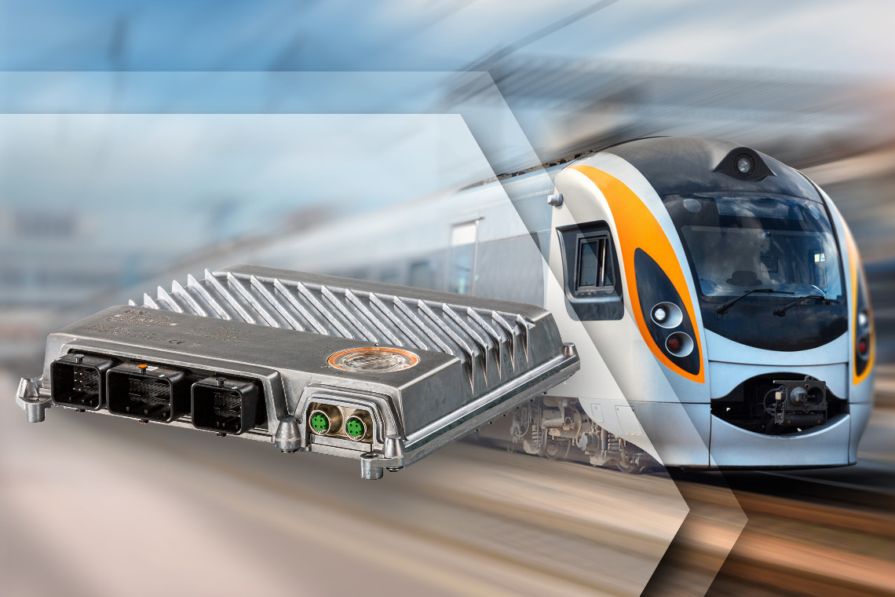
Convincing quality: TÜV SÜD Rail has certified B&R's X90 system for use in railway applications.

About B&R
B&R, a division of ABB Group, is a global leader in industrial automation headquartered in Austria. B&R combines state-of-the-art technology with advanced engineering to provide customers in virtually every industry with complete solutions for machine and factory automation, motion control, HMI and integrated safety technology. With Industrial IoT communication standards including OPC UA, POWERLINK and openSAFETY as well as its Automation Studio software, B&R is constantly redefining the future of automation engineering. The innovative spirit that keeps B&R at the forefront of industrial automation is driven by a commitment to simplifying processes and exceeding customer expectations.
For more information, visit www.br-automation.com.

